UNITED STATES
SECURITIES AND EXCHANGE COMMISSION
WASHINGTON, DC 20549
____________________
FORM 8-K
____________________
CURRENT REPORT
PURSUANT TO SECTION 13 OR 15(d)
OF THE SECURITIES EXCHANGE ACT OF 1934
Date of Report (Date of earliest event reported): July 29, 2026
MIMEDX GROUP, INC.
(Exact name of registrant as specified in charter)
Florida |  |  |  |  |  | 001-35887 |  |  |  |  |  | 26-2792552
(State or other jurisdiction |  |  |  |  |  | (Commission |  |  |  |  |  | (IRS Employer
of incorporation) |  |  |  |  |  | File Number) |  |  |  |  |  | Identification No.)
1775 West Oak Commons Ct., NE, Marietta GA 30062
(Address of principal executive offices) (Zip Code)
Registrant’s telephone number, including area code: (770) 651-9100
____________________
Check the appropriate box below if the Form 8-K filing is intended to simultaneously satisfy the filing obligation of the registrant under any of the following provisions (see General Instruction A.2. below):
☒ |  |  | Written communications pursuant to Rule 425 under the Securities Act (17 CFR 230.425)
☐ |  |  | Soliciting material pursuant to Rule 14a-12 under the Exchange Act (17 CFR 240.14a-12)
☐ |  |  | Pre-commencement communications pursuant to Rule 14d-2(b) under the Exchange Act (17 CFR 240.14d-2(b))
☐ |  |  | Pre-commencement communications pursuant to Rule 13e-4(c) under the Exchange Act (17 CFR 240.13e-4(c))
Securities registered pursuant to Section 12(b) of the Act:
Title of each class |  |  |  |  |  | Trading Symbol(s) |  |  |  |  |  | Name of each exchange  on which registered
Common Stock, $0.001 par value per share |  |  |  |  |  | MDXG |  |  |  |  |  | The Nasdaq Stock Market LLC
Indicate by check mark whether the registrant is an emerging growth company as defined in Rule 405 of the Securities Act of 1933 (§ 230.405 of this chapter) or Rule 12b-2 of the Securities Exchange Act of 1934 (§ 240.12b-2 of this chapter).
Emerging growth company ☐
If an emerging growth company, indicate by check mark if the registrant has elected not to use the extended transition period for complying with any new or revised financial accounting standards provided pursuant to Section 13(a) of the Exchange Act. ☐

Important Cautionary Statement
This report includes forward-looking statements. Statements regarding: (i) future sales or sales growth; (ii) our 2026 and longer term financial goals and expectations for future financial results, including levels of net sales, Adjusted EBITDA, Adjusted EBITDA margin, corporate expenses and cash; (iii) our expectations regarding the placental tissue market; (iv) our expectations regarding Medicare reimbursement; and (v) performance in different care settings, are forward-looking statements. Additional forward-looking statements may be identified by words such as “believe,” “expect,” “may,” “plan,” “goal,” “outlook,” “potential,” “will,” “preliminary,” and similar expressions, and are based on management’s current beliefs and expectations.
Forward-looking statements are subject to risks and uncertainties, and the Company cautions investors against placing undue reliance on such statements. Actual results may differ materially from those set forth in the forward-looking statements. Factors that could cause actual results to differ from expectations include: (i) future sales are uncertain and are affected by competition, access to customers, patient access to healthcare providers, the reimbursement environment and many other factors; (ii) the Company may change its plans due to unforeseen circumstances; (iii) the results of scientific research are uncertain and may have little or no value; (iv) our ability to sell our products in other countries depends on a number of factors including adequate levels of reimbursement, market acceptance of novel therapies, and our ability to build and manage a direct sales force or third party distribution relationship; (v) the effectiveness of amniotic tissue as a therapy for particular indications or conditions is the subject of further scientific and clinical studies; and (vi) we may alter the timing and amount of planned expenditures for research and development based regulatory developments. The Company describes additional risks and uncertainties in the Risk Factors section of its most recent annual report and quarterly reports filed with the Securities and Exchange Commission. Any forward-looking statements speak only as of the date of this report and the Company assumes no obligation to update any forward-looking statement.

Item 2.02 Results of Operations and Financial Condition

On July 29, 2026, MiMedx Group, Inc. (the “Company”), issued a press release (the “Earnings Press Release”) announcing its results for the second quarter of 2026. A copy of the Earnings Press Release is attached hereto as Exhibit 99.1 and is incorporated herein by reference.

The foregoing information is furnished pursuant to Item 2.02, “Results of Operations and Financial Condition”, including Exhibit 99.1 attached hereto, and shall not be deemed “filed” for purposes of Section 18 of the Securities Exchange Act of 1934, as amended (the “Exchange Act”), or otherwise subject to the liabilities of that section. It may only be incorporated by reference into another filing under the Exchange Act or Securities Act of 1933, as amended (the “Securities Act”), if such subsequent filing specifically references this Form 8-K. All information in the Earnings Press Release speaks as of the date thereof and the Company does not assume any obligation to update such information in the future. In addition, the Company disclaims any inference regarding the materiality of such information which otherwise may arise as a result of its furnishing such information under Item 2.02 of this report on Form 8-K.

Item 7.01 |  |  | Regulation FD
On July 29, 2026 at 4:30 PM Eastern Daylight Time, the Company intends to host a conference call and webcast (the “Earnings Call”) to discuss its financial and operating results for the first quarter of 2026. A copy of the slide presentation to be used by the Company in connection with the Earnings Call is attached hereto as Exhibit 99.2 and is incorporated herein by reference.

The Company updated its investor presentation on July 29, 2026. A copy of the presentation materials is furnished as Exhibit 99.3 and is incorporated herein by reference.

The foregoing information is furnished pursuant to Item 7.01, including Exhibit 99.2 attached hereto, and shall not be deemed “filed” for purposes of Section 18 of the Exchange Act, or otherwise subject to the liabilities of that section. It may only be incorporated by reference into another filing under the Exchange Act or Securities Act if such subsequent filing specifically references this Form 8-K.

Item 9.01 Financial Statements and Exhibits.
(d) Exhibits.
Exhibit No. |  |  |  |  |  | Description of Exhibit
99.1 |  |  |  |  |  | Earnings Press Release dated July 29, 2026
99.2 |  |  |  |  |  | Earnings Call Presentation dated July 29, 2026
99.3 |  |  |  |  |  | Investor Presentation dated July 29, 2026
104 |  |  |  |  |  | The cover page from this Current Report on Form 8-K, formatted in Inline XBRL.

SIGNATURES
Pursuant to the requirements of the Exchange Act, the Registrant has duly caused this report to be signed on its behalf by the undersigned hereunto duly authorized.
 |  |  |  |  |  | MIMEDX GROUP, INC.
July 29, 2026 |  |  | By: |  |  | /s/ Doug Rice
Doug Rice
Chief Financial Officer

MIMEDX Announces Second Quarter 2026 Operating & Financial Results
Reports Second Quarter Net Sales of $64 Million
Reiterates Full Year Financial Outlook on a Standalone Basis
Announces Plans to Acquire Sanara MedTech
Management to Host Conference Call Today, July 29, 2026, at 4:30 PM ET

MARIETTA, Ga., July 29, 2026 -- MiMedx Group, Inc. (Nasdaq: MDXG) (“MIMEDX” or the “Company”), today announced operating and financial results for the second quarter 2026.
Joseph H. Capper, MIMEDX Chief Executive Officer, commented, "During the second quarter, we delivered another strong performance in our Surgical franchise, with 15% year-over-year revenue growth balanced across our sheet and particulate products. Our sustained momentum in several Surgical settings represents a meaningful, long-term growth opportunity for the Company, and we are focused on expanding into other procedures."

Mr. Capper continued, "Meanwhile, our Wound business saw positive signs of recovery during the quarter as the industry navigates adjustments in the reimbursement landscape and the resulting implications for patient care. On a sequential basis, our overall Wound volume grew 22%, with volume in hospital outpatient departments and wound care centers growing at an even higher rate. This is clear evidence of the shift in behavior we have long predicted and expect to continue, particularly as Medicare remains committed to this new payment structure into 2027."

"Early in the second quarter, we took swift action to right-size our expense structure for the current market environment, which yielded improving results throughout the quarter, putting us on a path back to profitability for the second half of the year. We're encouraged by our sequential progress in the near-term, and our teams continue to excel at achieving our strategic objectives. To that end, we are reiterating our full-year 2026 net sales guidance range of $260-290 million. Given the momentum of our Surgical franchise and numerous other growth drivers, we believe MIMEDX is optimally positioned to emerge from the current transition stronger than others. Additionally, with today’s announcement to acquire Sanara MedTech, we are accelerating our plan to create long-term success and shareholder value," concluded Mr. Capper.

Second Quarter 2026 Results Discussion
Net Sales
MIMEDX reported net sales for the three months ended June 30, 2026 of $64 million, compared to $99 million for the three months ended June 30, 2025, a decrease of 35%. During the quarter, Surgical product sales increased 15% compared to the prior year period, led by sales of AMNIOFIX® and AMNIOEFFECT®. These results were offset by a year-over-year decrease in Wound sales of 61%. The performance of the Wound business in the quarter was negatively impacted by several Medicare reimbursement changes that went into effect on January 1.
Gross Profit and Margin
Gross profit for the three months ended June 30, 2026, was $44 million, compared to $80 million the prior year period. Gross margin for the three months ended June 30, 2026 was 69%, compared to 81% in the prior year period. The quarter-over-quarter decline in gross margin was driven primarily by the Medicare reimbursement rules negatively impacting the prices of our Wound products. Unfavorable product mix and other, one-time non-recurring expenses in connection with our cost reduction actions also contributed to the decline.

Operating Expenses
Selling, general and administrative ("SG&A") expenses for the three months ended June 30, 2026, were $60 million compared to $64 million for the three months ended June 30, 2025. The decrease in SG&A was driven primarily by lower expenses as a result of the cost reduction initiative announced in April as well as lower commissions on lower sales. These impacts were offset by higher bad debt expense, which increased $5 million, year over year, due to the credit deterioration of certain, legacy customers.
Research and development ("R&D") expenses for the three months ended June 30, 2026 and 2025 were $3 million and $3 million, respectively. R&D spend in the quarter reflects ongoing investments in the development of future products in our pipeline, including the costs associated with two 510(k) applications we made to the United States Food & Drug Administration.
Net (Loss) Income
Net loss for the three months ended June 30, 2026 was $15 million compared to net income of $10 million for the three months ended June 30, 2025.
Cash and Cash Equivalents

As of June 30, 2026, the Company had $136 million of cash and cash equivalents compared to $166 million as of December 31, 2025. As of June 30, 2026, our cash position, net of debt on our balance sheet, was $119 million.
MIMEDX to Acquire Sanara MedTech
MIMEDX today also announced that it has entered into a definitive agreement to acquire all of the outstanding shares of Sanara MedTech Inc. (Nasdaq: SMTI) (“Sanara”) in a cash and stock transaction valued at $35 per Sanara share with a total enterprise value of approximately $350 million.
Under the terms of the agreement, Sanara shareholders will receive $33.00 in cash and 0.4735 shares of MIMEDX common stock for each share of Sanara common stock they own, which represents a value of $2.00 per share, calculated based on the average closing price of MIMEDX common stock of $4.22 for the last five consecutive trading days through and including July 28, 2026. The merger consideration represents a premium of 46% to Sanara’s 30-day volume weighted average share price as of July 28, 2026.

MIMEDX expects to finance the cash portion of the transaction through a combination of cash on hand and a new, committed debt financing in the form of a $300 million term loan, which has been secured with Hayfin Capital Management, LLP. In connection with the execution and delivery of definitive documentation with respect to the debt financing by Hayfin, MIMEDX’s existing credit agreement will be terminated and all amounts outstanding will be repaid in full.

The transaction has been unanimously approved by the board of directors of both companies and is expected to close by the end of the year, subject to approval by Sanara shareholders, the receipt of required regulatory approvals and other customary closing conditions.

Financial Outlook
For 2026, MIMEDX continues to expect 2026 net sales to be in a range of $260 to $290 million. 2026 Adjusted EBITDA is expected to approach breakeven on a full year basis.

Longer-term, the Company continues to expect to achieve annual net sales growth in the low double-digits with an adjusted EBITDA margin above 20%.

Conference Call and Webcast

MIMEDX will host a conference call and webcast to review its second quarter 2026 results on Wednesday, July 29, 2026, beginning at 4:30 p.m., Eastern Time. The call can be accessed using the following information:
Webcast: Click here
U.S. Investors: 877-407-6184
International Investors: 201-389-0877
Conference ID: 13761338
A replay of the webcast will be available for approximately 30 days on the Company’s website at www.mimedx.com following the conclusion of the event.
Important Cautionary Statement
This press release includes forward-looking statements, including statements regarding (i) our 2026 and longer term financial goals and expectations for future financial results, including revenue, net sales growth and Adjusted EBITDA margin; (ii) growth opportunities, including in the Surgical setting; (iii) the continued impact of the Medicare reimbursement changes on our Wound Business; ; (iv) the impact of our restructuring and cost reduction initiatives, including expected cost savings, on our future profitability and growth; and (v) our agreement to acquire Sanara, including the expected benefits of the acquisition, expected closing date and the funding sources for the acquisition consideration.. Additional forward-looking statements may be identified by words such as "believe," "expect," "may," "plan," “goal,” “outlook,” "potential," "will," "preliminary," and similar expressions, and are based on management's current beliefs and expectations.

Forward-looking statements are subject to risks and uncertainties, and the Company cautions investors against placing undue reliance on such statements. Actual results may differ materially from those set forth in the forward-looking statements. Factors that could cause actual results to differ from expectations include: (i) future sales are uncertain and are affected by competition, access to customers, patient access to healthcare providers, the new reimbursement environment, which introduced tighter coverage parameters, lower reimbursement levels in certain categories, and incremental administrative complexity for providers and many other factors; (ii) the Company may change its plans due to unforeseen or evolving circumstances and market response to the reimbursement rules; (iii) the results of scientific research are uncertain and may have little or no value; (iv) our ability to sell our products in other countries depends on a number of factors including adequate levels of reimbursement, market acceptance of novel therapies, and our ability to build and manage a direct sales force or third party distribution relationship; (v) the effectiveness of amniotic tissue as a therapy for particular indications or

conditions is the subject of further scientific and clinical studies; (vi) we may alter the timing and amount of planned expenditures for research and development based on regulatory developments; (vii) Medicare spending; (viii) changes in the size of the addressable market for our products and (ix) the inability of the Company to successfully or timely consummate the acquisition of Sanara or, if consummated, failure to realize the anticipated benefits of the acquisition of Sanara. The Company describes additional risks and uncertainties in the Risk Factors section of its most recent annual report and quarterly reports filed with the Securities and Exchange Commission. Any forward-looking statements speak only as of the date of this press release and the Company assumes no obligation to update any forward-looking statement.

Important Information and Where to Find It
In connection with the proposed transaction, MIMEDX intends to file with the SEC a registration statement on Form S-4 that will include a proxy statement of Sanara and that also constitutes a prospectus of MIMEDX. Each of MIMEDX and Sanara may also file other relevant documents with the SEC regarding the proposed transaction. This communication is not a substitute for the proxy statement/prospectus or registration statement or any other document that MIMEDX or Sanara may file with the SEC. The definitive proxy statement/prospectus (if and when available) will be mailed to stockholders of Sanara. INVESTORS AND SECURITY HOLDERS ARE URGED TO READ THE REGISTRATION STATEMENT, PROXY STATEMENT/PROSPECTUS AND ANY OTHER RELEVANT DOCUMENTS THAT MAY BE FILED WITH THE SEC, AS WELL AS ANY AMENDMENTS OR SUPPLEMENTS TO THESE DOCUMENTS, CAREFULLY AND IN THEIR ENTIRETY IF AND WHEN THEY BECOME AVAILABLE BECAUSE THEY CONTAIN OR WILL CONTAIN IMPORTANT INFORMATION ABOUT THE PROPOSED TRANSACTION. Investors and security holders will be able to obtain free copies of the registration statement and proxy statement/prospectus (if and when available) and other documents containing important information about MIMEDX, Sanara and the proposed transaction, once such documents are filed with the SEC through the website maintained by the SEC at http://www.sec.gov. Copies of the documents filed with the SEC by MIMEDX will be available free of charge on MIMEDX’s website at https://investors.mimedx.com/. Copies will also be available at no charge at the Investors Relations section of Sanara’s website at https://ir.sanaramedtech.com/.

Participants in the Solicitation
Sanara, MIMEDX and certain of their respective directors and executive officers may be deemed to be participants in the solicitation of proxies in respect of the proposed transaction. Information about the directors and executive officers of Sanara, including a description of their direct or indirect interests, by security holdings or otherwise, is set forth in Sanara’s proxy statement for its 2026 Annual Meeting of Stockholders, which was filed with the SEC on April 17, 2026. Information about the directors and executive officers of MIMEDX, including a description of their direct or indirect interests, by security holdings or otherwise, is set forth in MIMEDX ’s proxy statement for its 2026 Annual Meeting of Stockholders, which was filed with the SEC on April 29, 2026. Other information regarding the participants in the proxy solicitations and a description of their direct and indirect interests, by security holdings or otherwise, will be contained in the proxy statement/prospectus and other relevant materials to be filed with the SEC regarding the proposed transaction when such materials become available. Investors should read the proxy statement/prospectus carefully when it becomes available before making any voting or investment decisions. You may obtain free copies of these documents from Sanara and MIMEDX using the sources indicated above.
No Offer or Solicitation
This communication does not constitute an offer to sell or the solicitation of an offer to subscribe for or buy any securities or a solicitation of any vote or approval with respect to the proposed transactions or otherwise, nor shall there be any sale, issuance or transfer of securities in any jurisdiction in which such offer, solicitation or sale would be unlawful prior to registration or qualification under the securities laws of such jurisdiction.
About MIMEDX
MIMEDX is a pioneer and leader focused on helping humans heal. With more than a decade of helping clinicians manage chronic and other hard-to-heal wounds, MIMEDX is dedicated to providing a leading portfolio of products for applications in the wound care, burn, and surgical sectors of healthcare. The Company’s vision is to be the leading global provider of healing solutions through relentless innovation to restore quality of life. For additional information, please visit www.mimedx.com.

Contact:
Matt Notarianni
Investor Relations
470.304.7291
mnotarianni@mimedx.com
Selected Unaudited Financial Information
MiMedx Group, Inc.
Condensed Consolidated Balance Sheets
(in thousands) Unaudited
 |  |  | June 30,  2026 |  |  |  |  |  | December 31,  2025
ASSETS
Current assets:
Cash and cash equivalents |  |  | $ 135,839 |  |  |  |  |  | $ 166,121
Accounts receivable, net |  |  | 41,297 |  |  |  |  |  | 75,707
Inventory |  |  | 20,931 |  |  |  |  |  | 25,340
Other current assets |  |  | 7,298 |  |  |  |  |  | 10,303
Total current assets |  |  | 205,365 |  |  |  |  |  | 277,471
Property and equipment, net |  |  | 4,914 |  |  |  |  |  | 4,713
Deferred tax asset, net |  |  | 27,295 |  |  |  |  |  | 19,596
Goodwill |  |  | 19,441 |  |  |  |  |  | 19,441
Intangible assets, net |  |  | 12,086 |  |  |  |  |  | 14,158
Other assets |  |  | 11,897 |  |  |  |  |  | 7,274
Total assets |  |  | $ 280,998 |  |  |  |  |  | $ 342,653
LIABILITIES AND STOCKHOLDERS’ EQUITY
Current liabilities:
Current portion of long term debt |  |  | $ 1,500 |  |  |  |  |  | $ 1,500
Accounts payable |  |  | 8,293 |  |  |  |  |  | 14,528
Accrued compensation |  |  | 13,175 |  |  |  |  |  | 31,065
Accrued expenses |  |  | 11,140 |  |  |  |  |  | 11,383
Other current liabilities |  |  | 4,390 |  |  |  |  |  | 5,790
Total current liabilities |  |  | 38,498 |  |  |  |  |  | 64,266
Long term debt, net |  |  | 15,706 |  |  |  |  |  | 16,467
Other liabilities |  |  | 10,791 |  |  |  |  |  | 5,372
Total liabilities |  |  | 64,995 |  |  |  |  |  | 86,105
Total stockholders' equity |  |  | 216,003 |  |  |  |  |  | 256,548
Total liabilities and stockholders’ equity |  |  | $ 280,998 |  |  |  |  |  | $ 342,653

MiMedx Group, Inc.
Condensed Consolidated Statements of Operations
(in thousands, except share and per share amounts) Unaudited
 |  |  | Three Months Ended June 30, |  |  |  |  |  |  |  |  |  |  |  | Six Months Ended June 30,
 |  |  | 2026 |  |  |  |  |  | 2025 |  |  |  |  |  | 2026 |  |  |  |  |  | 2025
Net sales |  |  | $ 64,362 |  |  |  |  |  | $ 98,605 |  |  |  |  |  | $ 123,353 |  |  |  |  |  | $ 186,810
Cost of sales |  |  | 19,981 |  |  |  |  |  | 18,681 |  |  |  |  |  | 37,348 |  |  |  |  |  | 35,239
Gross profit |  |  | 44,381 |  |  |  |  |  | 79,924 |  |  |  |  |  | 86,005 |  |  |  |  |  | 151,571
Operating expenses:
Selling, general and administrative |  |  | 59,779 |  |  |  |  |  | 64,151 |  |  |  |  |  | 113,010 |  |  |  |  |  | 124,120
Research and development |  |  | 2,777 |  |  |  |  |  | 3,303 |  |  |  |  |  | 6,917 |  |  |  |  |  | 6,632
Amortization of intangible assets |  |  | 291 |  |  |  |  |  | 100 |  |  |  |  |  | 592 |  |  |  |  |  | 199
Operating income |  |  | (18,466) |  |  |  |  |  | 12,370 |  |  |  |  |  | (34,514) |  |  |  |  |  | 20,620
Other expense, net
Interest income, net |  |  | 788 |  |  |  |  |  | 738 |  |  |  |  |  | 1,673 |  |  |  |  |  | 1,244
Other expense, net |  |  | (102) |  |  |  |  |  | (101) |  |  |  |  |  | (270) |  |  |  |  |  | (247)
(Loss) income before income tax |  |  | (17,780) |  |  |  |  |  | 13,007 |  |  |  |  |  | (33,111) |  |  |  |  |  | 21,617
Income tax benefit (provision) |  |  | 2,940 |  |  |  |  |  | (3,389) |  |  |  |  |  | 7,411 |  |  |  |  |  | (4,978)
Net (loss) income |  |  | $ (14,840) |  |  |  |  |  | $ 9,618 |  |  |  |  |  | $ (25,700) |  |  |  |  |  | $ 16,639
Basic net (loss) income per common share |  |  | $ (0.10) |  |  |  |  |  | $ 0.07 |  |  |  |  |  | $ (0.17) |  |  |  |  |  | $ 0.11
Diluted net (loss) income per common share |  |  | $ (0.10) |  |  |  |  |  | $ 0.06 |  |  |  |  |  | $ (0.17) |  |  |  |  |  | $ 0.11
Weighted average common shares outstanding - basic |  |  | 147,795,741 |  |  |  |  |  | 147,761,332 |  |  |  |  |  | 148,119,083 |  |  |  |  |  | 147,518,179
Weighted average common shares outstanding - diluted |  |  | 147,795,741 |  |  |  |  |  | 149,317,281 |  |  |  |  |  | 148,119,083 |  |  |  |  |  | 149,529,544

MiMedx Group, Inc.
Condensed Consolidated Statements of Cash Flows
(in thousands) Unaudited
 |  |  | Six Months Ended June 30,
 |  |  | 2026 |  |  |  |  |  | 2025
Net cash flows (used in) provided by operating activities |  |  | (8,136) |  |  |  |  |  | 19,718
Net cash flows used in investing activities |  |  | (6,277) |  |  |  |  |  | (1,293)
Net cash flows used in financing activities |  |  | (15,869) |  |  |  |  |  | (3,972)
Net change in cash |  |  | $ (30,282) |  |  |  |  |  | $ 14,453

Reconciliation of Non-GAAP Measures
In addition to our GAAP results, we provide certain non-GAAP measures including Adjusted EBITDA and related margins, Free Cash Flow, Adjusted Gross Profit, Adjusted Gross Margin, Adjusted Net Income,

and Adjusted Earnings Per Share ("Adjusted EPS"). We believe that the presentation of these measures provides important supplemental information to management and investors regarding our performance. These measures are not a substitute for GAAP measures. Company management uses these non-GAAP measures as aids in monitoring our ongoing financial performance from quarter-to-quarter and year-to-year on a regular basis and for benchmarking against comparable companies.
These non-GAAP financial measures reflect the exclusion of the following items:
•Share-based compensation - expense recognized related to awards to employees and our board of directors issued pursuant to our share-based compensation plans. This expense is reflected amongst cost of sales, research and development expense, and selling, general, and administrative expense in the unaudited condensed consolidated statements of operations.
•Amortization of acquired intangible assets - reflects amortization expense recognized solely related to assets which were acquired as part of a transaction. These expenses are generally reflected in cost of sales in our unaudited condensed consolidated statements of operations.
•Transaction-related expenses – reflects expenses incrementally incurred resulting from the consummation of material strategic transactions or the integration of acquired assets or operations into our core business. These expenses are generally reflected in selling, general and administrative expense and other expense, net in our unaudited condensed consolidated statements of operations.
•Strategic legal and regulatory expenses - relates to litigation and regulatory expenses deemed strategically important to our operations. Litigation expenses primarily relate to legal fees incurred and relate to suits filed against former employees and their employers for violation of non-compete and non-solicitation agreements and certain patent infringement matters. Regulatory expenses relate to legal fees incurred stemming from action taken against the United States Food & Drug Administration ("FDA") surrounding the designation of one of our products. These expenses are generally reflected in selling, general and administrative expense in our unaudited condensed consolidated statements of operations.
•Reorganization expense - expenses incurred toward the realignment of our operating strategy. These expenses relate to severance expenses related to certain executive leaders and other employment actions, including the implementation of our cost reduction initiative during the second quarter of 2026. These expenses are reflected as a component of cost of sales, selling,

general and administrative expense, and research and development expense in the unaudited condensed consolidated statements of operations.
•Strategic software implementation costs - incremental expenses incurred toward the implementation of software as a service arrangements which are not capitalizable under GAAP and are determined to be material to the Company's core operations. These expenses are reflected in the caption of the unaudited condensed consolidated statements of operations which is commensurate with the intended use of the software. For the quarter ended June 30, 2026, this is primarily cost of sales.
•Long-term effective income tax rate adjustment - for purposes of calculating Adjusted Net Income and Adjusted Earnings Per Share, reflects our expectation of a long-term effective tax rate, which is normalized and balance sheet-agnostic. Actual tax expense will be based on GAAP earnings, and may differ from the expected long-term effective tax rate due to a variety of factors, including the tax treatment of various transactions included in GAAP net income and other reconciling items that are excluded in determining Adjusted Net Income and Adjusted EPS. The actual long-term normalized effective tax rate was 25% for each of the quarters ended June 30, 2026 and 2025.

Adjusted EBITDA and Adjusted EBITDA margin
Adjusted EBITDA consists of GAAP net (loss) income excluding (i) strategic legal and regulatory expenses, (ii) reorganization expenses, (iii) amortization of intangible assets, (iv) share-based compensation expense (reversal), (v) depreciation expense, (vi) strategic software implementation costs, (vii) transaction-related expenses, (viii) interest income, net, and (ix) income tax provision (benefit) expense.
A reconciliation of GAAP net income to Adjusted EBITDA and the calculation of Adjusted EBITDA margin appears in the table below (in thousands):
 |  |  | Three Months Ended June 30, |  |  |  |  |  |  |  |  |  |  |  | Six Months Ended June 30,
 |  |  | 2026 |  |  |  |  |  | 2025 |  |  |  |  |  | 2026 |  |  |  |  |  | 2025
Net (loss) income |  |  | $ (14,840) |  |  |  |  |  | $ 9,618 |  |  |  |  |  | $ (25,700) |  |  |  |  |  | $ 16,639
Non-GAAP Adjustments:
Strategic legal and regulatory expenses |  |  | 3,874 |  |  |  |  |  | 2,530 |  |  |  |  |  | 8,429 |  |  |  |  |  | 4,175
Reorganization expenses |  |  | 3,815 |  |  |  |  |  | 826 |  |  |  |  |  | 3,815 |  |  |  |  |  | 826
Amortization of intangible assets |  |  | 1,091 |  |  |  |  |  | 2,606 |  |  |  |  |  | 2,180 |  |  |  |  |  | 5,252
Share-based compensation expense (reversal) |  |  | 903 |  |  |  |  |  | 4,754 |  |  |  |  |  | (793) |  |  |  |  |  | 9,014
Depreciation expense |  |  | 440 |  |  |  |  |  | 563 |  |  |  |  |  | 968 |  |  |  |  |  | 1,120
Strategic software implementation costs |  |  | 354 |  |  |  |  |  | — |  |  |  |  |  | 354 |  |  |  |  |  | —
Transaction-related expenses |  |  | (30) |  |  |  |  |  | 633 |  |  |  |  |  | 146 |  |  |  |  |  | 640
Interest income, net |  |  | (788) |  |  |  |  |  | (738) |  |  |  |  |  | (1,673) |  |  |  |  |  | (1,244)
Income tax provision (benefit) expense |  |  | (2,940) |  |  |  |  |  | 3,389 |  |  |  |  |  | (7,411) |  |  |  |  |  | 4,978
Adjusted EBITDA |  |  | $ (8,121) |  |  |  |  |  | $ 24,181 |  |  |  |  |  | $ (19,685) |  |  |  |  |  | $ 41,400
Adjusted EBITDA margin |  |  | (12.6) % |  |  |  |  |  | 24.5 % |  |  |  |  |  | (16.0) % |  |  |  |  |  | 22.2 %

Adjusted Net Income
Adjusted Net Income provides a view of our operating performance, exclusive of certain items which are non-recurring or not reflective of our core operations.
Adjusted Net Income is defined as GAAP net (loss) income plus (i) strategic legal and regulatory expenses, (ii) reorganization expenses, (iii) amortization of acquired intangible assets, (iv) strategic software implementation costs, (v) transaction-related expenses, and (vi) long-term effective income tax rate adjustment.

A reconciliation of GAAP net income to Adjusted Net Income appears in the table below (in thousands):
 |  |  | Three Months Ended June 30, |  |  |  |  |  |  |  |  |  |  |  | Six Months Ended June 30,
 |  |  | 2026 |  |  |  |  |  | 2025 |  |  |  |  |  | 2026 |  |  |  |  |  | 2025
Net (loss) income |  |  | $ (14,840) |  |  |  |  |  | $ 9,618 |  |  |  |  |  | $ (25,700) |  |  |  |  |  | $ 16,639
Strategic legal and regulatory expenses |  |  | 3,874 |  |  |  |  |  | 2,530 |  |  |  |  |  | 8,429 |  |  |  |  |  | 4,175
Reorganization expenses |  |  | 3,815 |  |  |  |  |  | 826 |  |  |  |  |  | 3,815 |  |  |  |  |  | 826
Amortization of acquired intangible assets |  |  | 799 |  |  |  |  |  | 2,506 |  |  |  |  |  | 1,599 |  |  |  |  |  | 5,053
Strategic software implementation costs |  |  | 354 |  |  |  |  |  | — |  |  |  |  |  | 354 |  |  |  |  |  | —
Transaction-related expenses |  |  | (30) |  |  |  |  |  | 633 |  |  |  |  |  | 146 |  |  |  |  |  | 640
Long-term effective income tax rate adjustment |  |  | (698) |  |  |  |  |  | (1,487) |  |  |  |  |  | (2,719) |  |  |  |  |  | (3,100)
Adjusted net (loss) income |  |  | $ (6,726) |  |  |  |  |  | $ 14,626 |  |  |  |  |  | $ (14,076) |  |  |  |  |  | $ 24,233

A reconciliation of various line items included in our GAAP unaudited condensed consolidated statements of operations to Adjusted Net Income for the three months ended June 30, 2026 and 2025 are presented in the tables below (in thousands):
 |  |  | Three Months Ended June 30, 2026
 |  |  | Gross Profit |  |  |  |  |  | Selling, General & Administrative Expense |  |  |  |  |  | Research and Development Expense |  |  |  |  |  | Net Loss
Reported GAAP Measure |  |  | $ 44,381 |  |  |  |  |  | $ 59,779 |  |  |  |  |  | $ 2,777 |  |  |  |  |  | $ (14,840)
Amortization of acquired intangible assets |  |  | 799 |  |  |  |  |  | — |  |  |  |  |  | — |  |  |  |  |  | 799
Strategic legal and regulatory expenses |  |  | — |  |  |  |  |  | (3,874) |  |  |  |  |  | — |  |  |  |  |  | 3,874
Reorganization expenses |  |  | 1,901 |  |  |  |  |  | (1,808) |  |  |  |  |  | (106) |  |  |  |  |  | 3,815
Transaction related expenses |  |  | — |  |  |  |  |  | 30 |  |  |  |  |  | — |  |  |  |  |  | (30)
Strategic software implementation costs |  |  | 354 |  |  |  |  |  | — |  |  |  |  |  | — |  |  |  |  |  | 354
Long-term effective income tax rate adjustment |  |  | — |  |  |  |  |  | — |  |  |  |  |  | — |  |  |  |  |  | (698)
Non-GAAP Measure |  |  | $ 47,435 |  |  |  |  |  | $ 54,127 |  |  |  |  |  | $ 2,671 |  |  |  |  |  | $ (6,726)
Gross Profit Margin |  |  | 69.0 %
Gross Profit Margin, as adjusted |  |  | 73.7 %

 |  |  | Three months ended June 30, 2025
 |  |  | Gross Profit |  |  |  |  |  | Selling, General & Administrative Expense |  |  |  |  |  | Research and Development Expense |  |  |  |  |  | Net Income
Reported GAAP Measure |  |  | $ 79,924 |  |  |  |  |  | $ 64,151 |  |  |  |  |  | $ 3,303 |  |  |  |  |  | $ 9,618
Amortization of acquired intangible assets |  |  | 2,506 |  |  |  |  |  | — |  |  |  |  |  | — |  |  |  |  |  | 2,506
Strategic legal and regulatory expenses |  |  | — |  |  |  |  |  | (2,530) |  |  |  |  |  | — |  |  |  |  |  | 2,530
Transaction related expenses |  |  | — |  |  |  |  |  | (565) |  |  |  |  |  | — |  |  |  |  |  | 633
Reorganization expense |  |  | — |  |  |  |  |  | (826) |  |  |  |  |  | — |  |  |  |  |  | 826
Long-term effective income tax rate adjustment |  |  | — |  |  |  |  |  | — |  |  |  |  |  | — |  |  |  |  |  | (1,487)
Non-GAAP Measure |  |  | $ 82,430 |  |  |  |  |  | $ 60,230 |  |  |  |  |  | $ 3,303 |  |  |  |  |  | $ 14,626
Gross Profit Margin |  |  | 81.1 %
Gross Profit Margin, as adjusted |  |  | 83.6 %

 |  |  | Six Months Ended June 30, 2026
 |  |  | Gross Profit |  |  |  |  |  | Selling, General & Administrative Expense |  |  |  |  |  | Research and Development Expense |  |  |  |  |  | Net Income
Reported GAAP Measure |  |  | $ 86,005 |  |  |  |  |  | $ 113,010 |  |  |  |  |  | $ 6,917 |  |  |  |  |  | $ (25,700)
Amortization of acquired intangible assets |  |  | 1,599 |  |  |  |  |  | — |  |  |  |  |  | — |  |  |  |  |  | 1,599
Strategic legal and regulatory expenses |  |  | — |  |  |  |  |  | (8,429) |  |  |  |  |  | — |  |  |  |  |  | 8,429
Reorganization expenses |  |  | 1,901 |  |  |  |  |  | (1,808) |  |  |  |  |  | (106) |  |  |  |  |  | 3,815
Transaction related expenses |  |  | — |  |  |  |  |  | (115) |  |  |  |  |  | — |  |  |  |  |  | 146
Strategic software implementation costs |  |  | 354 |  |  |  |  |  | — |  |  |  |  |  | — |  |  |  |  |  | 354
Long-term effective income tax rate adjustment |  |  | — |  |  |  |  |  | — |  |  |  |  |  | — |  |  |  |  |  | (2,719)
Non-GAAP Measure |  |  | 89,859 |  |  |  |  |  | $ 102,658 |  |  |  |  |  | $ 6,811 |  |  |  |  |  | $ (14,076)
Gross Profit Margin |  |  | 69.7 %
Gross Profit Margin, as adjusted |  |  | 72.8 %

 |  |  | Six Months Ended June 30, 2025
 |  |  | Gross Profit |  |  |  |  |  | Selling, General & Administrative Expense |  |  |  |  |  | Research and Development Expense |  |  |  |  |  | Net Income
Reported GAAP Measure |  |  | $ 151,571 |  |  |  |  |  | $ 124,120 |  |  |  |  |  | $ 6,632 |  |  |  |  |  | $ 16,639
Amortization of acquired intangibles |  |  | 5,053 |  |  |  |  |  | — |  |  |  |  |  | — |  |  |  |  |  | 5,053
Strategic legal and regulatory expenses |  |  | — |  |  |  |  |  | (4,175) |  |  |  |  |  | — |  |  |  |  |  | 4,175
Transaction related expenses |  |  | — |  |  |  |  |  | (565) |  |  |  |  |  | — |  |  |  |  |  | 640
Reorganization expense |  |  | — |  |  |  |  |  | (826) |  |  |  |  |  | — |  |  |  |  |  | 826
Long-term effective income tax rate adjustment |  |  | — |  |  |  |  |  | — |  |  |  |  |  | — |  |  |  |  |  | (3,100)
Non-GAAP Measure |  |  | $ 156,624 |  |  |  |  |  | $ 118,554 |  |  |  |  |  | $ 6,632 |  |  |  |  |  | $ 24,233
Gross Profit Margin |  |  | 81.1 %
Gross Profit Margin, as adjusted |  |  | 83.8 %

Adjusted Earnings Per Share
Adjusted Earnings Per Share is intended to provide a normalized view of earnings per share by removing items that may be irregular, one-time, or non-recurring from net income. This enables us to identify underlying trends in our business that could otherwise be masked by such items. Adjusted Earnings Per Share consists of GAAP diluted net income per common share including adjustments for (i) amortization of acquired intangible assets, (ii) strategic legal and regulatory expenses, (iii) transaction-related expenses, and (iv) the long-term effective income tax rate adjustment.
A reconciliation of GAAP diluted earnings per share to Adjusted Earnings Per Share appears in the table below (per diluted share):
 |  |  | Three Months Ended June 30, |  |  |  |  |  |  |  |  |  |  |  | Six Months Ended June 30,
 |  |  | 2026 |  |  |  |  |  | 2025 |  |  |  |  |  | 2026 |  |  |  |  |  | 2025
GAAP net (loss) income per common share - diluted |  |  | $ (0.10) |  |  |  |  |  | $ 0.06 |  |  |  |  |  | $ (0.17) |  |  |  |  |  | $ 0.11
Amortization of acquired intangible assets |  |  | 0.01 |  |  |  |  |  | 0.02 |  |  |  |  |  | 0.01 |  |  |  |  |  | 0.03
Strategic legal and regulatory expenses |  |  | 0.03 |  |  |  |  |  | 0.02 |  |  |  |  |  | 0.06 |  |  |  |  |  | 0.03
Reorganization expenses |  |  | 0.03 |  |  |  |  |  | 0.01 |  |  |  |  |  | 0.03 |  |  |  |  |  | 0.01
Long-term effective income tax rate adjustment |  |  | (0.02) |  |  |  |  |  | (0.01) |  |  |  |  |  | (0.02) |  |  |  |  |  | (0.02)
Adjusted Earnings Per Share |  |  | (0.05) |  |  |  |  |  | 0.10 |  |  |  |  |  | (0.09) |  |  |  |  |  | 0.16
Weighted average common shares outstanding - adjusted |  |  | 147,795,741 |  |  |  |  |  | 149,317,281 |  |  |  |  |  | 148,119,083 |  |  |  |  |  | 149,529,544

Free Cash Flow
Free Cash Flow is intended to provide a measure of our ability to generate cash in excess of capital investments. It provides management with a view of cash flows which can be used to finance operational and strategic investments.
Free Cash Flow is defined as net cash provided by operating activities less capital expenditures, including purchases of equipment.
A reconciliation of GAAP net cash flows provided by operating activities to Free Cash Flow appears in the table below (in thousands):
 |  |  | Three Months Ended June 30, |  |  |  |  |  |  |  |  |  |  |  | Six Months Ended June 30,
 |  |  | 2026 |  |  |  |  |  | 2025 |  |  |  |  |  | 2026 |  |  |  |  |  | 2025
Net cash flows provided by operating activities |  |  | $ (10,015) |  |  |  |  |  | $ 14,419 |  |  |  |  |  | $ (8,136) |  |  |  |  |  | $ 19,718
Capital expenditures, including purchases of equipment |  |  | (598) |  |  |  |  |  | (179) |  |  |  |  |  | (1,168) |  |  |  |  |  | (556)
Free Cash Flow |  |  | $ (10,613) |  |  |  |  |  | $ 14,240 |  |  |  |  |  | $ (9,304) |  |  |  |  |  | $ 19,162

Other Information

Net Sales by Product Category by Quarter

Below is a summary of net sales by product category (in thousands):

 |  |  | Three Months Ended June 30, |  |  |  |  |  |  |  |  |  |  |  |  |  |  | Six Months Ended June 30,
 |  |  |  |  |  | 2026 |  |  |  |  |  | 2025 |  |  |  |  |  | 2026 |  |  |  |  |  | 2025
Surgical |  |  |  |  |  | $ 39,297 |  |  |  |  |  | $ 34,129 |  |  |  |  |  | $ 75,671 |  |  |  |  |  | $ 66,261
Wound |  |  |  |  |  | 25,065 |  |  |  |  |  | 64,476 |  |  |  |  |  | 47,682 |  |  |  |  |  | 120,549
Net sales |  |  |  |  |  | $ 64,362 |  |  |  |  |  | $ 98,605 |  |  |  |  |  | $ 123,353 |  |  |  |  |  | $ 186,810

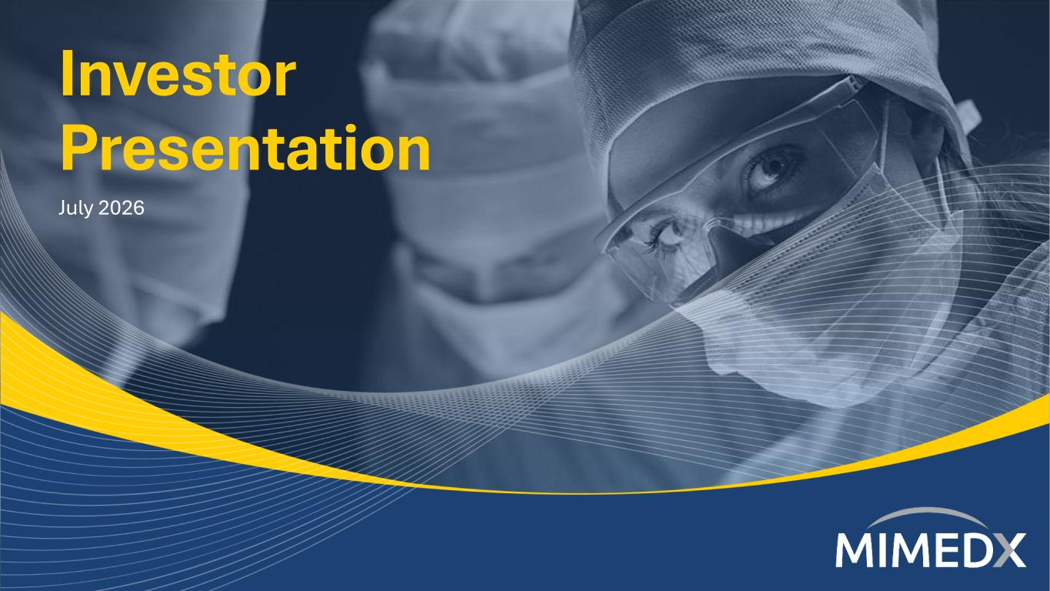
Investor Presentation July 2026

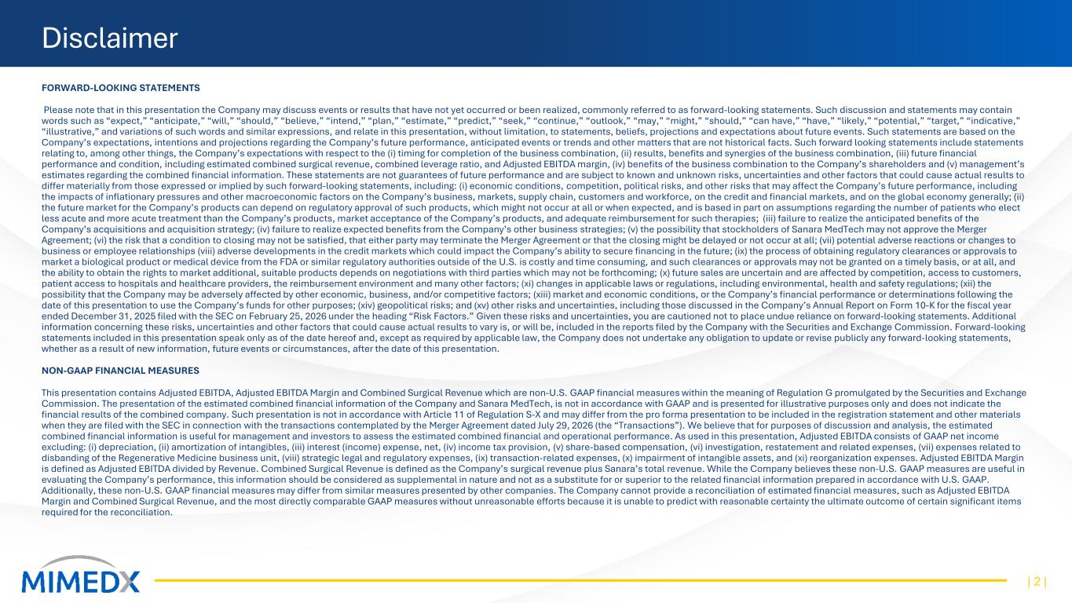
Disclaimer FORWARD-LOOKING STATEMENTS Please note that in this presentation the Company may discuss events or results that have not yet occurred or been realized, commonly referred to as forward-looking statements. Such discussion and statements may contain words such as “expect,” “anticipate,” “will,” “should,” “believe,” “intend,” “plan,” “estimate,” “predict,” “seek,” “continue,” “outlook,” “may,” “might,” “should,” “can have,” “have,” “likely,” “potential,” “target,” “indicative,” “illustrative,” and variations of such words and similar expressions, and relate in this presentation, without limitation, to statements, beliefs, projections and expectations about future events. Such statements are based on the Company’s expectations, intentions and projections regarding the Company’s future performance, anticipated events or trends and other matters that are not historical facts. Such forward looking statements include statements relating to, among other things, the Company’s expectations with respect to the (i) timing for completion of the business combination, (ii) results, benefits and synergies of the business combination, (iii) future financial performance and condition, including estimated combined surgical revenue, combined leverage ratio, and Adjusted EBITDA margin, (iv) benefits of the business combination to the Company’s shareholders and (v) management’s estimates regarding the combined financial information. These statements are not guarantees of future performance and are subject to known and unknown risks, uncertainties and other factors that could cause actual results to differ materially from those expressed or implied by such forward-looking statements, including: (i) economic conditions, competition, political risks, and other risks that may affect the Company’s future performance, including the impacts of inflationary pressures and other macroeconomic factors on the Company’s business, markets, supply chain, customers and workforce, on the credit and financial markets, and on the global economy generally; (ii) the future market for the Company’s products can depend on regulatory approval of such products, which might not occur at all or when expected, and is based in part on assumptions regarding the number of patients who elect less acute and more acute treatment than the Company’s products, market acceptance of the Company’s products, and adequate reimbursement for such therapies; (iii) failure to realize the anticipated benefits of the Company’s acquisitions and acquisition strategy; (iv) failure to realize expected benefits from the Company’s other business strategies; (v) the possibility that stockholders of Sanara MedTech may not approve the Merger Agreement; (vi) the risk that a condition to closing may not be satisfied, that either party may terminate the Merger Agreement or that the closing might be delayed or not occur at all; (vii) potential adverse reactions or changes to business or employee relationships (viii) adverse developments in the credit markets which could impact the Company’s ability to secure financing in the future; (ix) the process of obtaining regulatory clearances or approvals to market a biological product or medical device from the FDA or similar regulatory authorities outside of the U.S. is costly and time consuming, and such clearances or approvals may not be granted on a timely basis, or at all, and the ability to obtain the rights to market additional, suitable products depends on negotiations with third parties which may not be forthcoming; (x) future sales are uncertain and are affected by competition, access to customers, patient access to hospitals and healthcare providers, the reimbursement environment and many other factors; (xi) changes in applicable laws or regulations, including environmental, health and safety regulations; (xii) the possibility that the Company may be adversely affected by other economic, business, and/or competitive factors; (xiii) market and economic conditions, or the Company’s financial performance or determinations following the date of this presentation to use the Company’s funds for other purposes; (xiv) geopolitical risks; and (xv) other risks and uncertainties, including those discussed in the Company’s Annual Report on Form 10-K for the fiscal year ended December 31, 2025 filed with the SEC on February 25, 2026 under the heading “Risk Factors.” Given these risks and uncertainties, you are cautioned not to place undue reliance on forward-looking statements. Additional information concerning these risks, uncertainties and other factors that could cause actual results to vary is, or will be, included in the reports filed by the Company with the Securities and Exchange Commission. Forward-looking statements included in this presentation speak only as of the date hereof and, except as required by applicable law, the Company does not undertake any obligation to update or revise publicly any forward-looking statements, whether as a result of new information, future events or circumstances, after the date of this presentation. NON-GAAP FINANCIAL MEASURES This presentation contains Adjusted EBITDA, Adjusted EBITDA Margin and Combined Surgical Revenue which are non-U.S. GAAP financial measures within the meaning of Regulation G promulgated by the Securities and Exchange Commission. The presentation of the estimated combined financial information of the Company and Sanara MedTech, is not in accordance with GAAP and is presented for illustrative purposes only and does not indicate the financial results of the combined company. Such presentation is not in accordance with Article 11 of Regulation S-X and may differ from the pro forma presentation to be included in the registration statement and other materials when they are filed with the SEC in connection with the transactions contemplated by the Merger Agreement dated July 29, 2026 (the “Transactions”). We believe that for purposes of discussion and analysis, the estimated combined financial information is useful for management and investors to assess the estimated combined financial and operational performance. As used in this presentation, Adjusted EBITDA consists of GAAP net income excluding: (i) depreciation, (ii) amortization of intangibles, (iii) interest (income) expense, net, (iv) income tax provision, (v) share-based compensation, (vi) investigation, restatement and related expenses, (vii) expenses related to disbanding of the Regenerative Medicine business unit, (viii) strategic legal and regulatory expenses, (ix) transaction-related expenses, (x) impairment of intangible assets, and (xi) reorganization expenses. Adjusted EBITDA Margin is defined as Adjusted EBITDA divided by Revenue. Combined Surgical Revenue is defined as the Company’s surgical revenue plus Sanara’s total revenue. While the Company believes these non-U.S. GAAP measures are useful in evaluating the Company’s performance, this information should be considered as supplemental in nature and not as a substitute for or superior to the related financial information prepared in accordance with U.S. GAAP. Additionally, these non-U.S. GAAP financial measures may differ from similar measures presented by other companies. The Company cannot provide a reconciliation of estimated financial measures, such as Adjusted EBITDA Margin and Combined Surgical Revenue, and the most directly comparable GAAP measures without unreasonable efforts because it is unable to predict with reasonable certainty the ultimate outcome of certain significant items required for the reconciliation. | 2 |

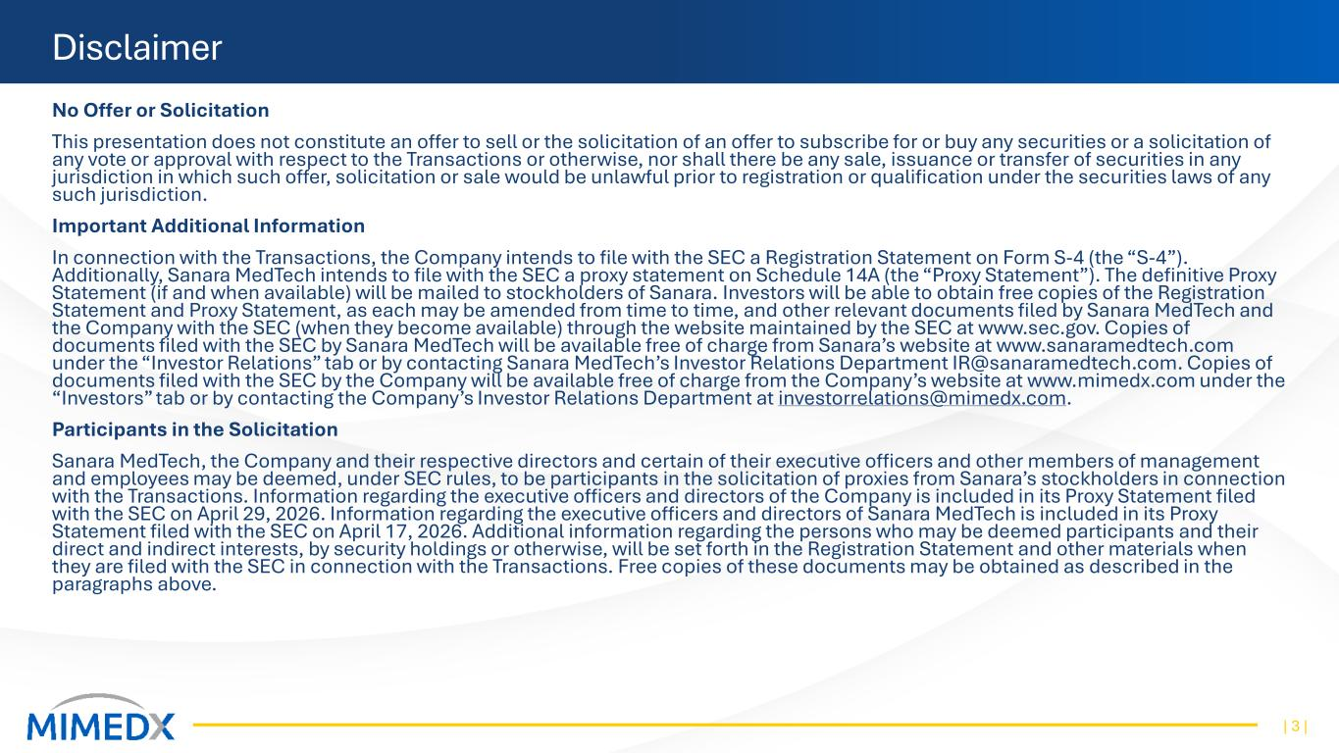
Disclaimer No Offer or Solicitation This presentation does not constitute an offer to sell or the solicitation of an offer to subscribe for or buy any securities or a solicitation of any vote or approval with respect to the Transactions or otherwise, nor shall there be any sale, issuance or transfer of securities in any jurisdiction in which such offer, solicitation or sale would be unlawful prior to registration or qualification under the securities laws of any such jurisdiction. Important Additional Information In connection with the Transactions, the Company intends to file with the SEC a Registration Statement on Form S-4 (the “S-4”). Additionally, Sanara MedTech intends to file with the SEC a proxy statement on Schedule 14A (the “Proxy Statement”). The definitive Proxy Statement (if and when available) will be mailed to stockholders of Sanara. Investors will be able to obtain free copies of the Registration Statement and Proxy Statement, as each may be amended from time to time, and other relevant documents filed by Sanara MedTech and the Company with the SEC (when they become available) through the website maintained by the SEC at www.sec.gov. Copies of documents filed with the SEC by Sanara MedTech will be available free of charge from Sanara’s website at www.sanaramedtech.com under the “Investor Relations” tab or by contacting Sanara MedTech’s Investor Relations Department IR@sanaramedtech.com. Copies of documents filed with the SEC by the Company will be available free of charge from the Company’s website at www.mimedx.com under the “Investors” tab or by contacting the Company’s Investor Relations Department at investorrelations@mimedx.com. Participants in the Solicitation Sanara MedTech, the Company and their respective directors and certain of their executive officers and other members of management and employees may be deemed, under SEC rules, to be participants in the solicitation of proxies from Sanara’s stockholders in connection with the Transactions. Information regarding the executive officers and directors of the Company is included in its Proxy Statement filed with the SEC on April 29, 2026. Information regarding the executive officers and directors of Sanara MedTech is included in its Proxy Statement filed with the SEC on April 17, 2026. Additional information regarding the persons who may be deemed participants and their direct and indirect interests, by security holdings or otherwise, will be set forth in the Registration Statement and other materials when they are filed with the SEC in connection with the Transactions. Free copies of these documents may be obtained as described in the paragraphs above. | 3 |

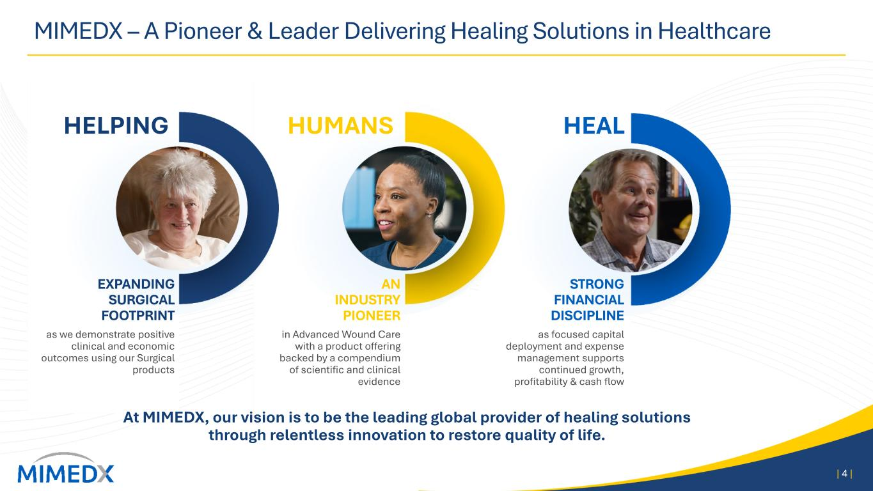
MIMEDX – A Pioneer & Leader Delivering Healing Solutions in Healthcare | 4 | At MIMEDX, our vision is to be the leading global provider of healing solutions through relentless innovation to restore quality of life. EXPANDING SURGICAL FOOTPRINT as we demonstrate positive clinical and economic outcomes using our Surgical products AN INDUSTRY PIONEER in Advanced Wound Care with a product offering backed by a compendium of scientific and clinical evidence STRONG FINANCIAL DISCIPLINE as focused capital deployment and expense management supports continued growth, profitability & cash flow HELPING HUMANS HEAL

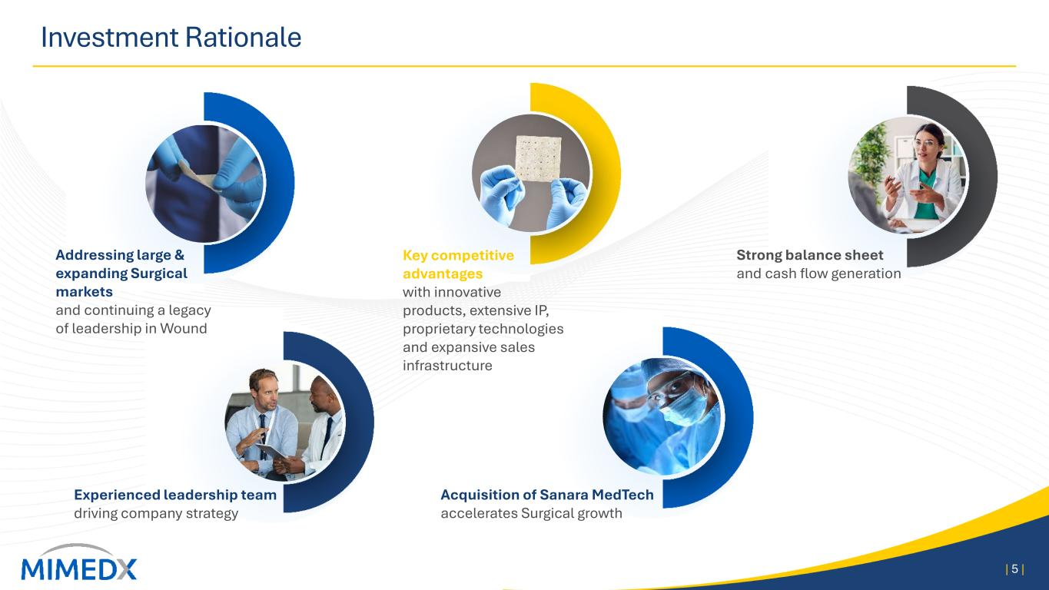
Investment Rationale | 5 | Addressing large & expanding Surgical markets and continuing a legacy of leadership in Wound Acquisition of Sanara MedTech accelerates Surgical growth Key competitive advantages with innovative products, extensive IP, proprietary technologies and expansive sales infrastructure Strong balance sheet and cash flow generation Experienced leadership team driving company strategy


Sanara MedTech Acquisition Details | 6 |

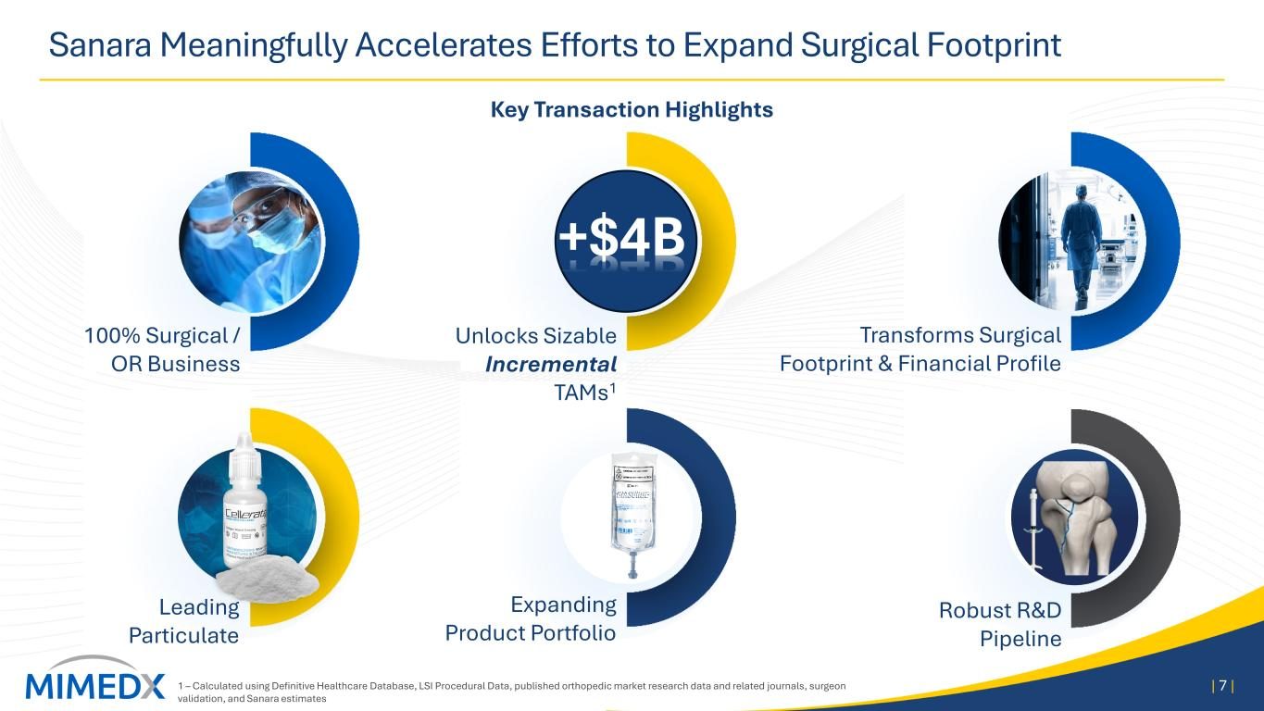
Sanara Meaningfully Accelerates Efforts to Expand Surgical Footprint | 7 | 100% Surgical / OR Business Leading Particulate Expanding Product Portfolio Unlocks Sizable Incremental TAMs1 +$4B Transforms Surgical Footprint & Financial Profile Robust R&D Pipeline Key Transaction Highlights 1 – Calculated using Definitive Healthcare Database, LSI Procedural Data, published orthopedic market research data and related journals, surgeon validation, and Sanara estimates

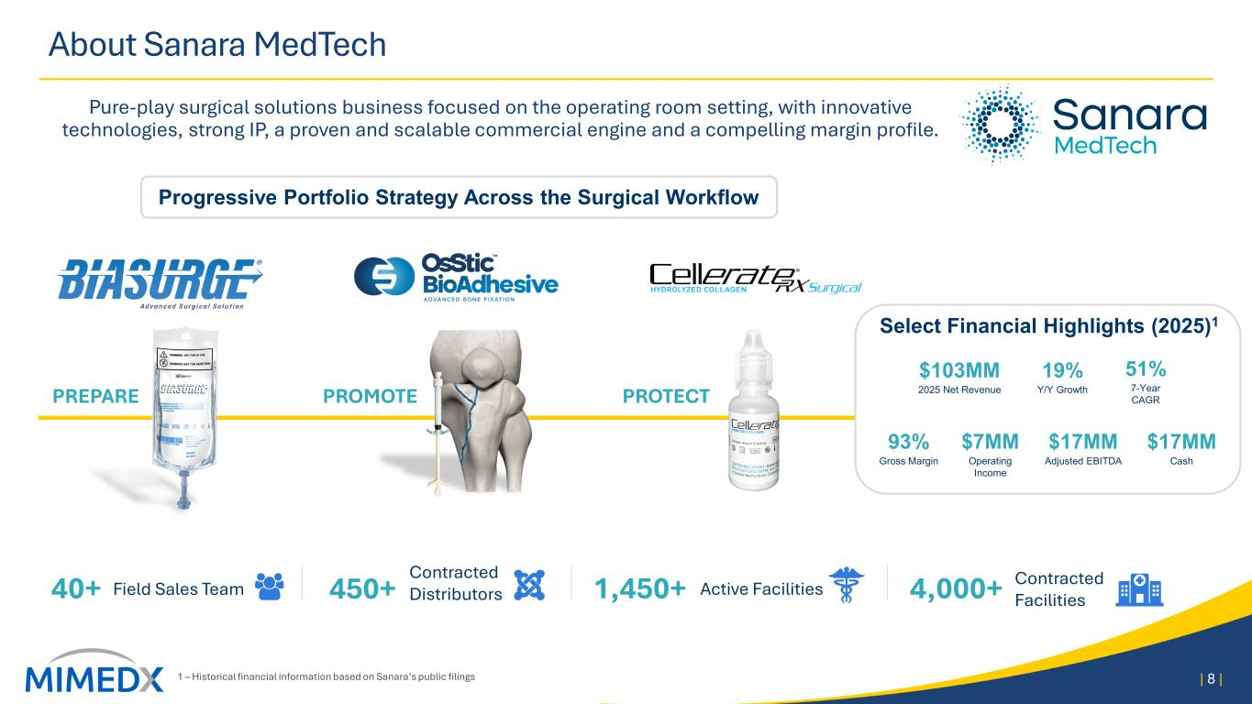
About Sanara MedTech Pure-play surgical solutions business focused on the operating room setting, with innovative technologies, strong IP, a proven and scalable commercial engine and a compelling margin profile. 1 – Historical financial information based on Sanara’s public filings | 8 | PREPARE PROMOTE PROTECT Progressive Portfolio Strategy Across the Surgical Workflow Select Financial Highlights (2025)1 $103MM 2025 Net Revenue 19% Y/Y Growth 51% 7-Year CAGR 93% Gross Margin $7MM Operating Income $17MM Adjusted EBITDA $17MM Cash 40+ Field Sales Team 450+ Contracted Distributors 1,450+ Active Facilities 4,000+ Contracted Facilities

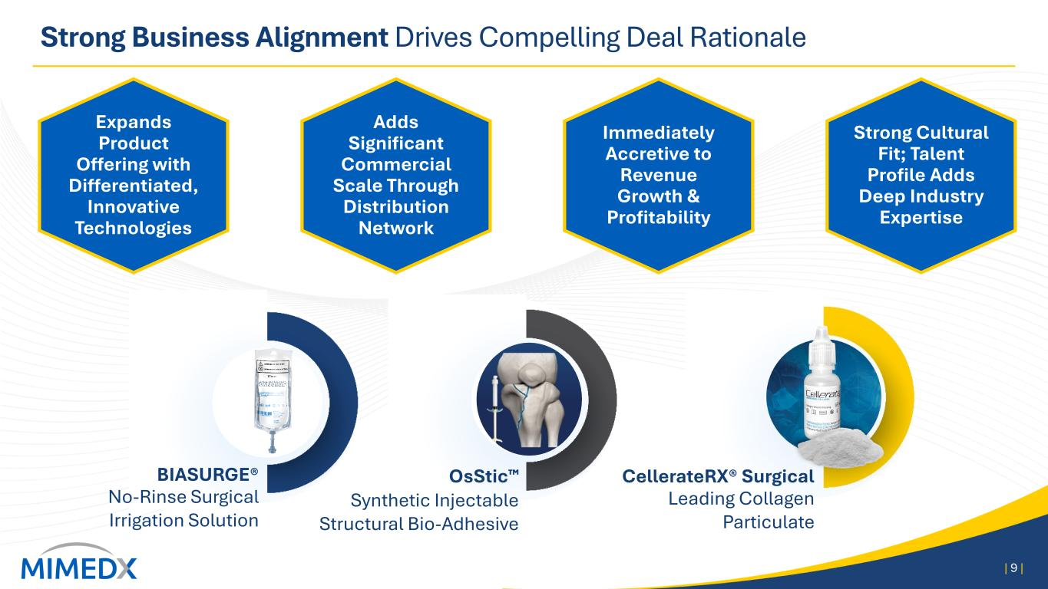
CellerateRX® Surgical Leading Collagen Particulate Strong Business Alignment Drives Compelling Deal Rationale | 9 | OsStic Synthetic Injectable Structural Bio-Adhesive BIASURGE® No-Rinse Surgical Irrigation Solution Expands Product Offering with Differentiated, Innovative Technologies Strong Cultural Fit; Talent Profile Adds Deep Industry Expertise Adds Significant Commercial Scale Through Distribution Network Immediately Accretive to Revenue Growth & Profitability

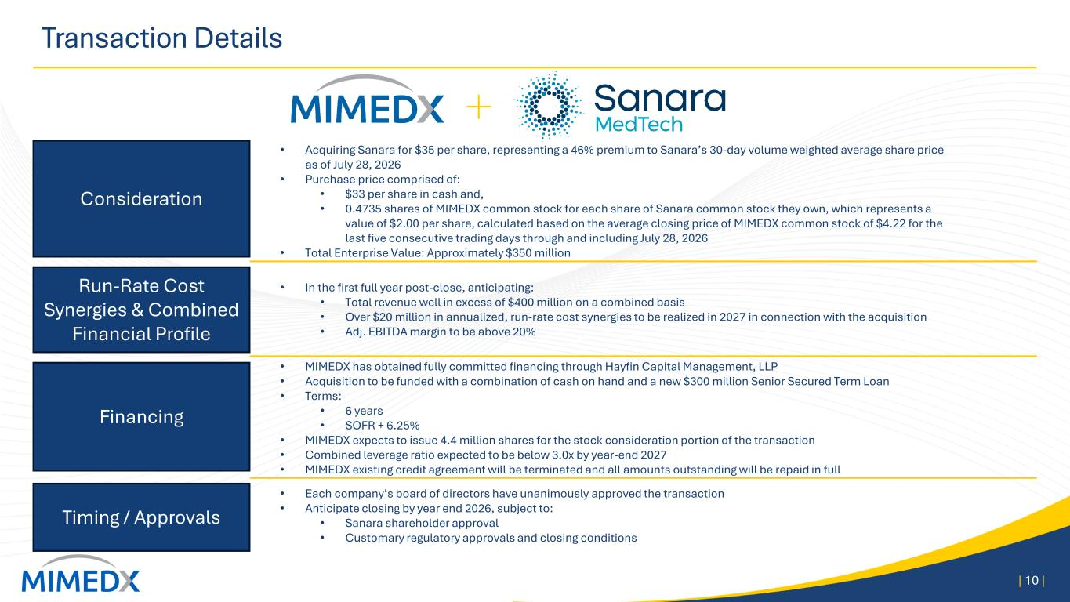
Transaction Details | 10 | Consideration Run-Rate Cost Synergies & Combined Financial Profile Timing / Approvals • Acquiring Sanara for $35 per share, representing a 46% premium to Sanara’s 30-day volume weighted average share price as of July 28, 2026 • Purchase price comprised of: • $33 per share in cash and, • 0.4735 shares of MIMEDX common stock for each share of Sanara common stock they own, which represents a value of $2.00 per share, calculated based on the average closing price of MIMEDX common stock of $4.22 for the last five consecutive trading days through and including July 28, 2026 • Total Enterprise Value: Approximately $350 million Financing • MIMEDX has obtained fully committed financing through Hayfin Capital Management, LLP • Acquisition to be funded with a combination of cash on hand and a new $300 million Senior Secured Term Loan • Terms: • 6 years • SOFR + 6.25% • MIMEDX expects to issue 4.4 million shares for the stock consideration portion of the transaction • Combined leverage ratio expected to be below 3.0x by year-end 2027 • MIMEDX existing credit agreement will be terminated and all amounts outstanding will be repaid in full • Each company’s board of directors have unanimously approved the transaction • Anticipate closing by year end 2026, subject to: • Sanara shareholder approval • Customary regulatory approvals and closing conditions • In the first full year post-close, anticipating: • Total revenue well in excess of $400 million on a combined basis • Over $20 million in annualized, run-rate cost synergies to be realized in 2027 in connection with the acquisition • Adj. EBITDA margin to be above 20%

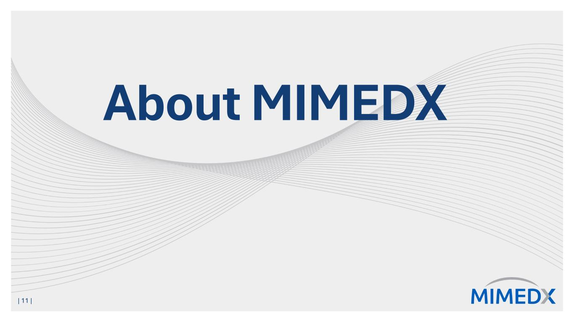
About MIMEDX | 11 |

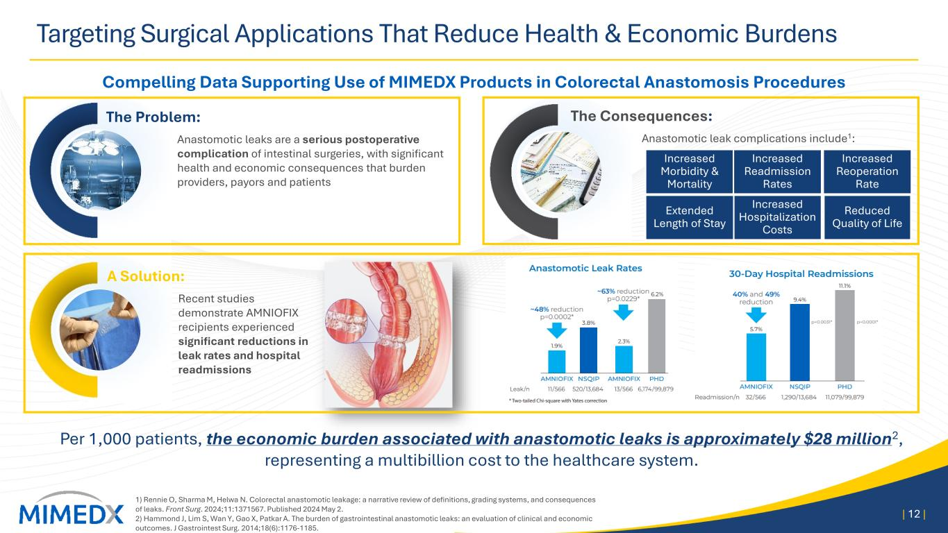
Increased Morbidity & Mortality Increased Hospitalization Costs Increased Reoperation Rate Reduced Quality of Life Extended Length of Stay Increased Readmission Rates The Consequences: Anastomotic leak complications include1: Targeting Surgical Applications That Reduce Health & Economic Burdens Compelling Data Supporting Use of MIMEDX Products in Colorectal Anastomosis Procedures 1) Rennie O, Sharma M, Helwa N. Colorectal anastomotic leakage: a narrative review of definitions, grading systems, and consequences of leaks. Front Surg. 2024;11:1371567. Published 2024 May 2. 2) Hammond J, Lim S, Wan Y, Gao X, Patkar A. The burden of gastrointestinal anastomotic leaks: an evaluation of clinical and economic outcomes. J Gastrointest Surg. 2014;18(6):1176-1185. | 12 | The Problem: Anastomotic leaks are a serious postoperative complication of intestinal surgeries, with significant health and economic consequences that burden providers, payors and patients A Solution: Recent studies demonstrate AMNIOFIX recipients experienced significant reductions in leak rates and hospital readmissions Per 1,000 patients, the economic burden associated with anastomotic leaks is approximately $28 million2, representing a multibillion cost to the healthcare system.

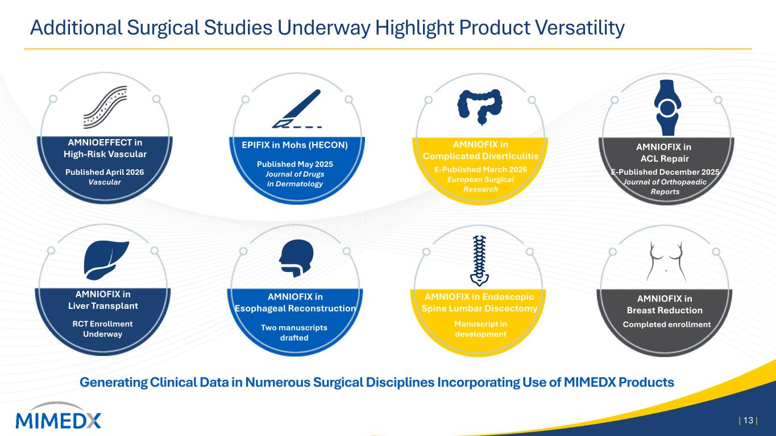
Additional Surgical Studies Underway Highlight Product Versatility | 13 | Generating Clinical Data in Numerous Surgical Disciplines Incorporating Use of MIMEDX Products AMNIOEFFECT in High-Risk Vascular Published April 2026 Vascular Published May 2025 Journal of Drugs in Dermatology EPIFIX in Mohs (HECON) E-Published March 2026 European Surgical Research AMNIOFIX in Complicated Diverticulitis AMNIOFIX in ACL Repair E-Published December 2025 Journal of Orthopaedic Reports AMNIOFIX in Liver Transplant RCT Enrollment Underway Manuscript in development Completed enrollment AMNIOFIX in Breast Reduction Two manuscripts drafted AMNIOFIX in Esophageal Reconstruction AMNIOFIX in Endoscopic Spine Lumbar Discectomy

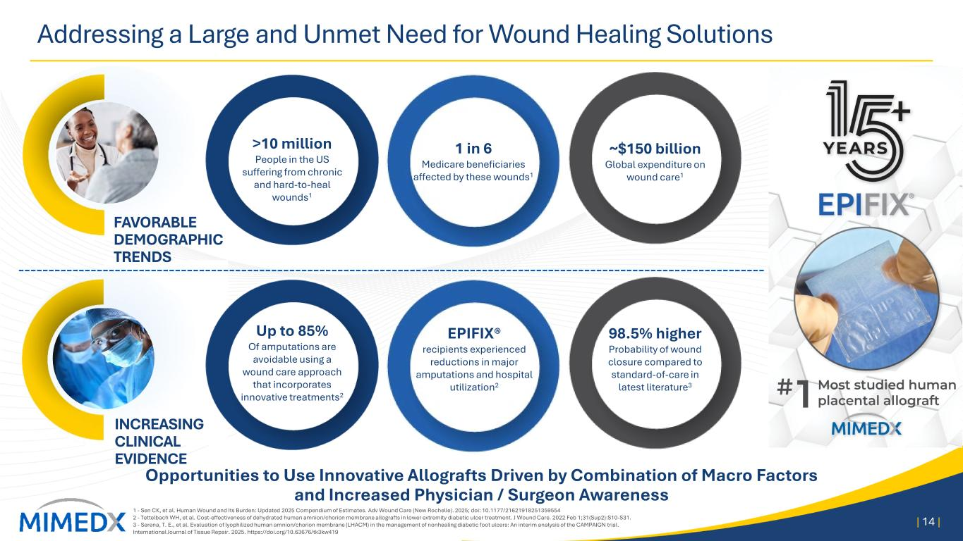
Addressing a Large and Unmet Need for Wound Healing Solutions 1 - Sen CK, et al. Human Wound and Its Burden: Updated 2025 Compendium of Estimates. Adv Wound Care (New Rochelle). 2025; doi: 10.1177/21621918251359554 2 - Tettelbach WH, et al. Cost-effectiveness of dehydrated human amnion/chorion membrane allografts in lower extremity diabetic ulcer treatment. J Wound Care. 2022 Feb 1;31(Sup2):S10-S31. 3 - Serena, T. E., et al. Evaluation of lyophilized human amnion/chorion membrane (LHACM) in the management of nonhealing diabetic foot ulcers: An interim analysis of the CAMPAIGN trial. International Journal of Tissue Repair. 2025. https://doi.org/10.63676/tk3kw419 | 14 | Opportunities to Use Innovative Allografts Driven by Combination of Macro Factors and Increased Physician / Surgeon Awareness INCREASING CLINICAL EVIDENCE FAVORABLE DEMOGRAPHIC TRENDS >10 million People in the US suffering from chronic and hard-to-heal wounds1 1 in 6 Medicare beneficiaries affected by these wounds1 Up to 85% Of amputations are avoidable using a wound care approach that incorporates innovative treatments2 EPIFIX® recipients experienced reductions in major amputations and hospital utilization2 98.5% higher Probability of wound closure compared to standard-of-care in latest literature3 ~$150 billion Global expenditure on wound care1

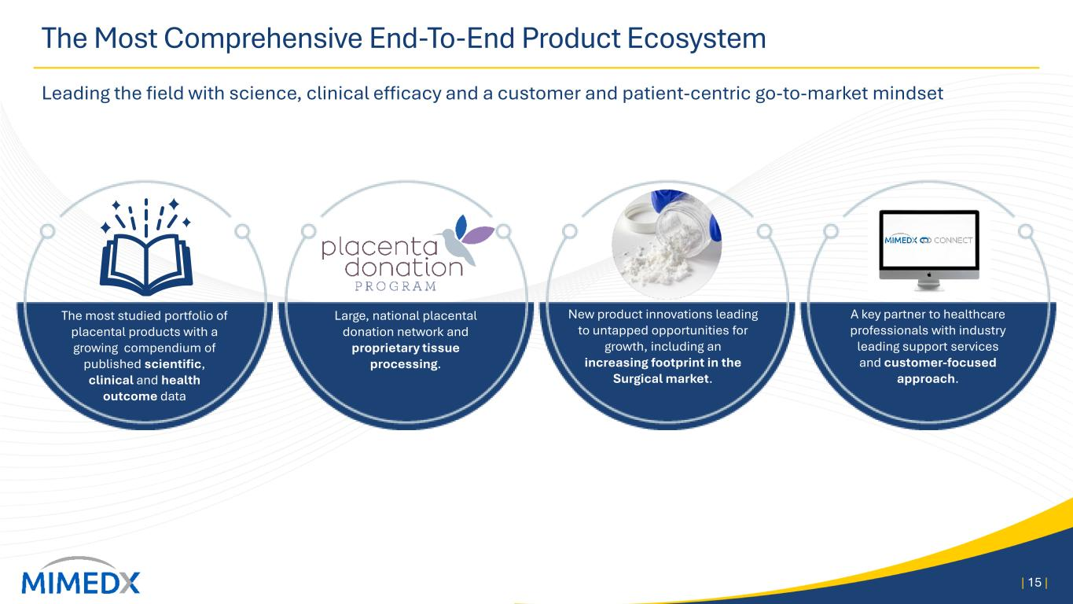
The Most Comprehensive End-To-End Product Ecosystem Leading the field with science, clinical efficacy and a customer and patient-centric go-to-market mindset | 15 | The most studied portfolio of placental products with a growing compendium of published scientific, clinical and health outcome data Large, national placental donation network and proprietary tissue processing. New product innovations leading to untapped opportunities for growth, including an increasing footprint in the Surgical market. A key partner to healthcare professionals with industry leading support services and customer-focused approach.

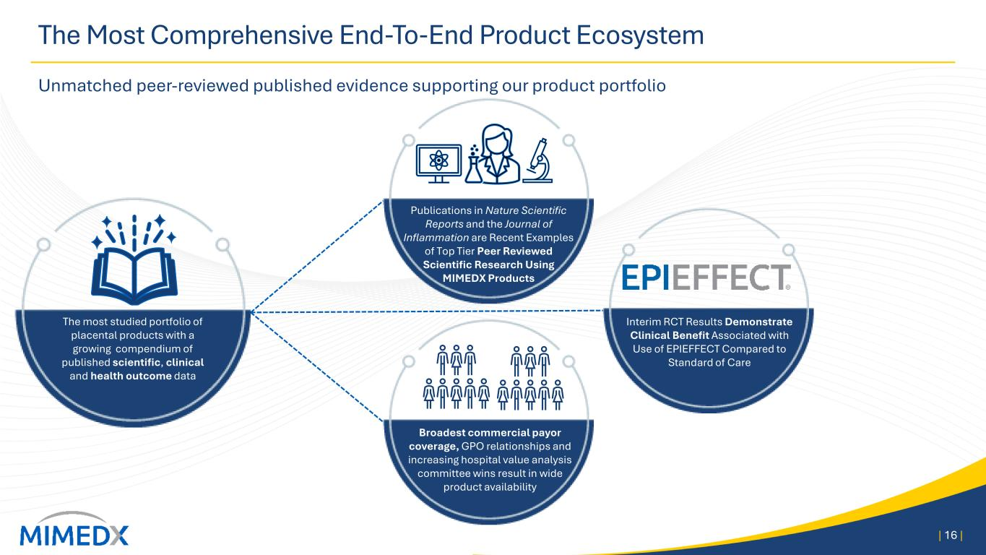
The Most Comprehensive End-To-End Product Ecosystem Unmatched peer-reviewed published evidence supporting our product portfolio | 16 | The most studied portfolio of placental products with a growing compendium of published scientific, clinical and health outcome data Broadest commercial payor coverage, GPO relationships and increasing hospital value analysis committee wins result in wide product availability Interim RCT Results Demonstrate Clinical Benefit Associated with Use of EPIEFFECT Compared to Standard of Care Publications in Nature Scientific Reports and the Journal of Inflammation are Recent Examples of Top Tier Peer Reviewed Scientific Research Using MIMEDX Products

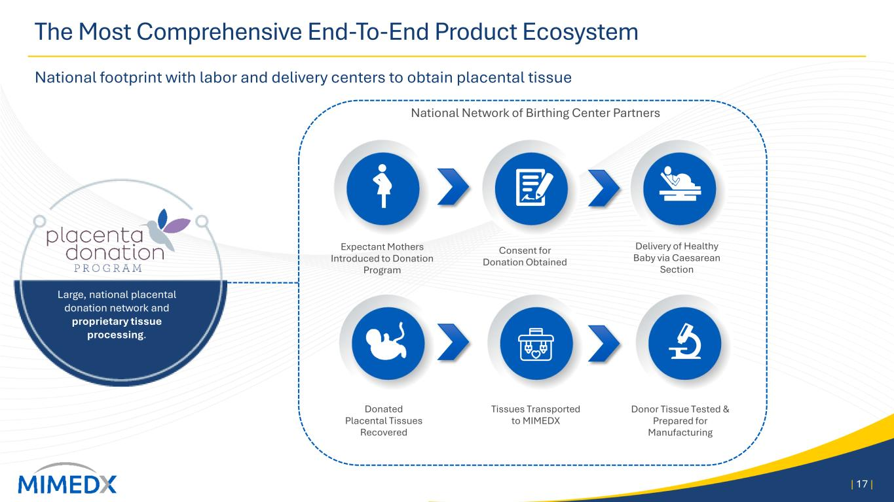
The Most Comprehensive End-To-End Product Ecosystem National footprint with labor and delivery centers to obtain placental tissue | 17 | Consent for Donation Obtained Delivery of Healthy Baby via Caesarean Section Donated Placental Tissues Recovered Tissues Transported to MIMEDX National Network of Birthing Center Partners Expectant Mothers Introduced to Donation Program Donor Tissue Tested & Prepared for Manufacturing Large, national placental donation network and proprietary tissue processing.

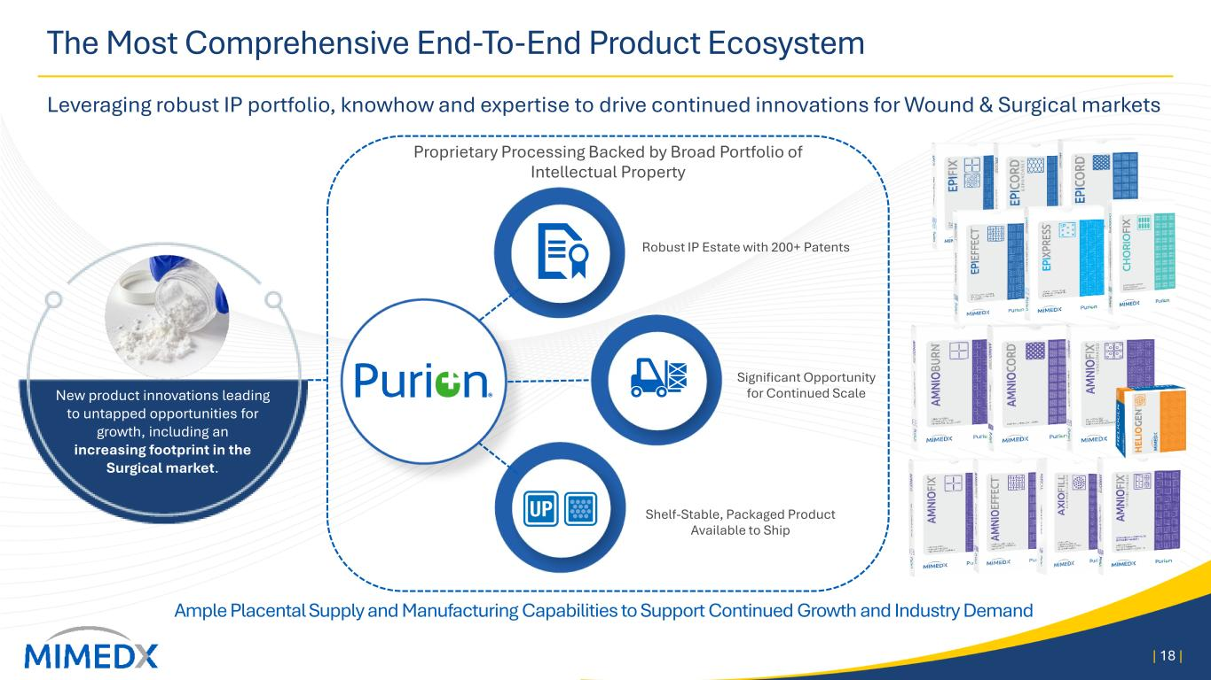
The Most Comprehensive End-To-End Product Ecosystem Leveraging robust IP portfolio, knowhow and expertise to drive continued innovations for Wound & Surgical markets | 18 | New product innovations leading to untapped opportunities for growth, including an increasing footprint in the Surgical market. Ample Placental Supply and Manufacturing Capabilities to Support Continued Growth and Industry Demand Proprietary Processing Backed by Broad Portfolio of Intellectual Property Shelf-Stable, Packaged Product Available to Ship Robust IP Estate with 200+ Patents Significant Opportunity for Continued Scale

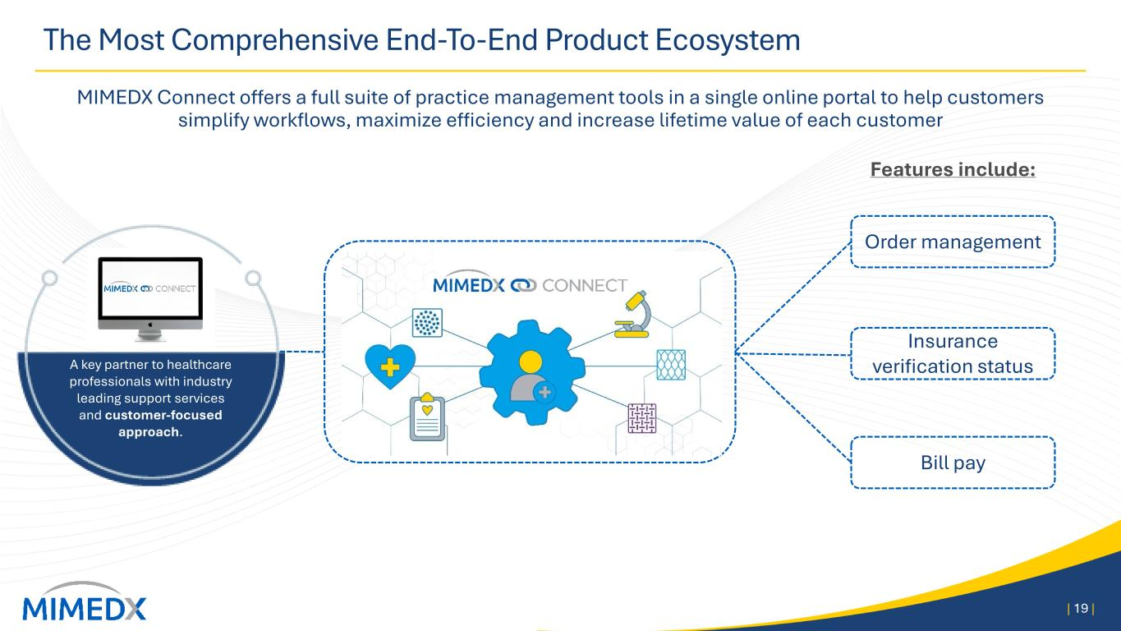
The Most Comprehensive End-To-End Product Ecosystem MIMEDX Connect offers a full suite of practice management tools in a single online portal to help customers simplify workflows, maximize efficiency and increase lifetime value of each customer | 19 | A key partner to healthcare professionals with industry leading support services and customer-focused approach. Order management Insurance verification status Bill pay Features include:

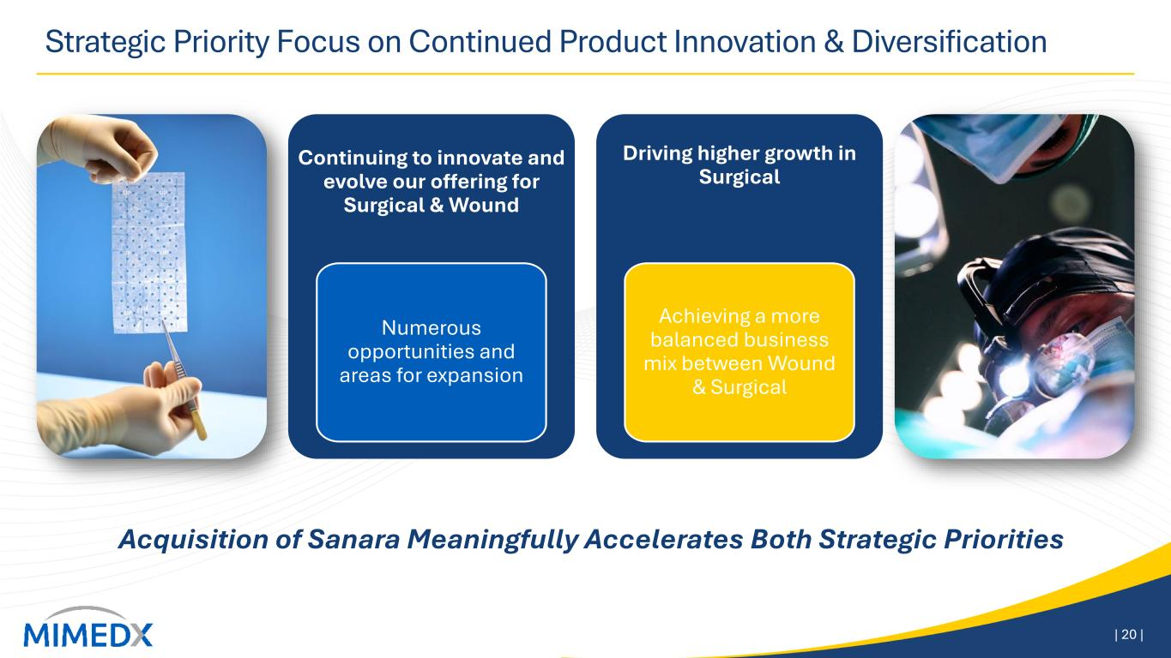
Strategic Priority Focus on Continued Product Innovation & Diversification | 20 | Continuing to innovate and evolve our offering for Surgical & Wound Numerous opportunities and areas for expansion Driving higher growth in Surgical Achieving a more balanced business mix between Wound & Surgical Acquisition of Sanara Meaningfully Accelerates Both Strategic Priorities

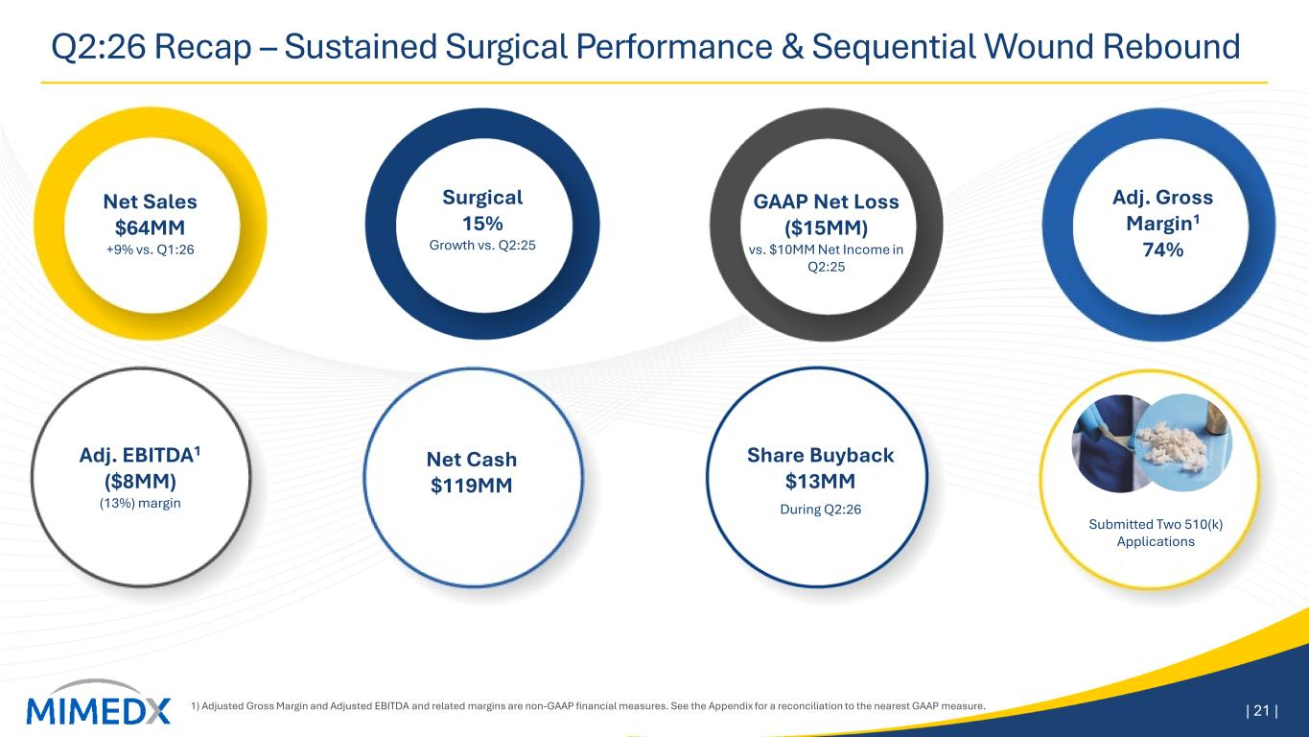
Q2:26 Recap – Sustained Surgical Performance & Sequential Wound Rebound 1) Adjusted Gross Margin and Adjusted EBITDA and related margins are non-GAAP financial measures. See the Appendix for a reconciliation to the nearest GAAP measure. | 21 | Surgical 15% Growth vs. Q2:25 Adj. Gross Margin1 74% GAAP Net Loss ($15MM) vs. $10MM Net Income in Q2:25 Net Sales $64MM +9% vs. Q1:26 Adj. EBITDA1 ($8MM) (13%) margin Net Cash $119MM During Q2:26 Share Buyback $13MM Submitted Two 510(k) Applications

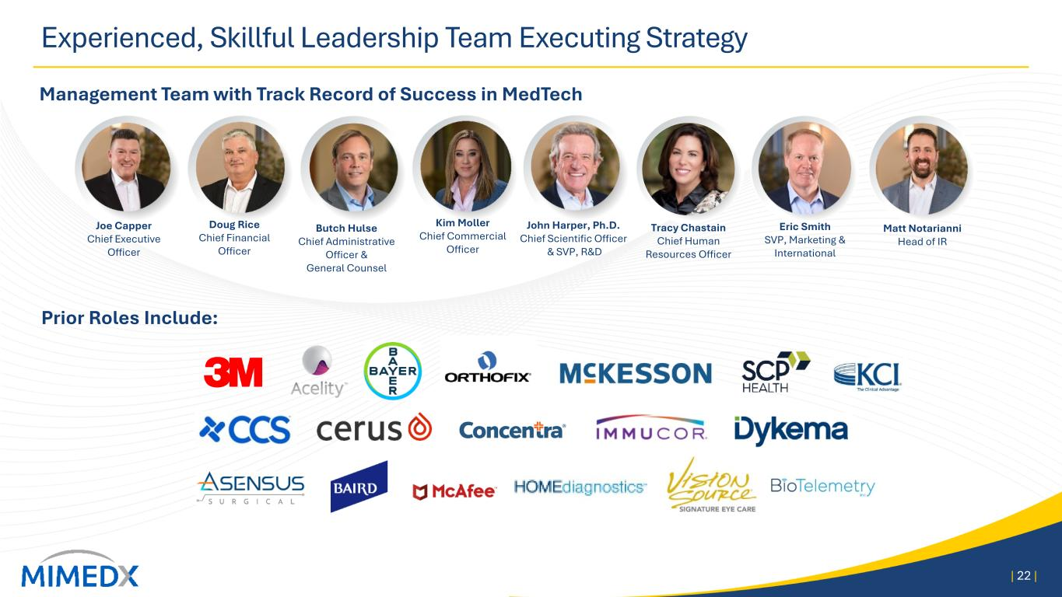
Experienced, Skillful Leadership Team Executing Strategy Prior Roles Include: Management Team with Track Record of Success in MedTech Joe Capper Chief Executive Officer Doug Rice Chief Financial Officer Butch Hulse Chief Administrative Officer & General Counsel Kim Moller Chief Commercial Officer John Harper, Ph.D. Chief Scientific Officer & SVP, R&D Matt Notarianni Head of IR 22| | Tracy Chastain Chief Human Resources Officer Eric Smith SVP, Marketing & International

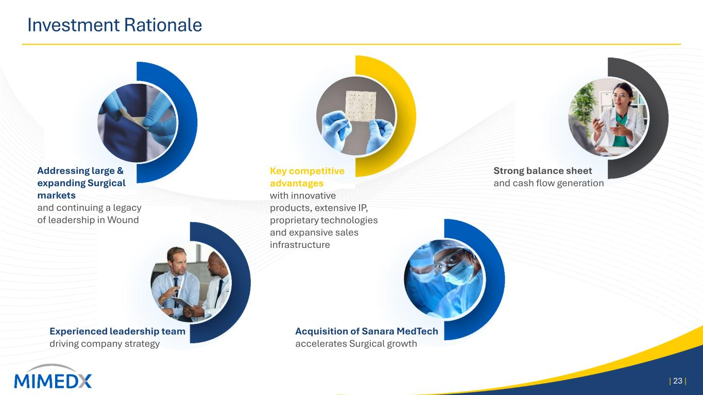
Investment Rationale | 23 | Addressing large & expanding Surgical markets and continuing a legacy of leadership in Wound Acquisition of Sanara MedTech accelerates Surgical growth Key competitive advantages with innovative products, extensive IP, proprietary technologies and expansive sales infrastructure Strong balance sheet and cash flow generation Experienced leadership team driving company strategy

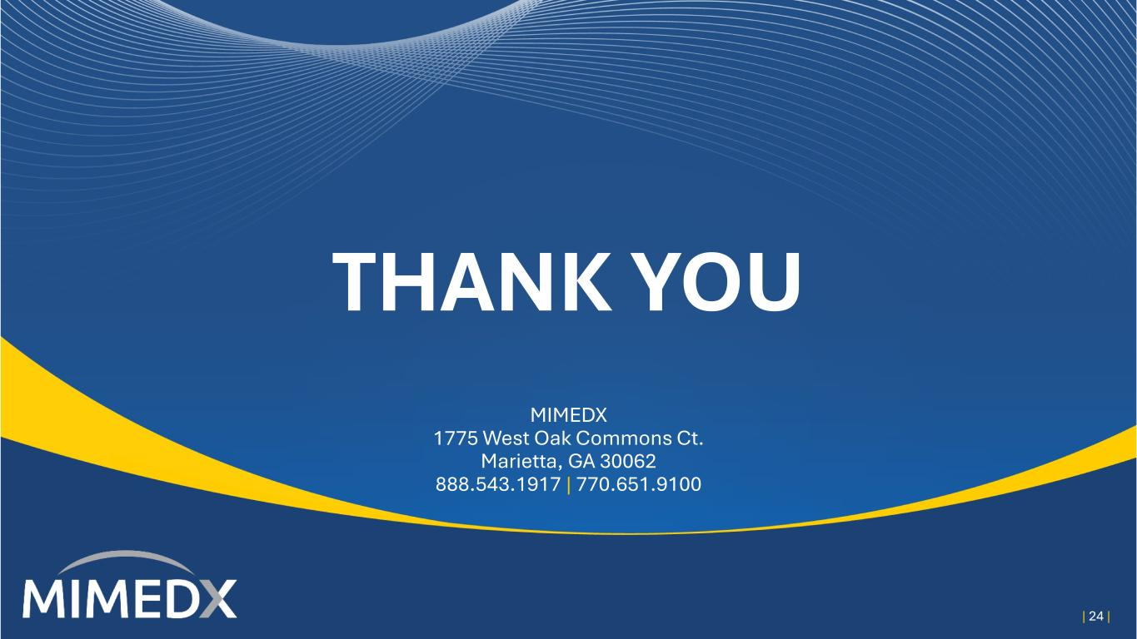
THANK YOU MIMEDX 1775 West Oak Commons Ct. Marietta, GA 30062 888.543.1917 | 770.651.9100 | 24 |

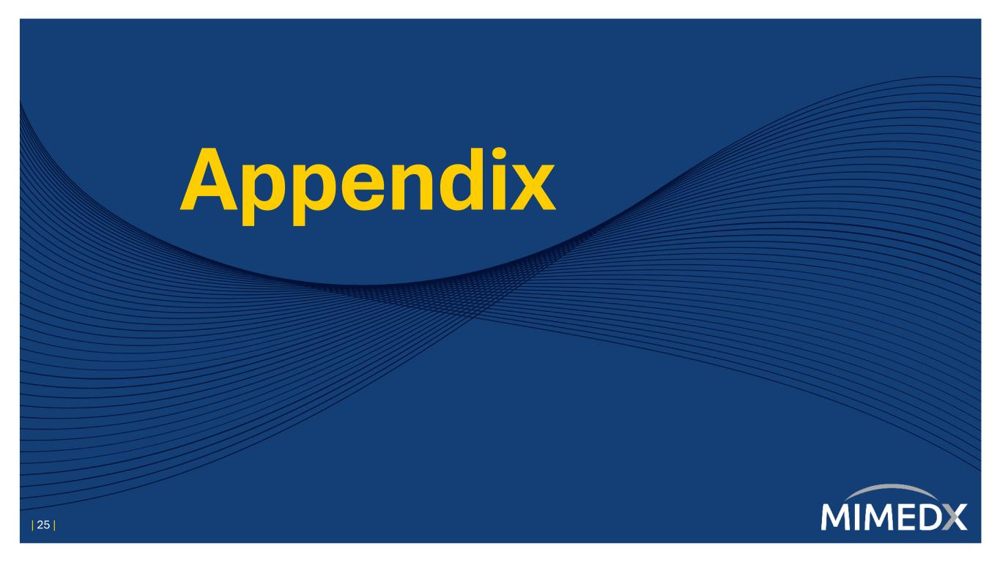
Appendix | 25 |

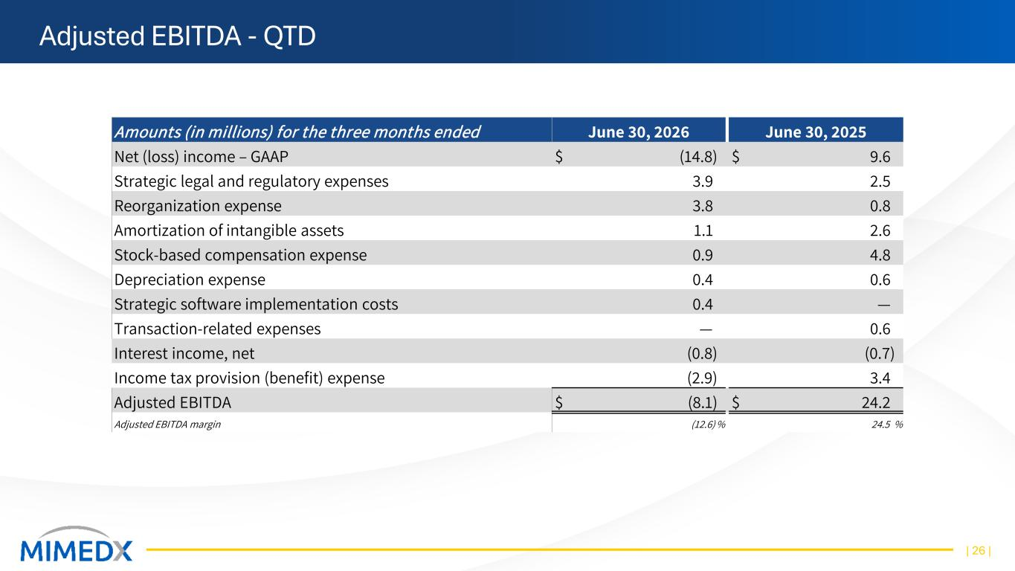
Adjusted EBITDA - QTD | 26 | Amounts (in millions) for the three months ended June 30, 2026 June 30, 2025 Net (loss) income – GAAP $ (14.8) $ 9.6 Strategic legal and regulatory expenses 3.9 2.5 Reorganization expense 3.8 0.8 Amortization of intangible assets 1.1 2.6 Stock-based compensation expense 0.9 4.8 Depreciation expense 0.4 0.6 Strategic software implementation costs 0.4 — Transaction-related expenses — 0.6 Interest income, net (0.8) (0.7) Income tax provision (benefit) expense (2.9) 3.4 Adjusted EBITDA $ (8.1) $ 24.2 Adjusted EBITDA margin (12.6) % 24.5 %

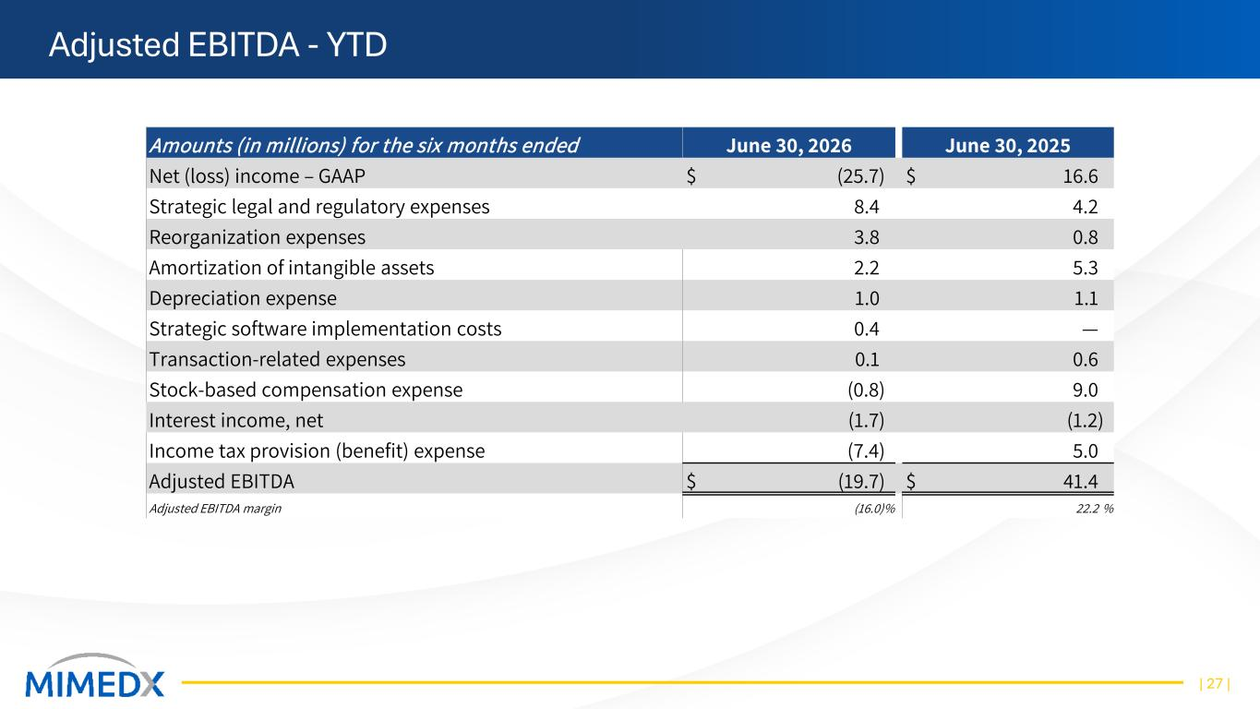
Adjusted EBITDA - YTD | 27 | Amounts (in millions) for the six months ended June 30, 2026 June 30, 2025 Net (loss) income – GAAP $ (25.7) $ 16.6 Strategic legal and regulatory expenses 8.4 4.2 Reorganization expenses 3.8 0.8 Amortization of intangible assets 2.2 5.3 Depreciation expense 1.0 1.1 Strategic software implementation costs 0.4 — Transaction-related expenses 0.1 0.6 Stock-based compensation expense (0.8) 9.0 Interest income, net (1.7) (1.2) Income tax provision (benefit) expense (7.4) 5.0 Adjusted EBITDA $ (19.7) $ 41.4 Adjusted EBITDA margin (16.0)% 22.2 %

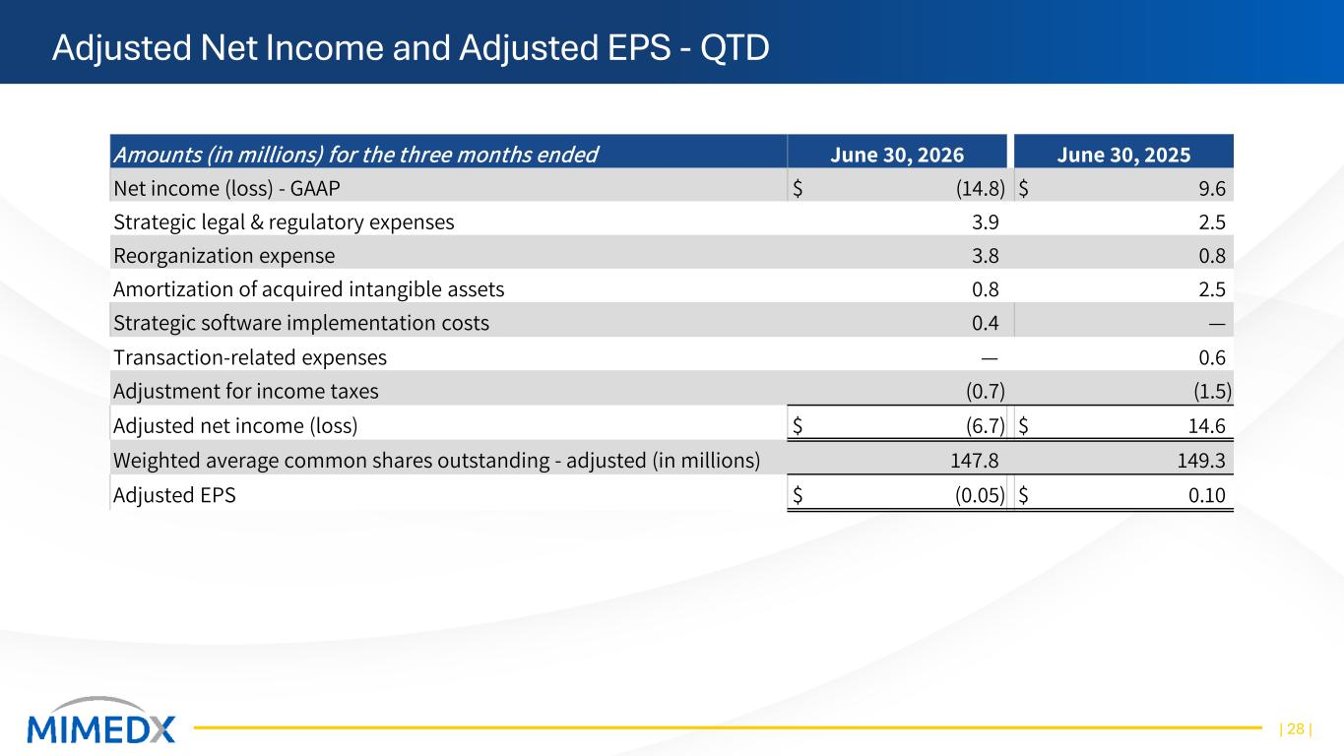
Adjusted Net Income and Adjusted EPS - QTD | 28 | Amounts (in millions) for the three months ended June 30, 2026 June 30, 2025 Net income (loss) - GAAP $ (14.8) $ 9.6 Strategic legal & regulatory expenses 3.9 2.5 Reorganization expense 3.8 0.8 Amortization of acquired intangible assets 0.8 2.5 Strategic software implementation costs 0.4 — Transaction-related expenses — 0.6 Adjustment for income taxes (0.7) (1.5) Adjusted net income (loss) $ (6.7) $ 14.6 Weighted average common shares outstanding - adjusted (in millions) 147.8 149.3 Adjusted EPS $ (0.05) $ 0.10

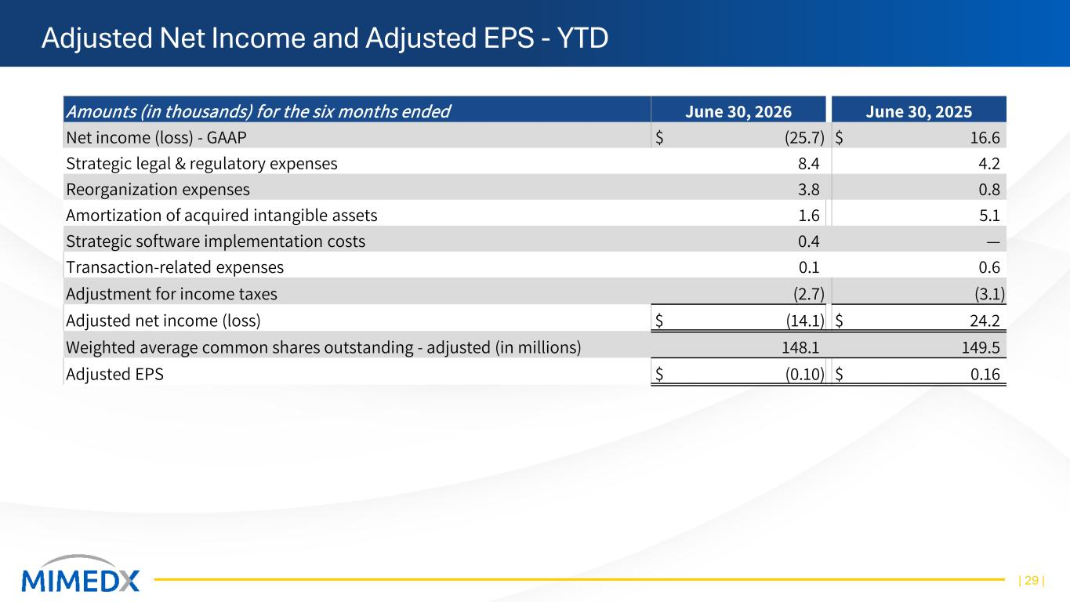
Adjusted Net Income and Adjusted EPS - YTD | 29 | Amounts (in thousands) for the six months ended June 30, 2026 June 30, 2025 Net income (loss) - GAAP $ (25.7) $ 16.6 Strategic legal & regulatory expenses 8.4 4.2 Reorganization expenses 3.8 0.8 Amortization of acquired intangible assets 1.6 5.1 Strategic software implementation costs 0.4 — Transaction-related expenses 0.1 0.6 Adjustment for income taxes (2.7) (3.1) Adjusted net income (loss) $ (14.1) $ 24.2 Weighted average common shares outstanding - adjusted (in millions) 148.1 149.5 Adjusted EPS $ (0.10) $ 0.16

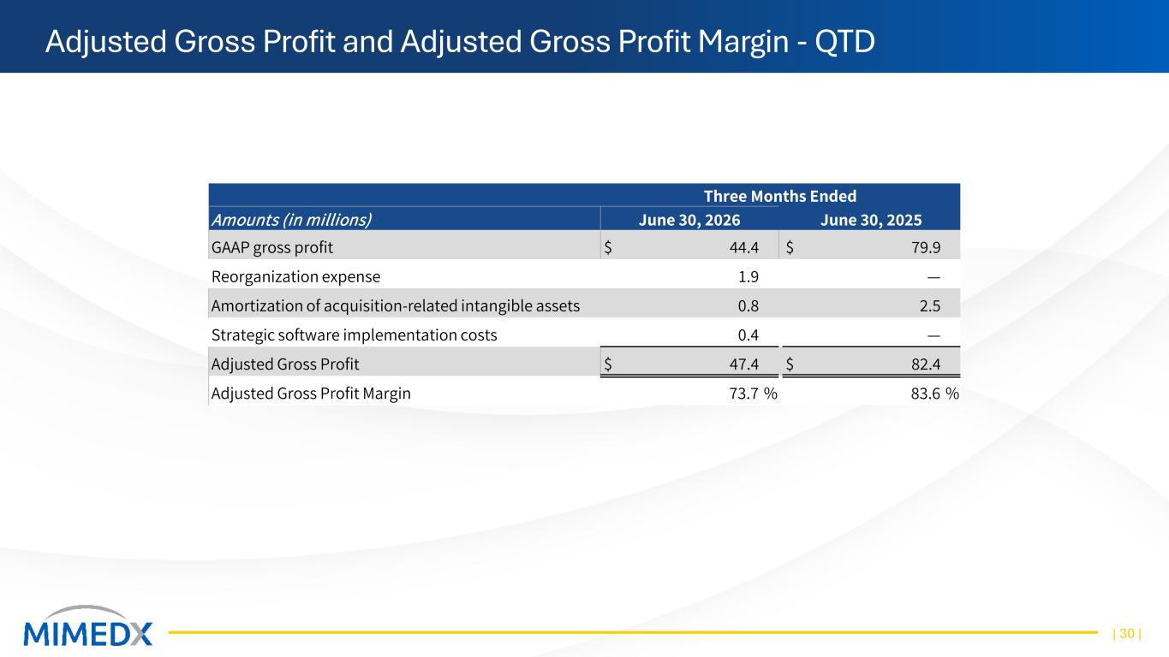
Adjusted Gross Profit and Adjusted Gross Profit Margin - QTD | 30 | Three Months Ended Amounts (in millions) June 30, 2026 June 30, 2025 GAAP gross profit $ 44.4 $ 79.9 Reorganization expense 1.9 — Amortization of acquisition-related intangible assets 0.8 2.5 Strategic software implementation costs 0.4 — Adjusted Gross Profit $ 47.4 $ 82.4 Adjusted Gross Profit Margin 73.7 % 83.6 %

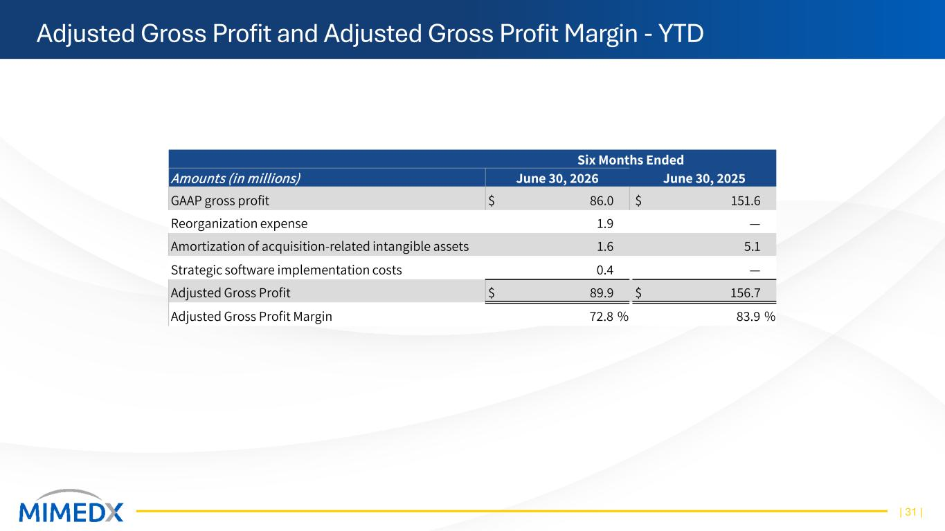
Adjusted Gross Profit and Adjusted Gross Profit Margin - YTD | 31 | Six Months Ended Amounts (in millions) June 30, 2026 June 30, 2025 GAAP gross profit $ 86.0 $ 151.6 Reorganization expense 1.9 — Amortization of acquisition-related intangible assets 1.6 5.1 Strategic software implementation costs 0.4 — Adjusted Gross Profit $ 89.9 $ 156.7 Adjusted Gross Profit Margin 72.8 % 83.9 %


Investor Conference Call July 29, 2026

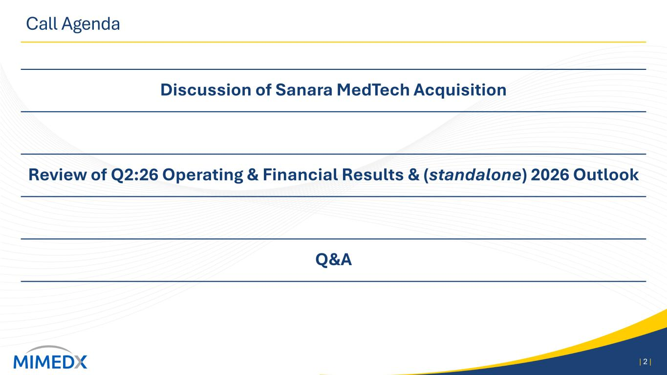
Call Agenda Discussion of Sanara MedTech Acquisition Review of Q2:26 Operating & Financial Results & (standalone) 2026 Outlook Q&A | 2 |

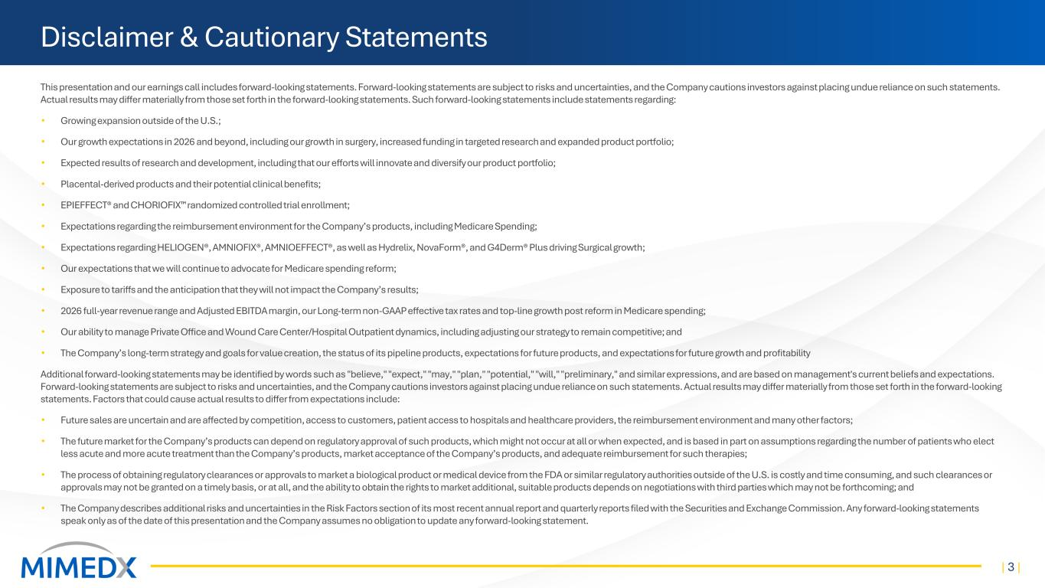
Disclaimer & Cautionary Statements This presentation and our earnings call includes forward-looking statements. Forward-looking statements are subject to risks and uncertainties, and the Company cautions investors against placing undue reliance on such statements. Actual results may differ materially from those set forth in the forward-looking statements. Such forward-looking statements include statements regarding: • Growing expansion outside of the U.S.; • Our growth expectations in 2026 and beyond, including our growth in surgery, increased funding in targeted research and expanded product portfolio; • Expected results of research and development, including that our efforts will innovate and diversify our product portfolio; • Placental-derived products and their potential clinical benefits; • EPIEFFECT® and CHORIOFIX randomized controlled trial enrollment; • Expectations regarding the reimbursement environment for the Company’s products, including Medicare Spending; • Expectations regarding HELIOGEN®, AMNIOFIX®, AMNIOEFFECT®, as well as Hydrelix, NovaForm®, and G4Derm® Plus driving Surgical growth; • Our expectations that we will continue to advocate for Medicare spending reform; • Exposure to tariffs and the anticipation that they will not impact the Company’s results; • 2026 full-year revenue range and Adjusted EBITDA margin, our Long-term non-GAAP effective tax rates and top-line growth post reform in Medicare spending; • Our ability to manage Private Office and Wound Care Center/Hospital Outpatient dynamics, including adjusting our strategy to remain competitive; and • The Company’s long-term strategy and goals for value creation, the status of its pipeline products, expectations for future products, and expectations for future growth and profitability Additional forward-looking statements may be identified by words such as "believe," "expect," "may," "plan," "potential," "will," "preliminary," and similar expressions, and are based on management's current beliefs and expectations. Forward-looking statements are subject to risks and uncertainties, and the Company cautions investors against placing undue reliance on such statements. Actual results may differ materially from those set forth in the forward-looking statements. Factors that could cause actual results to differ from expectations include: • Future sales are uncertain and are affected by competition, access to customers, patient access to hospitals and healthcare providers, the reimbursement environment and many other factors; • The future market for the Company’s products can depend on regulatory approval of such products, which might not occur at all or when expected, and is based in part on assumptions regarding the number of patients who elect less acute and more acute treatment than the Company’s products, market acceptance of the Company’s products, and adequate reimbursement for such therapies; • The process of obtaining regulatory clearances or approvals to market a biological product or medical device from the FDA or similar regulatory authorities outside of the U.S. is costly and time consuming, and such clearances or approvals may not be granted on a timely basis, or at all, and the ability to obtain the rights to market additional, suitable products depends on negotiations with third parties which may not be forthcoming; and • The Company describes additional risks and uncertainties in the Risk Factors section of its most recent annual report and quarterly reports filed with the Securities and Exchange Commission. Any forward-looking statements speak only as of the date of this presentation and the Company assumes no obligation to update any forward-looking statement. | 3 |

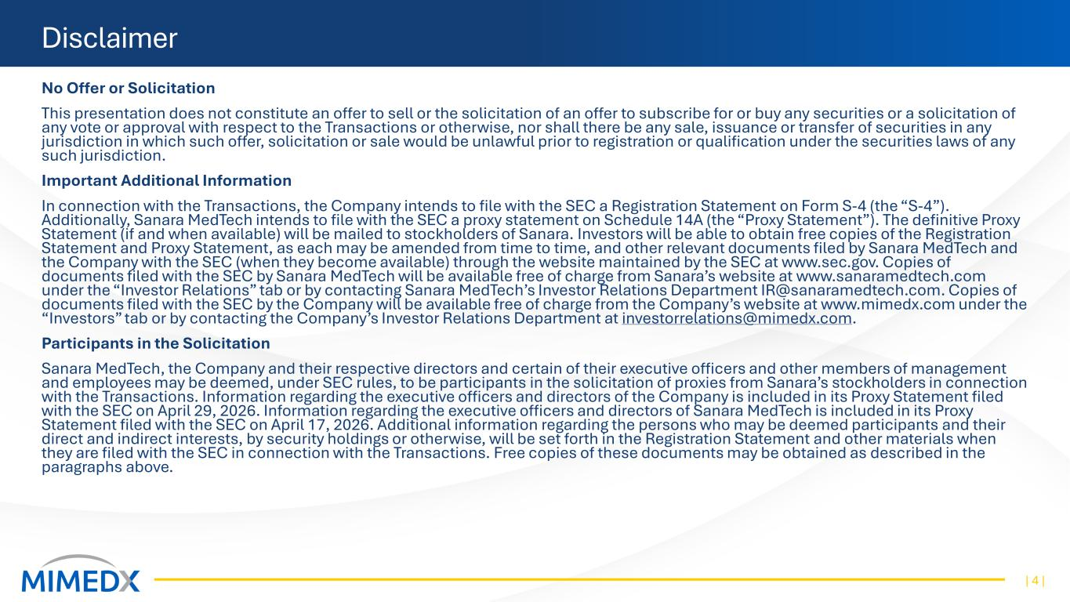
Disclaimer No Offer or Solicitation This presentation does not constitute an offer to sell or the solicitation of an offer to subscribe for or buy any securities or a solicitation of any vote or approval with respect to the Transactions or otherwise, nor shall there be any sale, issuance or transfer of securities in any jurisdiction in which such offer, solicitation or sale would be unlawful prior to registration or qualification under the securities laws of any such jurisdiction. Important Additional Information In connection with the Transactions, the Company intends to file with the SEC a Registration Statement on Form S-4 (the “S-4”). Additionally, Sanara MedTech intends to file with the SEC a proxy statement on Schedule 14A (the “Proxy Statement”). The definitive Proxy Statement (if and when available) will be mailed to stockholders of Sanara. Investors will be able to obtain free copies of the Registration Statement and Proxy Statement, as each may be amended from time to time, and other relevant documents filed by Sanara MedTech and the Company with the SEC (when they become available) through the website maintained by the SEC at www.sec.gov. Copies of documents filed with the SEC by Sanara MedTech will be available free of charge from Sanara’s website at www.sanaramedtech.com under the “Investor Relations” tab or by contacting Sanara MedTech’s Investor Relations Department IR@sanaramedtech.com. Copies of documents filed with the SEC by the Company will be available free of charge from the Company’s website at www.mimedx.com under the “Investors” tab or by contacting the Company’s Investor Relations Department at investorrelations@mimedx.com. Participants in the Solicitation Sanara MedTech, the Company and their respective directors and certain of their executive officers and other members of management and employees may be deemed, under SEC rules, to be participants in the solicitation of proxies from Sanara’s stockholders in connection with the Transactions. Information regarding the executive officers and directors of the Company is included in its Proxy Statement filed with the SEC on April 29, 2026. Information regarding the executive officers and directors of Sanara MedTech is included in its Proxy Statement filed with the SEC on April 17, 2026. Additional information regarding the persons who may be deemed participants and their direct and indirect interests, by security holdings or otherwise, will be set forth in the Registration Statement and other materials when they are filed with the SEC in connection with the Transactions. Free copies of these documents may be obtained as described in the paragraphs above. | 4 |


Opening Remarks Joseph H. Capper, Chief Executive Officer | 5 |

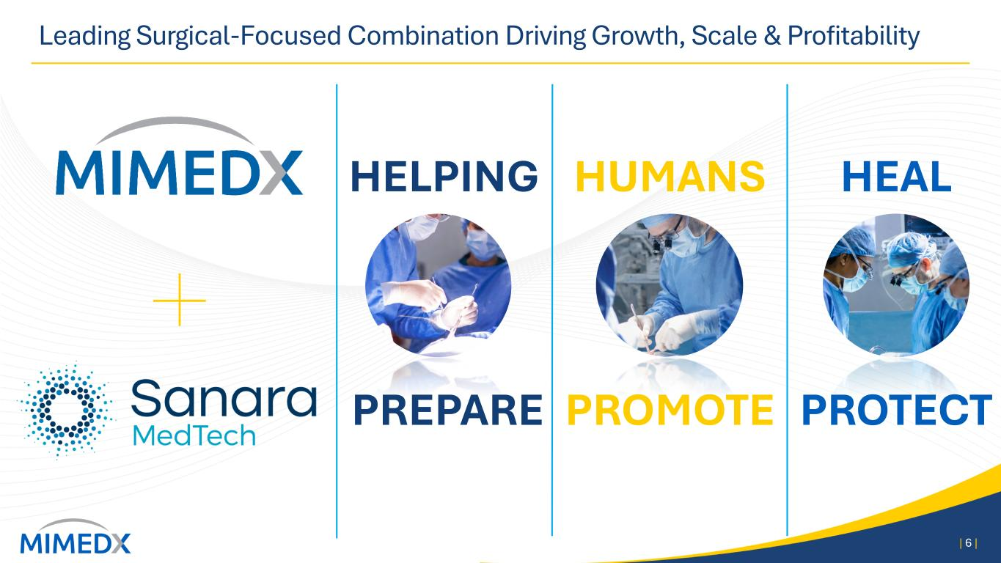
Leading Surgical-Focused Combination Driving Growth, Scale & Profitability | 6 | HEAL PROTECT HUMANS PROMOTE HELPING PREPARE

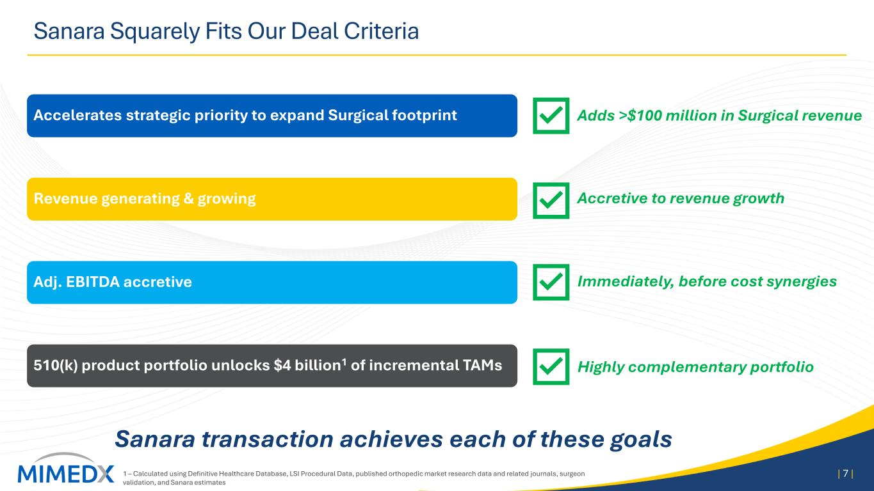
Sanara Squarely Fits Our Deal Criteria Accelerates strategic priority to expand Surgical footprint Revenue generating & growing Adj. EBITDA accretive 510(k) product portfolio unlocks $4 billion1 of incremental TAMs | 7 | Sanara transaction achieves each of these goals Adds >$100 million in Surgical revenue Accretive to revenue growth Immediately, before cost synergies Highly complementary portfolio 1 – Calculated using Definitive Healthcare Database, LSI Procedural Data, published orthopedic market research data and related journals, surgeon validation, and Sanara estimates

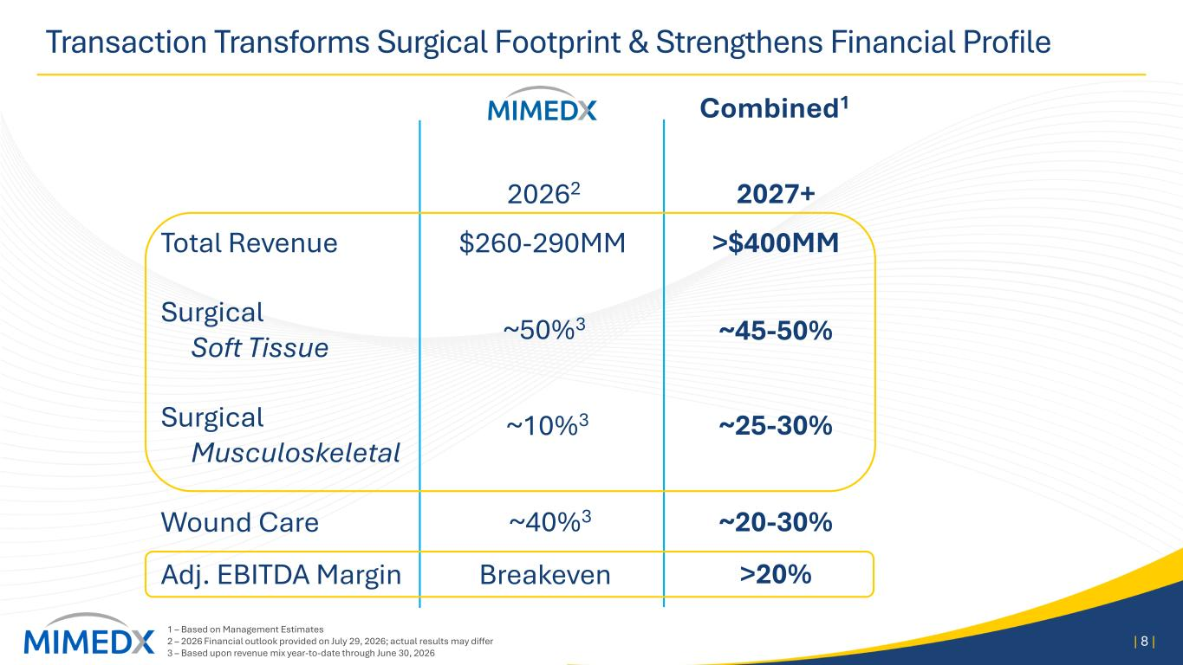
Transaction Transforms Surgical Footprint & Strengthens Financial Profile 1 – Based on Management Estimates 2 – 2026 Financial outlook provided on July 29, 2026; actual results may differ 3 – Based upon revenue mix year-to-date through June 30, 2026 | 8 | Surgical Soft Tissue Surgical Musculoskeletal Wound Care Total Revenue Adj. EBITDA Margin 20262 2027+ $260-290MM >$400MM Breakeven ~40%3 ~50%3 ~10%3 ~45-50% ~25-30% ~20-30% >20% Combined1

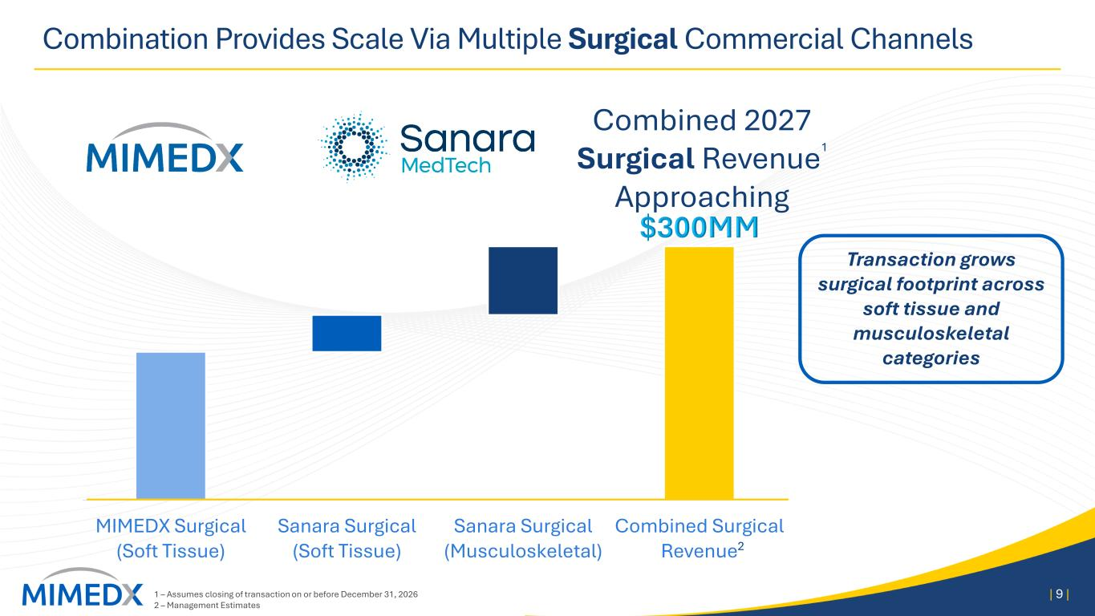
Combination Provides Scale Via Multiple Surgical Commercial Channels | 9 | Transaction grows surgical footprint across soft tissue and musculoskeletal categories MIMEDX Surgical (Soft Tissue) Sanara Surgical (Soft Tissue) Sanara Surgical (Musculoskeletal) Combined Surgical Revenue Combined 2027 Surgical Revenue Approaching 2 1 – Assumes closing of transaction on or before December 31, 2026 2 – Management Estimates 1

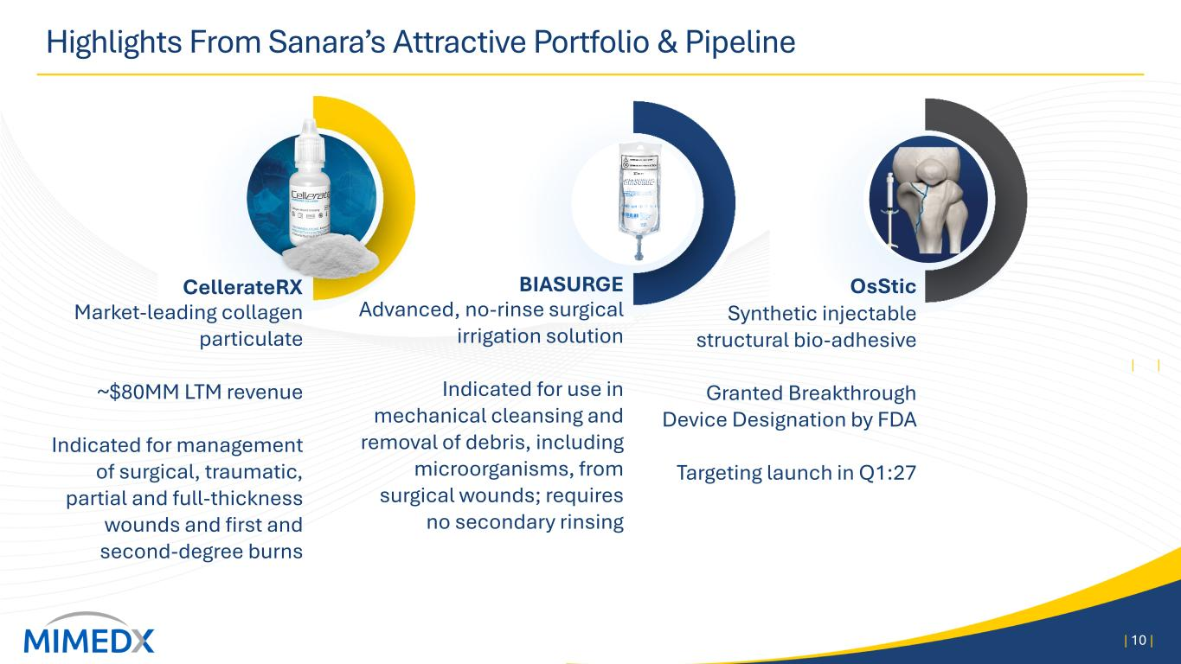
CellerateRX Market-leading collagen particulate ~$80MM LTM revenue Indicated for management of surgical, traumatic, partial and full-thickness wounds and first and second-degree burns Highlights From Sanara’s Attractive Portfolio & Pipeline | 10 | | 10 | OsStic Synthetic injectable structural bio-adhesive Granted Breakthrough Device Designation by FDA Targeting launch in Q1:27 BIASURGE Advanced, no-rinse surgical irrigation solution Indicated for use in mechanical cleansing and removal of debris, including microorganisms, from surgical wounds; requires no secondary rinsing

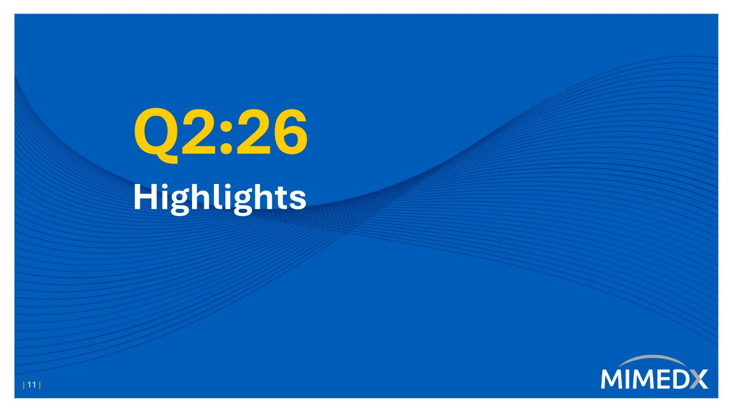
Q2:26 Highlights | 11 |

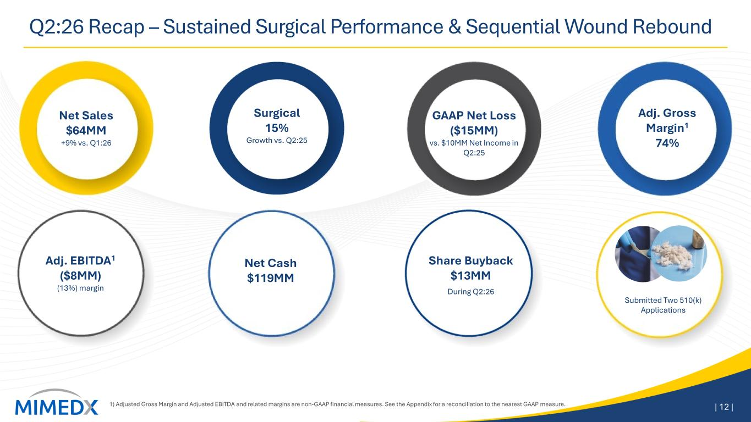
Q2:26 Recap – Sustained Surgical Performance & Sequential Wound Rebound 1) Adjusted Gross Margin and Adjusted EBITDA and related margins are non-GAAP financial measures. See the Appendix for a reconciliation to the nearest GAAP measure. | 12 | Surgical 15% Growth vs. Q2:25 Adj. Gross Margin1 74% GAAP Net Loss ($15MM) vs. $10MM Net Income in Q2:25 Net Sales $64MM +9% vs. Q1:26 Adj. EBITDA1 ($8MM) (13%) margin Net Cash $119MM During Q2:26 Share Buyback $13MM Submitted Two 510(k) Applications

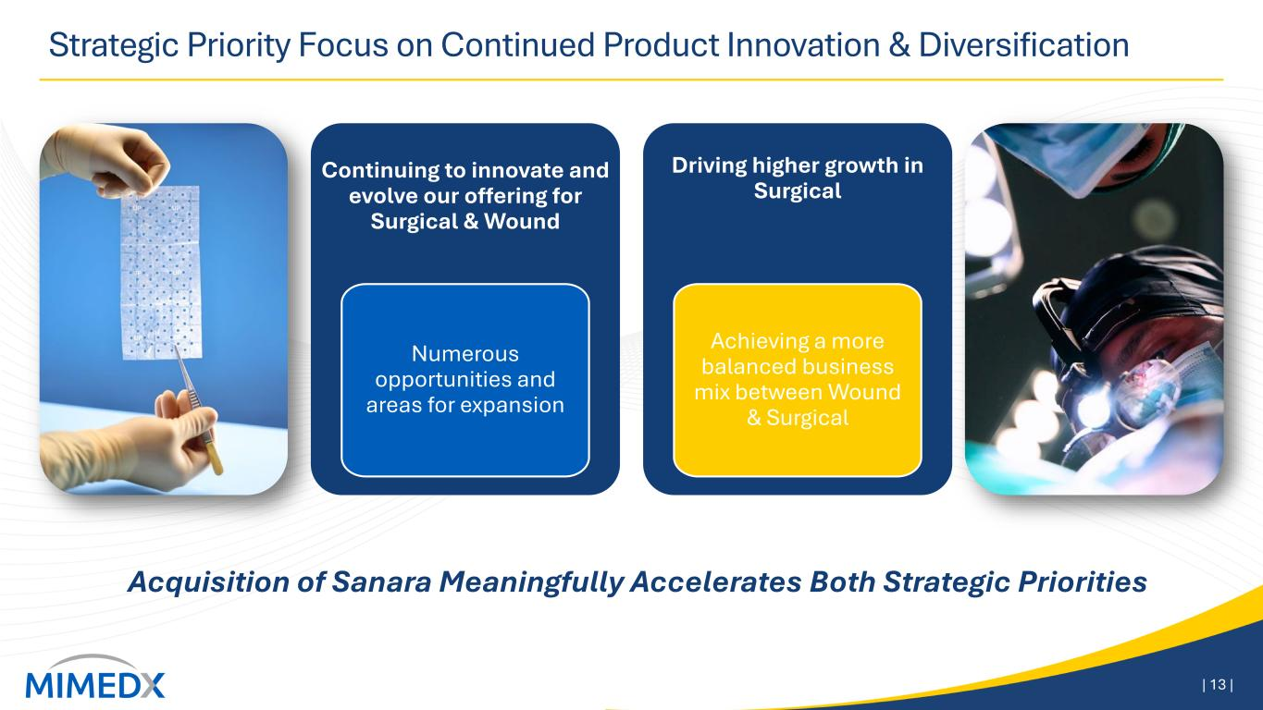
Strategic Priority Focus on Continued Product Innovation & Diversification | 13 | Continuing to innovate and evolve our offering for Surgical & Wound Numerous opportunities and areas for expansion Driving higher growth in Surgical Achieving a more balanced business mix between Wound & Surgical Acquisition of Sanara Meaningfully Accelerates Both Strategic Priorities

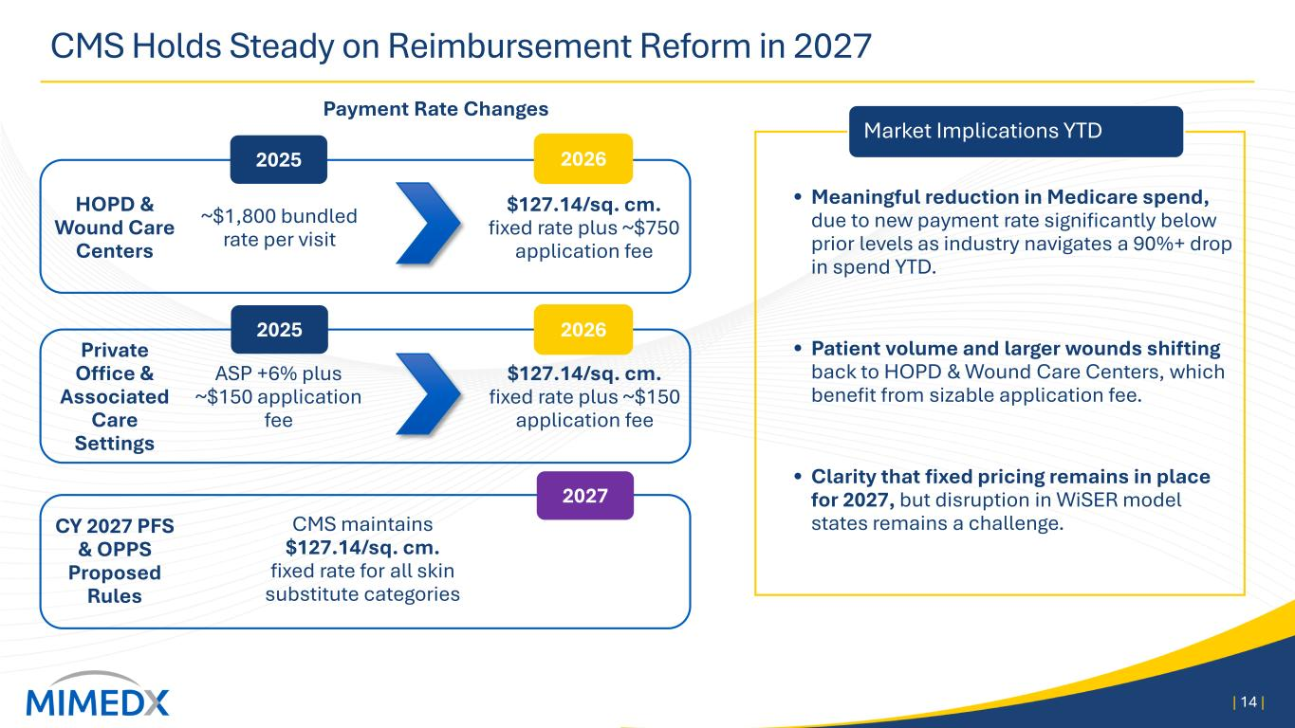
• Meaningful reduction in Medicare spend, due to new payment rate significantly below prior levels as industry navigates a 90%+ drop in spend YTD. • Patient volume and larger wounds shifting back to HOPD & Wound Care Centers, which benefit from sizable application fee. • Clarity that fixed pricing remains in place for 2027, but disruption in WiSER model states remains a challenge. CMS Holds Steady on Reimbursement Reform in 2027 | 14 | Payment Rate Changes HOPD & Wound Care Centers Private Office & Associated Care Settings ~$1,800 bundled rate per visit ASP +6% plus ~$150 application fee $127.14/sq. cm. fixed rate plus ~$750 application fee $127.14/sq. cm. fixed rate plus ~$150 application fee 2025 2026 2025 2026 Market Implications YTD 2027 CY 2027 PFS & OPPS Proposed Rules CMS maintains $127.14/sq. cm. fixed rate for all skin substitute categories

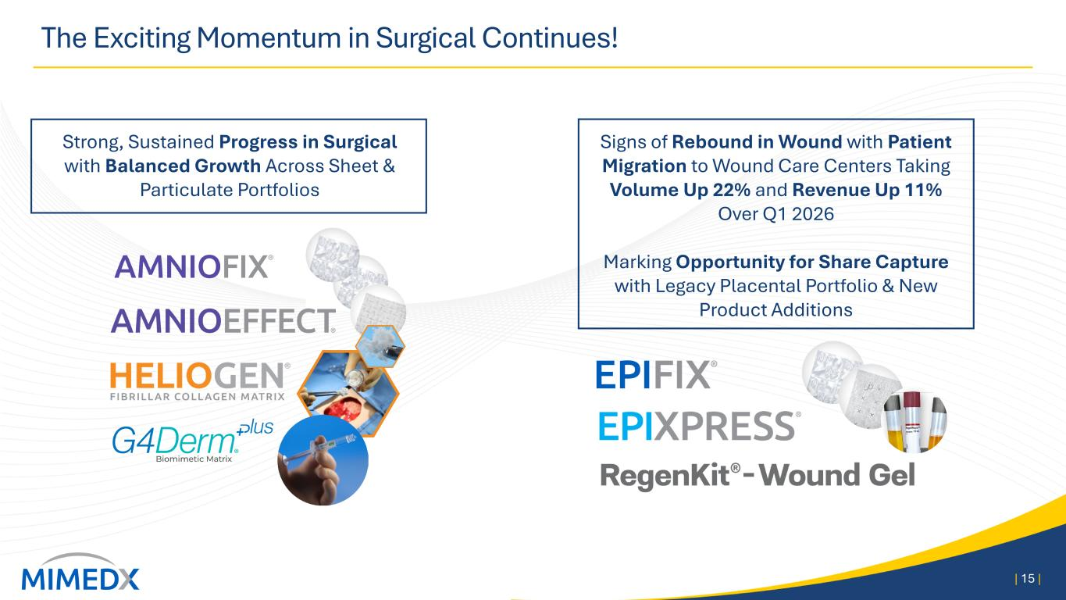
The Exciting Momentum in Surgical Continues! | 15 | Strong, Sustained Progress in Surgical with Balanced Growth Across Sheet & Particulate Portfolios Signs of Rebound in Wound with Patient Migration to Wound Care Centers Taking Volume Up 22% and Revenue Up 11% Over Q1 2026 Marking Opportunity for Share Capture with Legacy Placental Portfolio & New Product Additions

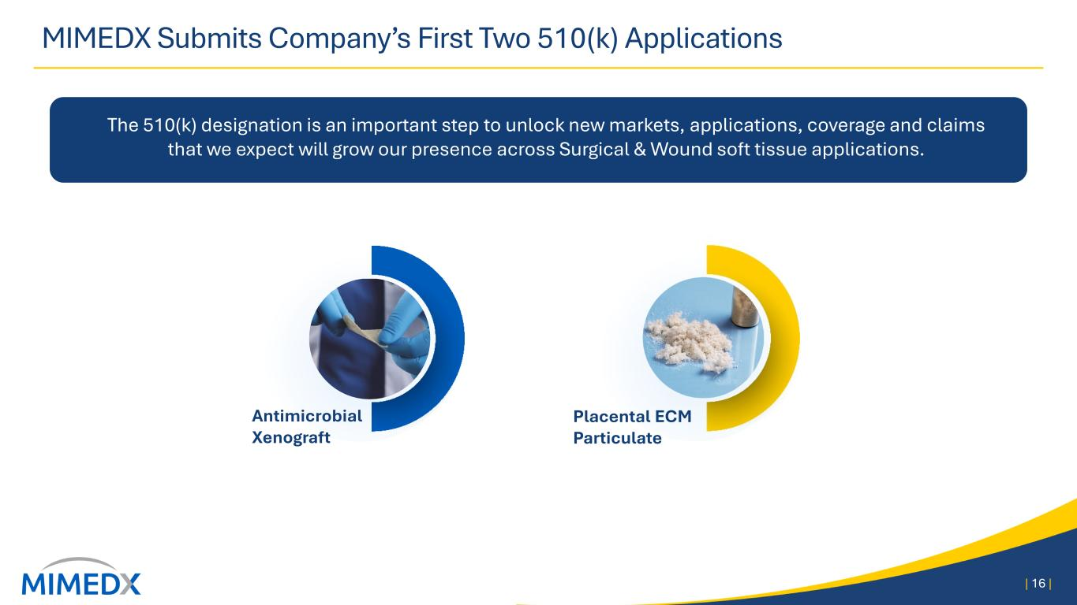
MIMEDX Submits Company’s First Two 510(k) Applications | 16 | Placental ECM Particulate Antimicrobial Xenograft The 510(k) designation is an important step to unlock new markets, applications, coverage and claims that we expect will grow our presence across Surgical & Wound soft tissue applications.


Financial Results Doug Rice, Chief Financial Officer | 17 |

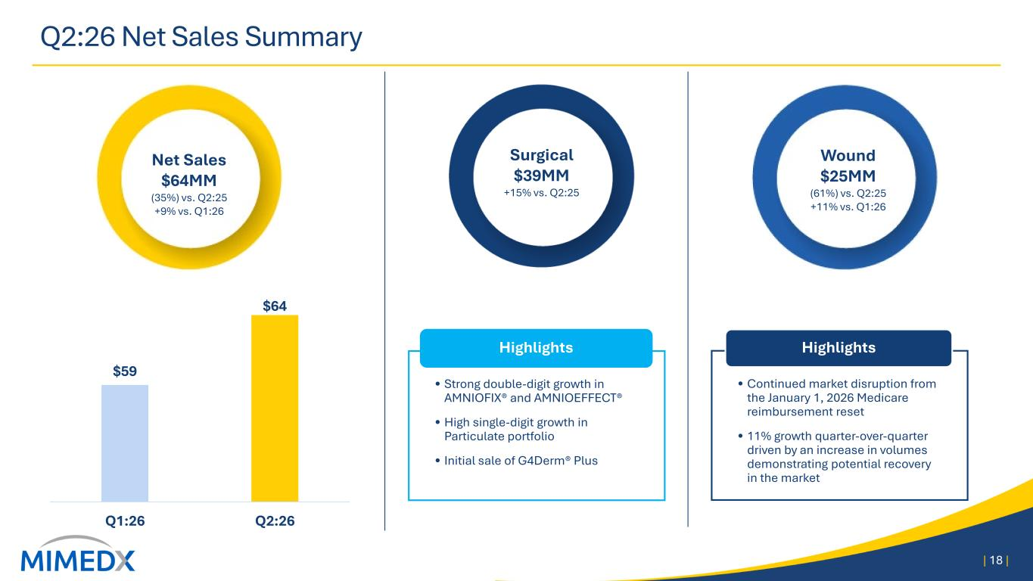
• Strong double-digit growth in AMNIOFIX® and AMNIOEFFECT® • High single-digit growth in Particulate portfolio • Initial sale of G4Derm® Plus Highlights Q2:26 Net Sales Summary | 18 | • Continued market disruption from the January 1, 2026 Medicare reimbursement reset • 11% growth quarter-over-quarter driven by an increase in volumes demonstrating potential recovery in the market Highlights UPDATE Surgical $39MM +15% vs. Q2:25 Wound $25MM (61%) vs. Q2:25 +11% vs. Q1:26 Net Sales $64MM (35%) vs. Q2:25 +9% vs. Q1:26 $59 $64 Q1:26 Q2:26

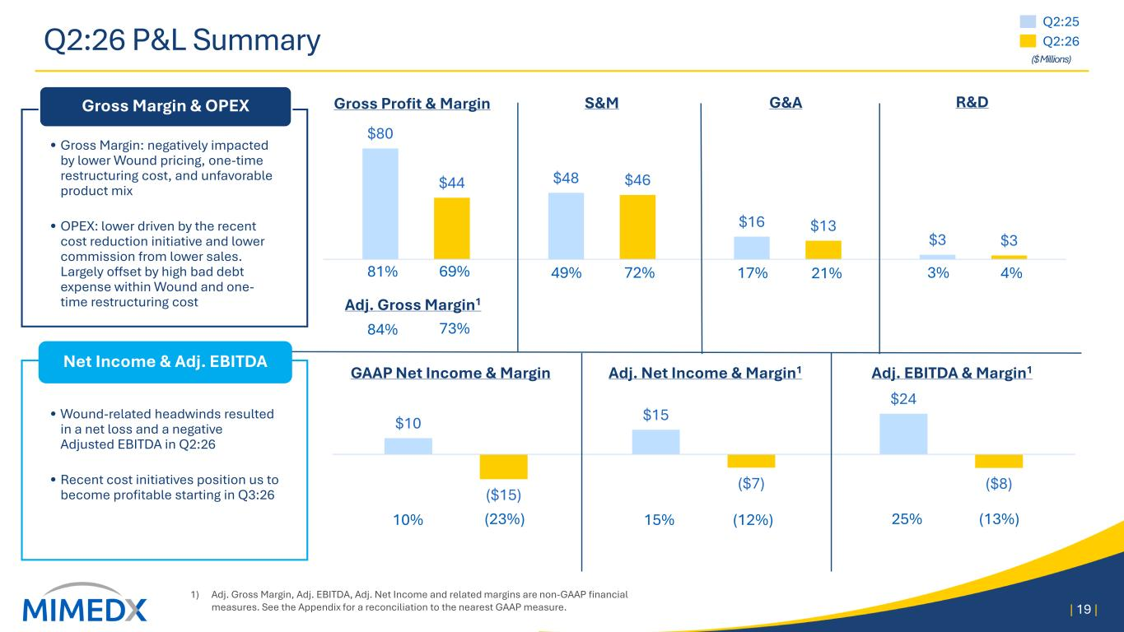
Q2:26 P&L Summary 1) Adj. Gross Margin, Adj. EBITDA, Adj. Net Income and related margins are non-GAAP financial measures. See the Appendix for a reconciliation to the nearest GAAP measure. | 19 | $10 $15 $24 ($15) ($7) ($8) $80 $48 $16 $3 $44 $46 $13 $3 Adj. EBITDA & Margin1GAAP Net Income & Margin R&D 49% 72% 3% 4% 10% (23%) 25% (13%) Adj. Net Income & Margin1 15% (12%) Gross Profit & Margin 81% 69% G&A 17% 21% Adj. Gross Margin1 84% 73% • Wound-related headwinds resulted in a net loss and a negative Adjusted EBITDA in Q2:26 • Recent cost initiatives position us to become profitable starting in Q3:26 Net Income & Adj. EBITDA • Gross Margin: negatively impacted by lower Wound pricing, one-time restructuring cost, and unfavorable product mix • OPEX: lower driven by the recent cost reduction initiative and lower commission from lower sales. Largely offset by high bad debt expense within Wound and one- time restructuring cost Gross Margin & OPEX UPDATE S&M Q2:25 Q2:26 ($ Millions)

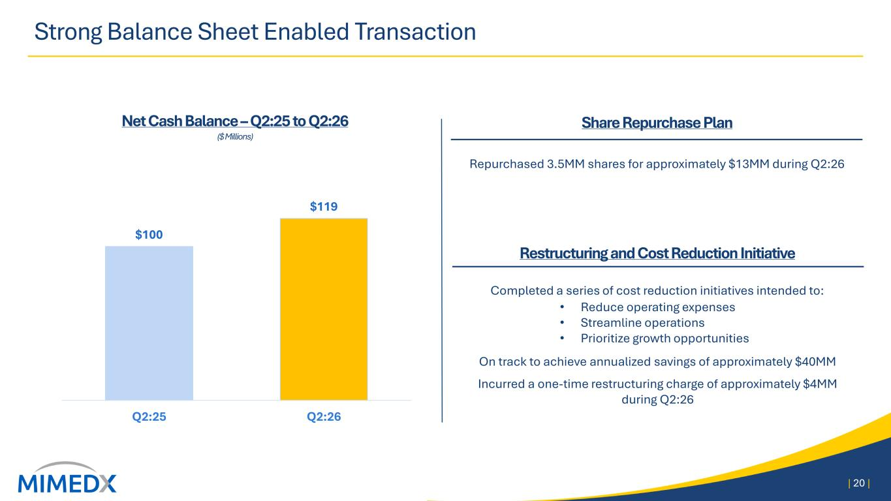
Strong Balance Sheet Enabled Transaction | 20 | Net Cash Balance – Q2:25 to Q2:26 ($ Millions) $100 $119 Q2:25 Q2:26 Restructuring and Cost Reduction Initiative Completed a series of cost reduction initiatives intended to: • Reduce operating expenses • Streamline operations • Prioritize growth opportunities On track to achieve annualized savings of approximately $40MM Incurred a one-time restructuring charge of approximately $4MM during Q2:26 Share Repurchase Plan Repurchased 3.5MM shares for approximately $13MM during Q2:26

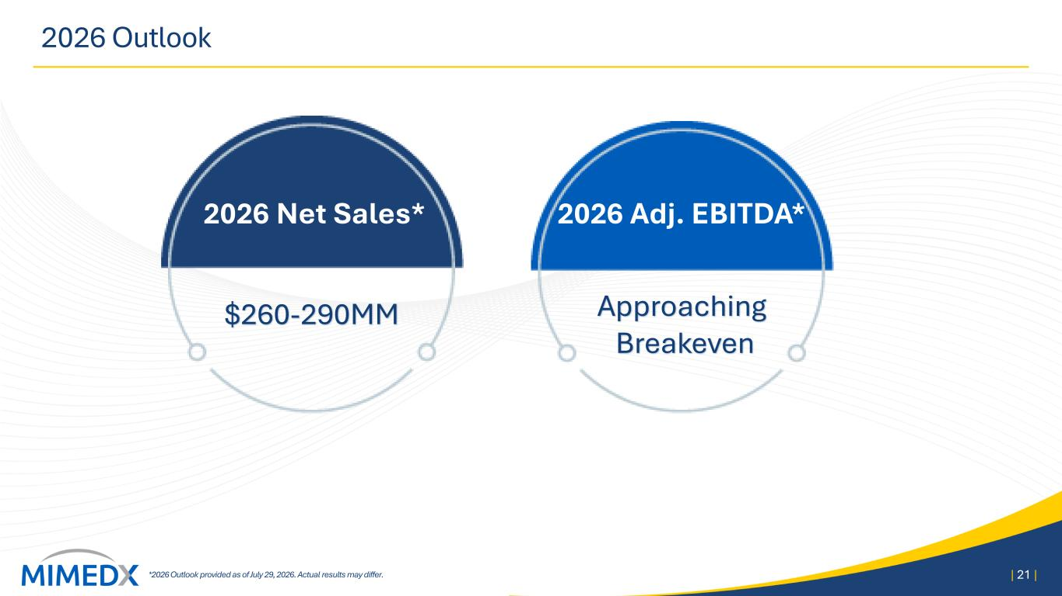
2026 Outlook *2026 Outlook provided as of July 29, 2026. Actual results may differ. | 21 | $260-290MM Approaching Breakeven 2026 Net Sales* 2026 Adj. EBITDA*

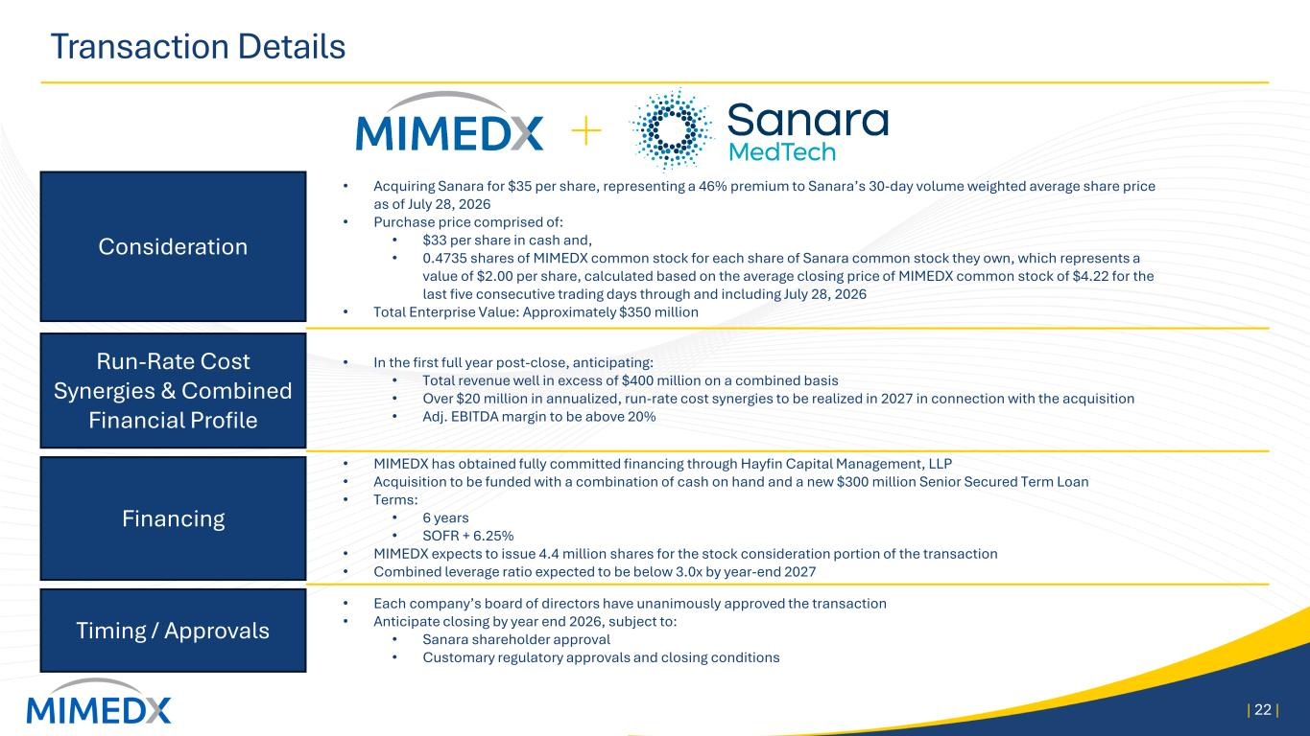
Transaction Details | 22 | Consideration Run-Rate Cost Synergies & Combined Financial Profile Timing / Approvals • Acquiring Sanara for $35 per share, representing a 46% premium to Sanara’s 30-day volume weighted average share price as of July 28, 2026 • Purchase price comprised of: • $33 per share in cash and, • 0.4735 shares of MIMEDX common stock for each share of Sanara common stock they own, which represents a value of $2.00 per share, calculated based on the average closing price of MIMEDX common stock of $4.22 for the last five consecutive trading days through and including July 28, 2026 • Total Enterprise Value: Approximately $350 million Financing • MIMEDX has obtained fully committed financing through Hayfin Capital Management, LLP • Acquisition to be funded with a combination of cash on hand and a new $300 million Senior Secured Term Loan • Terms: • 6 years • SOFR + 6.25% • MIMEDX expects to issue 4.4 million shares for the stock consideration portion of the transaction • Combined leverage ratio expected to be below 3.0x by year-end 2027 • Each company’s board of directors have unanimously approved the transaction • Anticipate closing by year end 2026, subject to: • Sanara shareholder approval • Customary regulatory approvals and closing conditions • In the first full year post-close, anticipating: • Total revenue well in excess of $400 million on a combined basis • Over $20 million in annualized, run-rate cost synergies to be realized in 2027 in connection with the acquisition • Adj. EBITDA margin to be above 20%


Closing Remarks, Q&A | 23 |

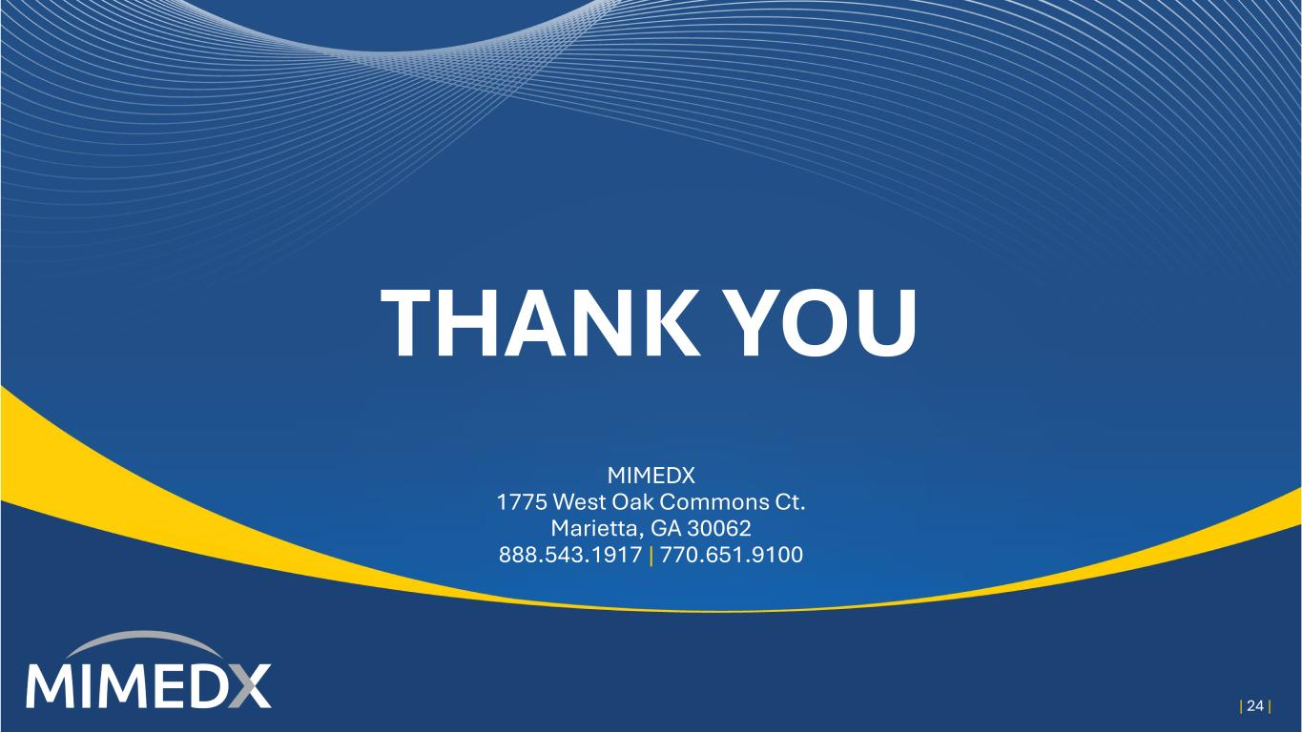
THANK YOU MIMEDX 1775 West Oak Commons Ct. Marietta, GA 30062 888.543.1917 | 770.651.9100 | 24 |

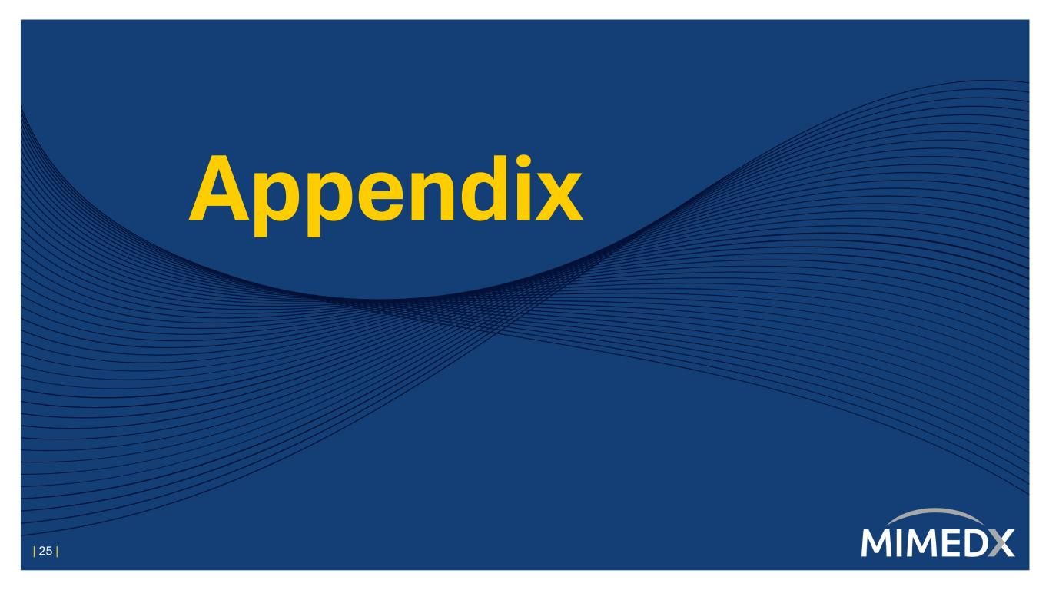
Appendix | 25 |

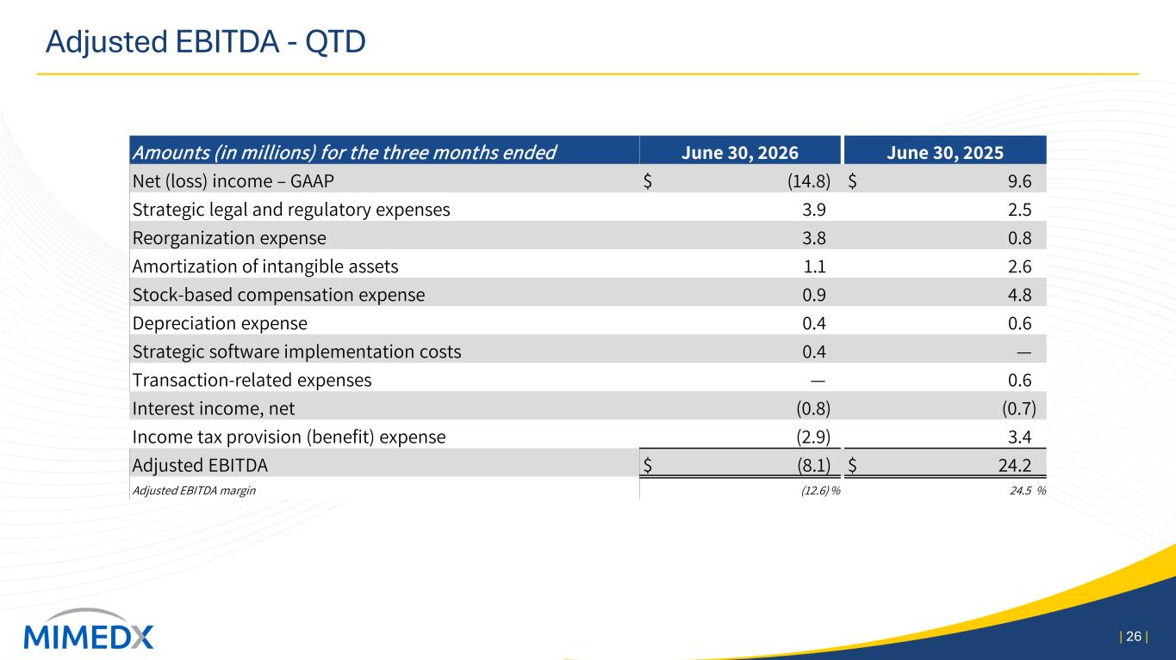
Adjusted EBITDA - QTD | 26 | Amounts (in millions) for the three months ended June 30, 2026 June 30, 2025 Net (loss) income – GAAP $ (14.8) $ 9.6 Strategic legal and regulatory expenses 3.9 2.5 Reorganization expense 3.8 0.8 Amortization of intangible assets 1.1 2.6 Stock-based compensation expense 0.9 4.8 Depreciation expense 0.4 0.6 Strategic software implementation costs 0.4 — Transaction-related expenses — 0.6 Interest income, net (0.8) (0.7) Income tax provision (benefit) expense (2.9) 3.4 Adjusted EBITDA $ (8.1) $ 24.2 Adjusted EBITDA margin (12.6) % 24.5 %

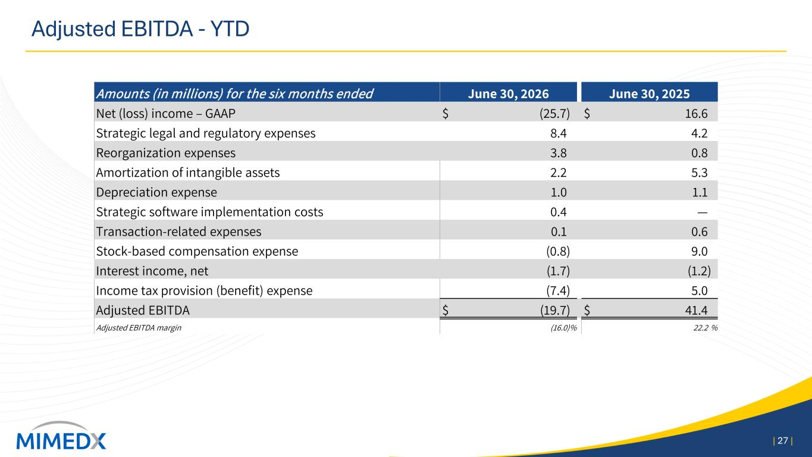
Adjusted EBITDA - YTD | 27 | Amounts (in millions) for the six months ended June 30, 2026 June 30, 2025 Net (loss) income – GAAP $ (25.7) $ 16.6 Strategic legal and regulatory expenses 8.4 4.2 Reorganization expenses 3.8 0.8 Amortization of intangible assets 2.2 5.3 Depreciation expense 1.0 1.1 Strategic software implementation costs 0.4 — Transaction-related expenses 0.1 0.6 Stock-based compensation expense (0.8) 9.0 Interest income, net (1.7) (1.2) Income tax provision (benefit) expense (7.4) 5.0 Adjusted EBITDA $ (19.7) $ 41.4 Adjusted EBITDA margin (16.0)% 22.2 %

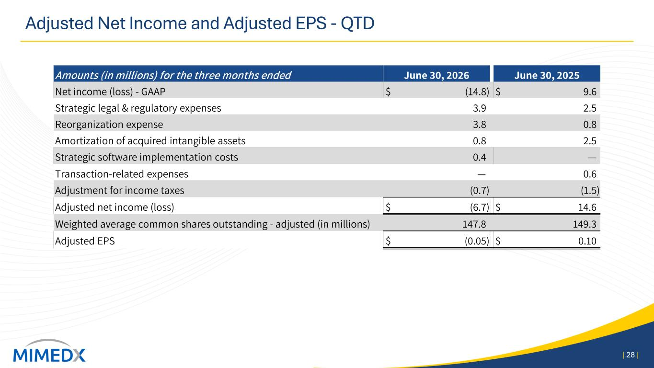
Adjusted Net Income and Adjusted EPS - QTD | 28 | Amounts (in millions) for the three months ended June 30, 2026 June 30, 2025 Net income (loss) - GAAP $ (14.8) $ 9.6 Strategic legal & regulatory expenses 3.9 2.5 Reorganization expense 3.8 0.8 Amortization of acquired intangible assets 0.8 2.5 Strategic software implementation costs 0.4 — Transaction-related expenses — 0.6 Adjustment for income taxes (0.7) (1.5) Adjusted net income (loss) $ (6.7) $ 14.6 Weighted average common shares outstanding - adjusted (in millions) 147.8 149.3 Adjusted EPS $ (0.05) $ 0.10

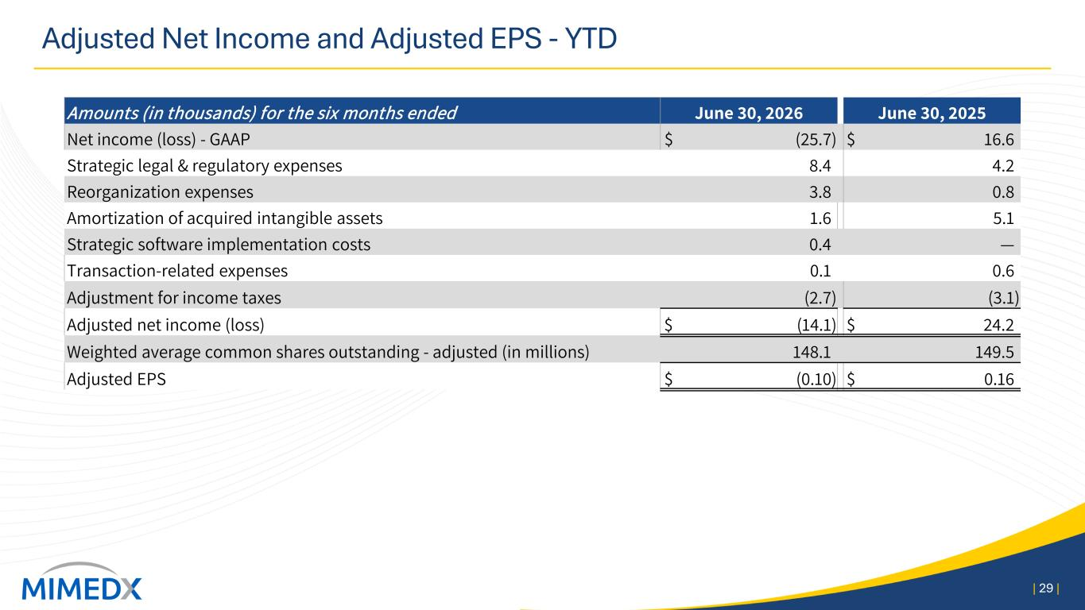
Adjusted Net Income and Adjusted EPS - YTD | 29 | Amounts (in thousands) for the six months ended June 30, 2026 June 30, 2025 Net income (loss) - GAAP $ (25.7) $ 16.6 Strategic legal & regulatory expenses 8.4 4.2 Reorganization expenses 3.8 0.8 Amortization of acquired intangible assets 1.6 5.1 Strategic software implementation costs 0.4 — Transaction-related expenses 0.1 0.6 Adjustment for income taxes (2.7) (3.1) Adjusted net income (loss) $ (14.1) $ 24.2 Weighted average common shares outstanding - adjusted (in millions) 148.1 149.5 Adjusted EPS $ (0.10) $ 0.16

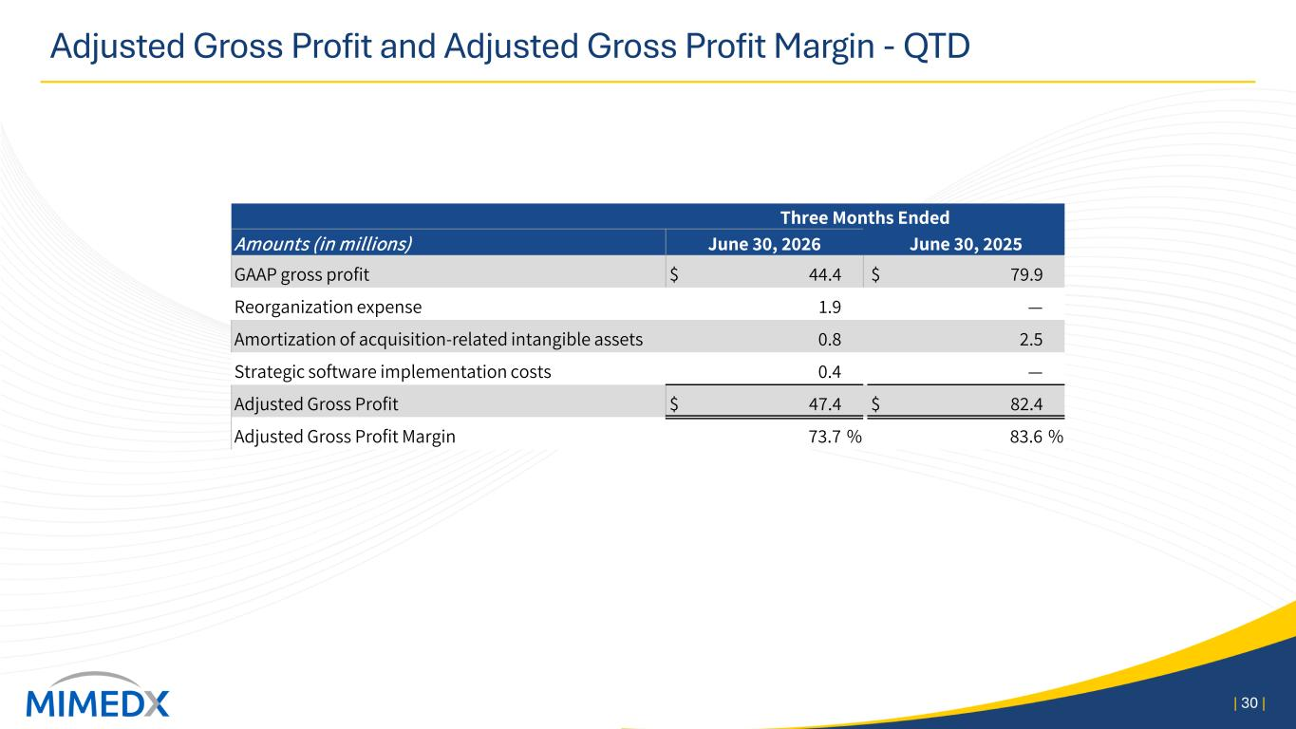
Adjusted Gross Profit and Adjusted Gross Profit Margin - QTD | 30 | Three Months Ended Amounts (in millions) June 30, 2026 June 30, 2025 GAAP gross profit $ 44.4 $ 79.9 Reorganization expense 1.9 — Amortization of acquisition-related intangible assets 0.8 2.5 Strategic software implementation costs 0.4 — Adjusted Gross Profit $ 47.4 $ 82.4 Adjusted Gross Profit Margin 73.7 % 83.6 %

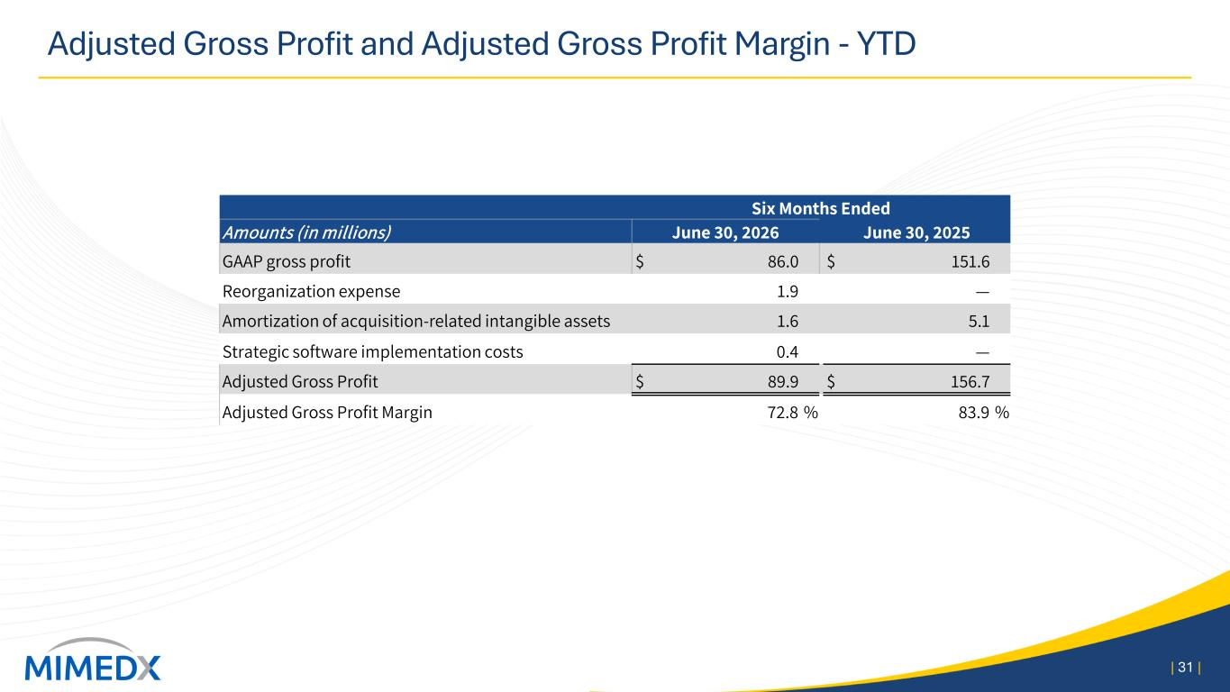
Adjusted Gross Profit and Adjusted Gross Profit Margin - YTD | 31 | Six Months Ended Amounts (in millions) June 30, 2026 June 30, 2025 GAAP gross profit $ 86.0 $ 151.6 Reorganization expense 1.9 — Amortization of acquisition-related intangible assets 1.6 5.1 Strategic software implementation costs 0.4 — Adjusted Gross Profit $ 89.9 $ 156.7 Adjusted Gross Profit Margin 72.8 % 83.9 %

