UNITED STATES

SECURITIES AND EXCHANGE COMMISSION
WASHINGTON, DC 20549

FORM 8-K

CURRENT REPORT

PURSUANT TO SECTION 13 OR 15(d)
OF THE SECURITIES EXCHANGE ACT OF 1934

Date of Report (Date of earliest event reported): September 21, 2020

MIMEDX GROUP, INC.

(Exact name of registrant as specified in charter)

Florida

001-35887

26-2792552

(State or other jurisdiction
of incorporation)

(Commission
File Number)

(IRS Employer
Identification No.)

1775 West Oak Commons Ct., NE, Marietta GA 30062

(Address of principal executive offices) (Zip Code)

Registrant’s telephone number, including area code: (770) 651-9100

Check the appropriate box below if the Form 8-K filing is intended to simultaneously satisfy the filing obligation of the registrant under any of the following provisions (see General Instruction A.2. below):

- Written communications pursuant to Rule 425 under the Securities Act (17 CFR 230.425)

- Soliciting material pursuant to Rule 14a-12 under the Exchange Act (17 CFR 240.14a-12)

- Pre-commencement communications pursuant to Rule 14d-2(b) under the Exchange Act (17 CFR 240.14d-2(b))

- Pre-commencement communications pursuant to Rule 13e-4(c) under the Exchange Act (17 CFR 240.13e-4(c))

Securities registered pursuant to Section 12(b) of the Act:

Title of each class |  | Trading |  | Name of each exchange
 |  | Symbol(s) |  | on which registered
None |  | n/a |  | n/a

Indicate by check mark whether the registrant is an emerging growth company as defined in Rule 405 of the Securities Act of 1933 (§ 230.405 of this chapter) or Rule 12b-2 of the Securities Exchange Act of 1934 (§ 240.12b-2 of this chapter).

Emerging growth company ☐

If an emerging growth company, indicate by check mark if the registrant has elected not to use the extended transition period for complying with any new or revised financial accounting standards provided pursuant to Section 13(a) of the Exchange Act. ☐

Item 7.01 Regulation FD Disclosure

Beginning on September 21, 2020, certain executive officers of MiMedx Group, Inc. (the “Company” or the “Registrant”) will hold conference calls with institutional investors. A copy of the presentation materials to be used during these calls is furnished as Exhibit 99.1 to this Current Report on Form 8-K and is incorporated by reference herein. All information in the presentation materials speak as of the date thereof, and MiMedx does not assume any obligation to update such information in the future.

Item 8.01 Other.

On September 21, 2020, the Company (1) announced a range of expected net sales for the quarter that will end September 30, 2020, and (2) announced that it will hold the 2020 annual meeting of the Company’s shareholders (the “2020 Annual Meeting”) on November 20, 2020. A copy of the press release is attached hereto as Exhibit 99.2 and is incorporated herein by reference.

Any shareholder proposals or nominations under the Company’s Amended and Restated Bylaws must be received by the Company on or before October 1, 2020 and otherwise comply with the Company’s Amended and Restated Bylaws. For any proposal to be included in the Company’s proxy statement for the 2020 Annual Meeting pursuant to Rule 14a-8 under the Securities Exchange Act of 1934, as amended, such proposal must be received by the Company on or before October 1, 2020 and otherwise comply with the requirements of Rule 14a-8.

Item 9.01 Financial Statements and Exhibits.

(d) Exhibits.

Exhibit | Description of Exhibit
No. | Description of Exhibit
99.1 | Slide presentation dated September 21, 2020.
99.2 | Press release dated September 21, 2020.
104 | The cover page from this Current Report on Form 8-K, formatted in Inline XBRL.

SIGNATURES

Pursuant to the requirements of the Exchange Act, the Registrant has duly caused this report to be signed on its behalf by the undersigned hereunto duly authorized.

MIMEDX GROUP, INC.

Date: September 21, 2020 By: /s/ Peter M. Carlson

Peter M. Carlson

Chief Financial Officer

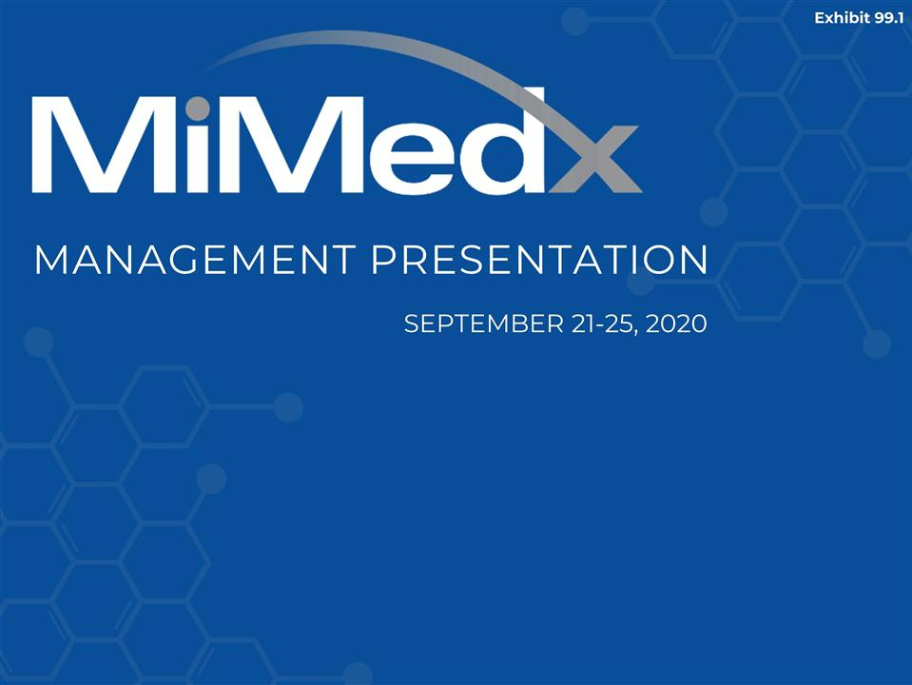

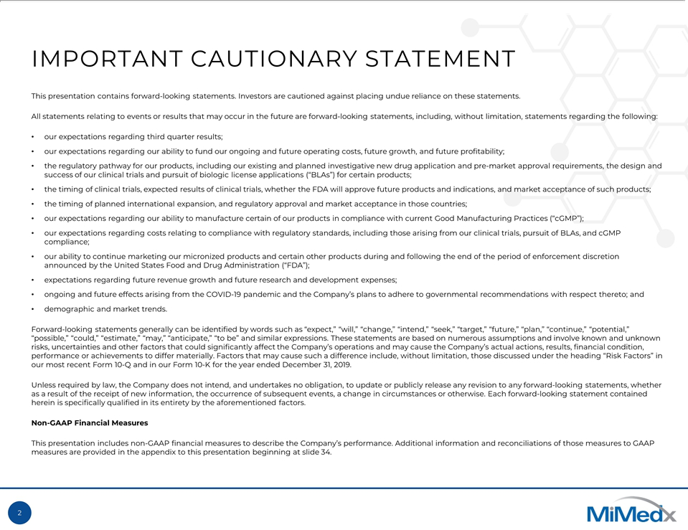

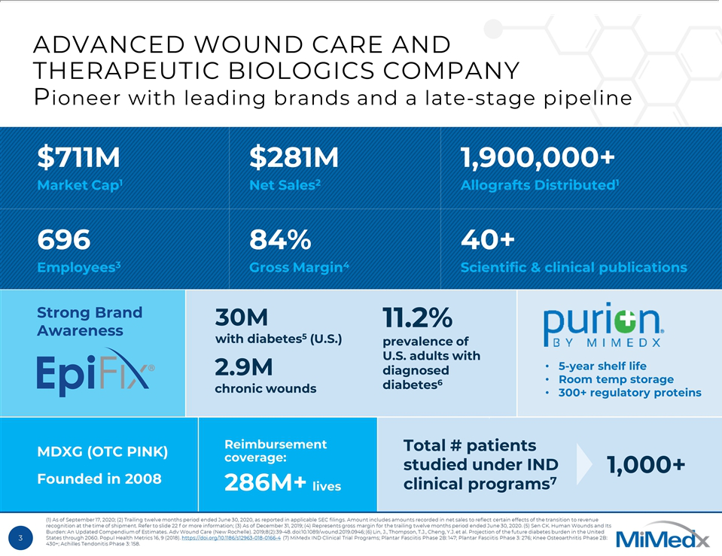

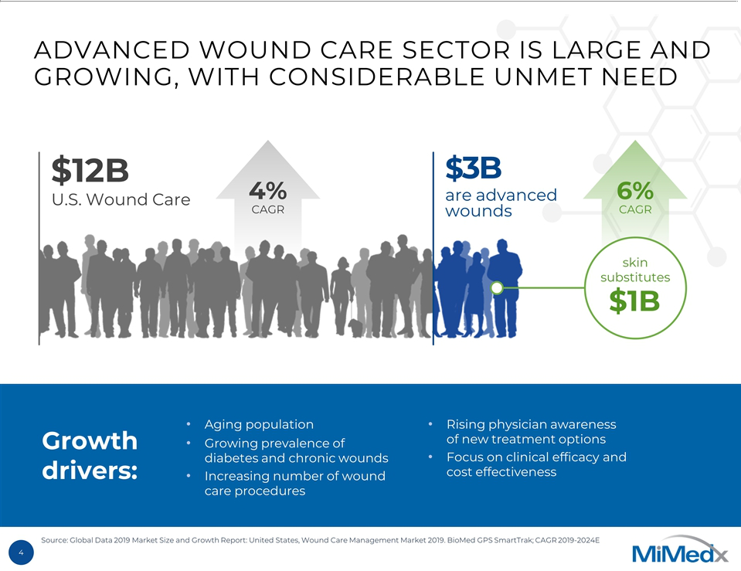

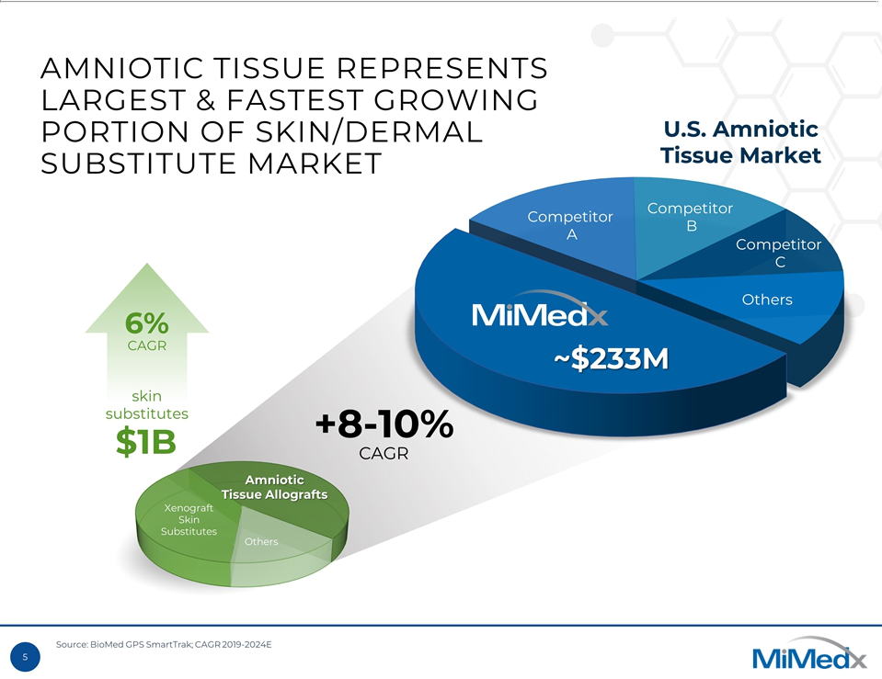

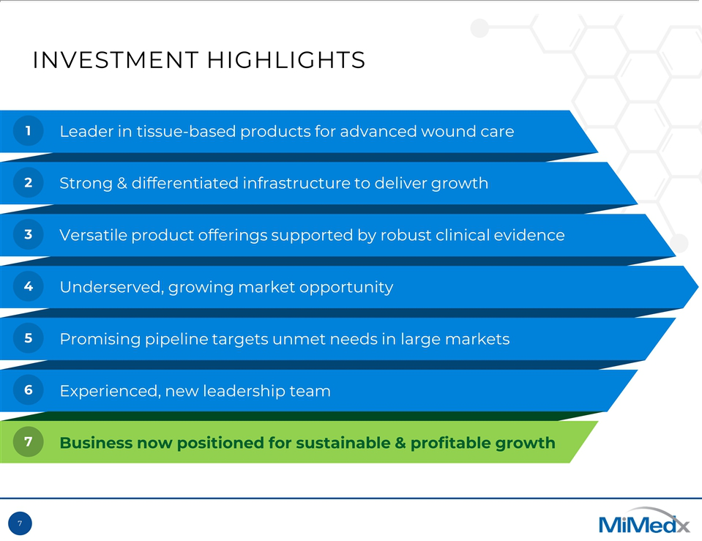

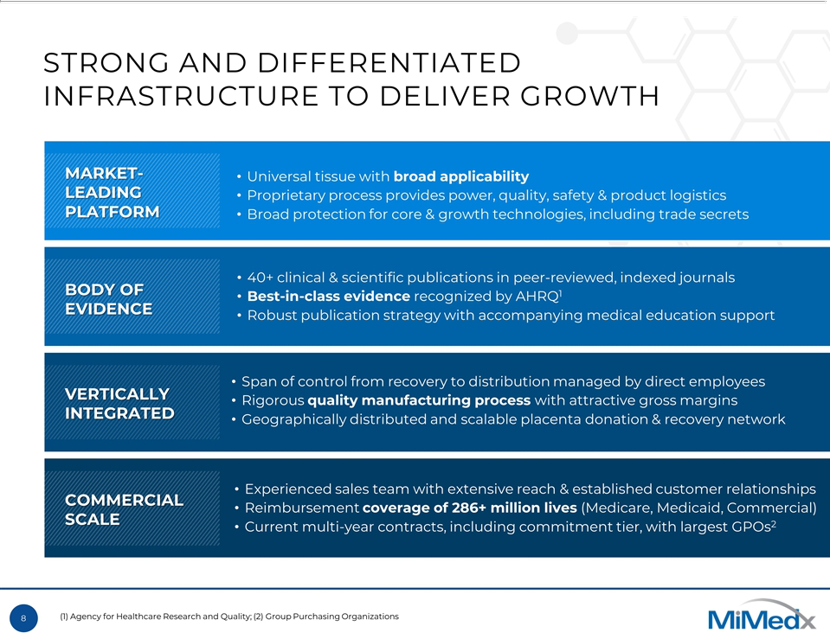

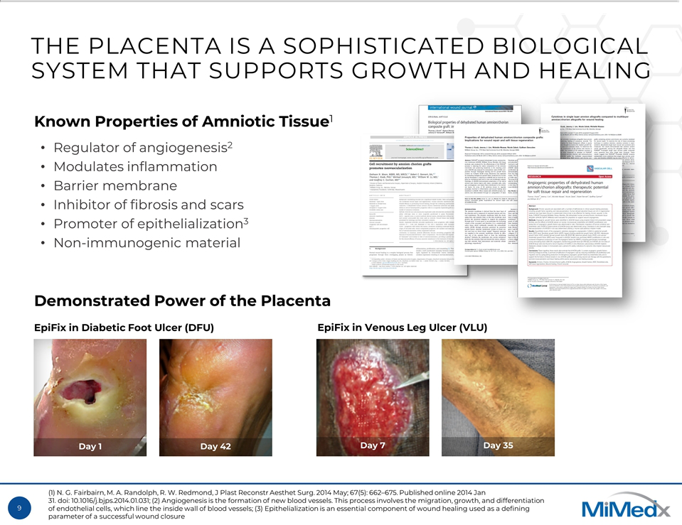

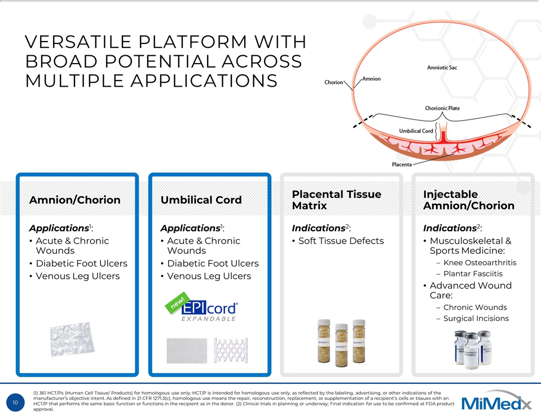

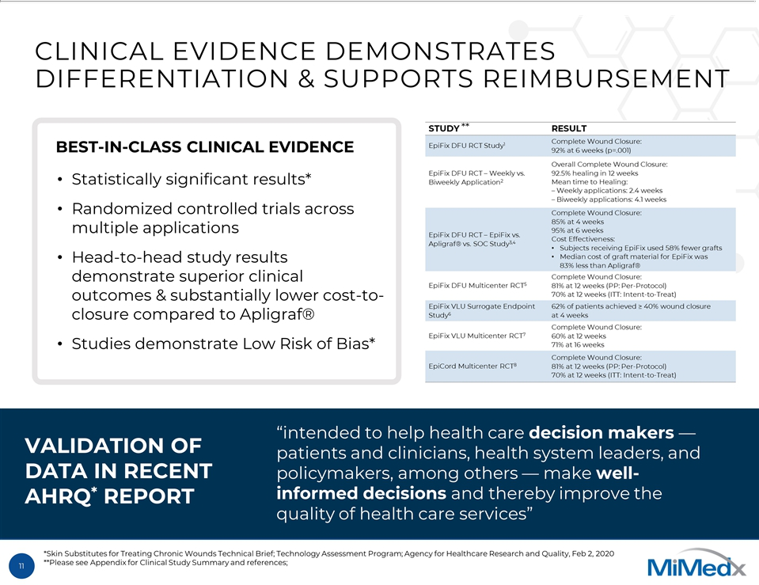

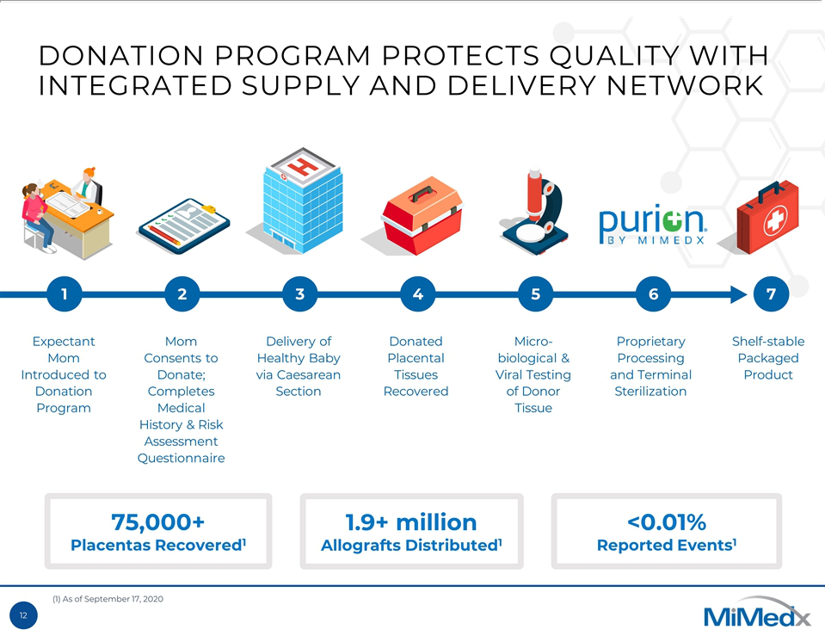

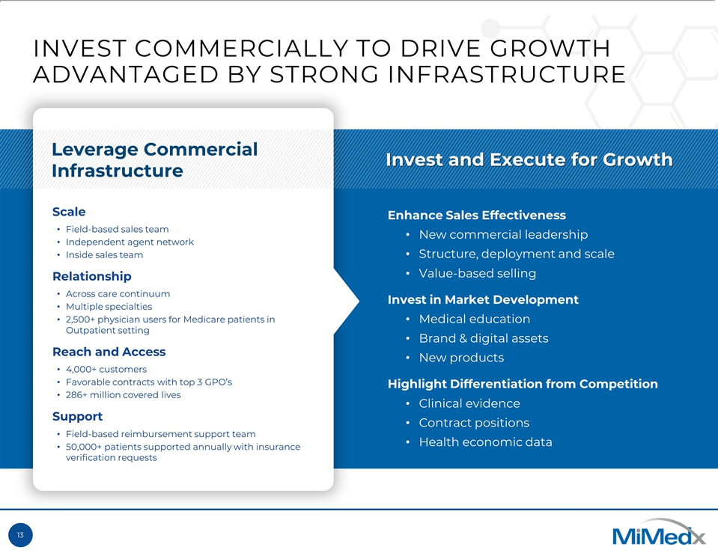

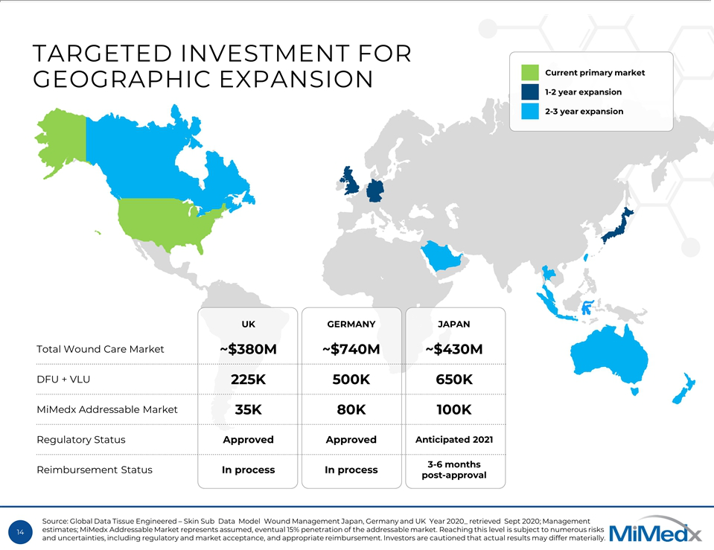

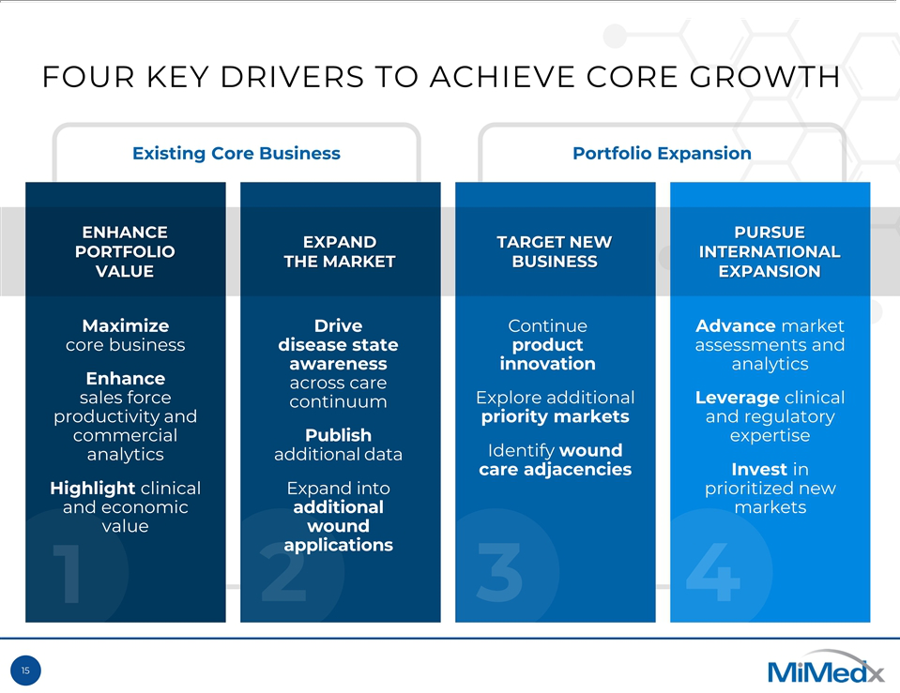

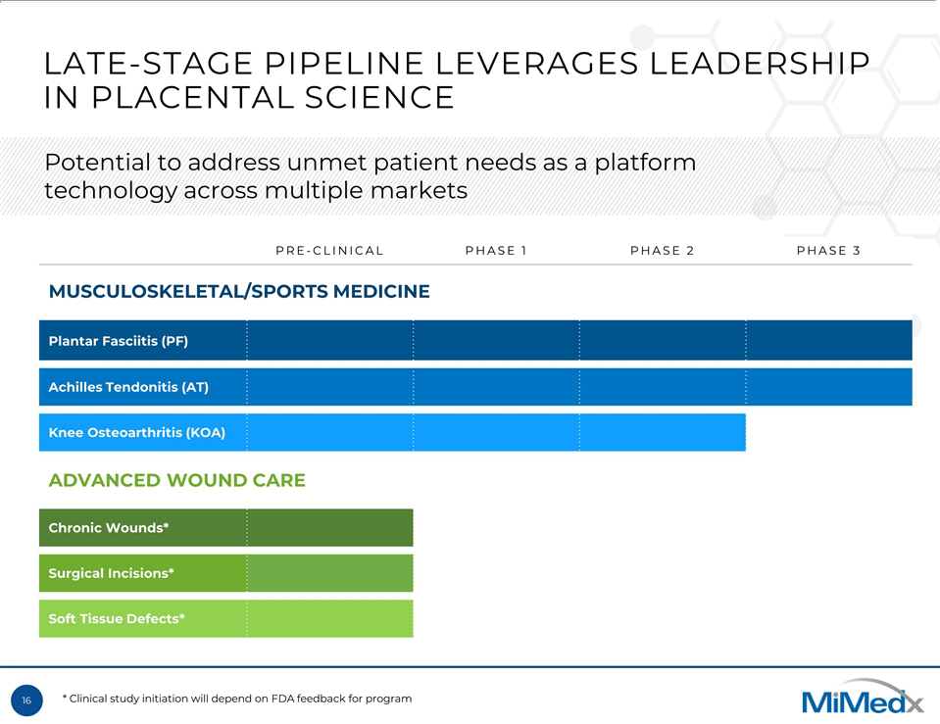

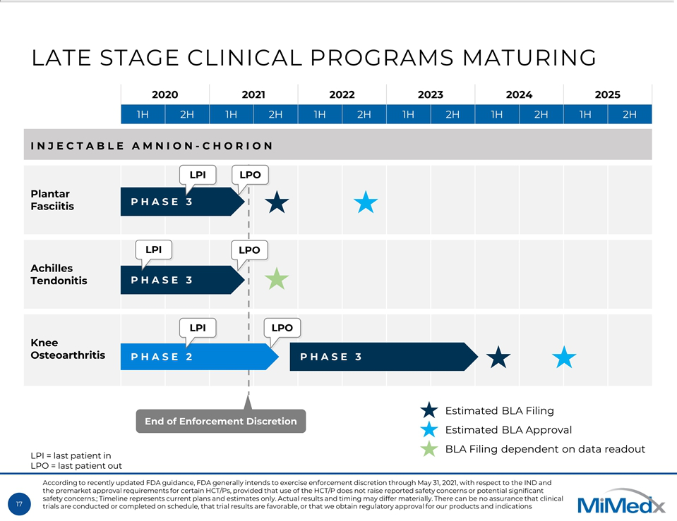

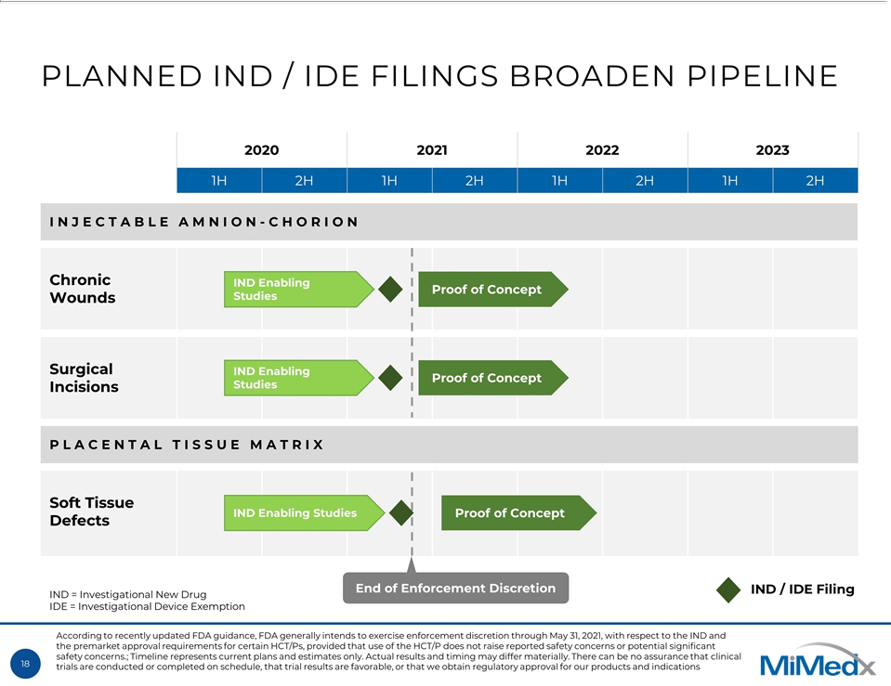

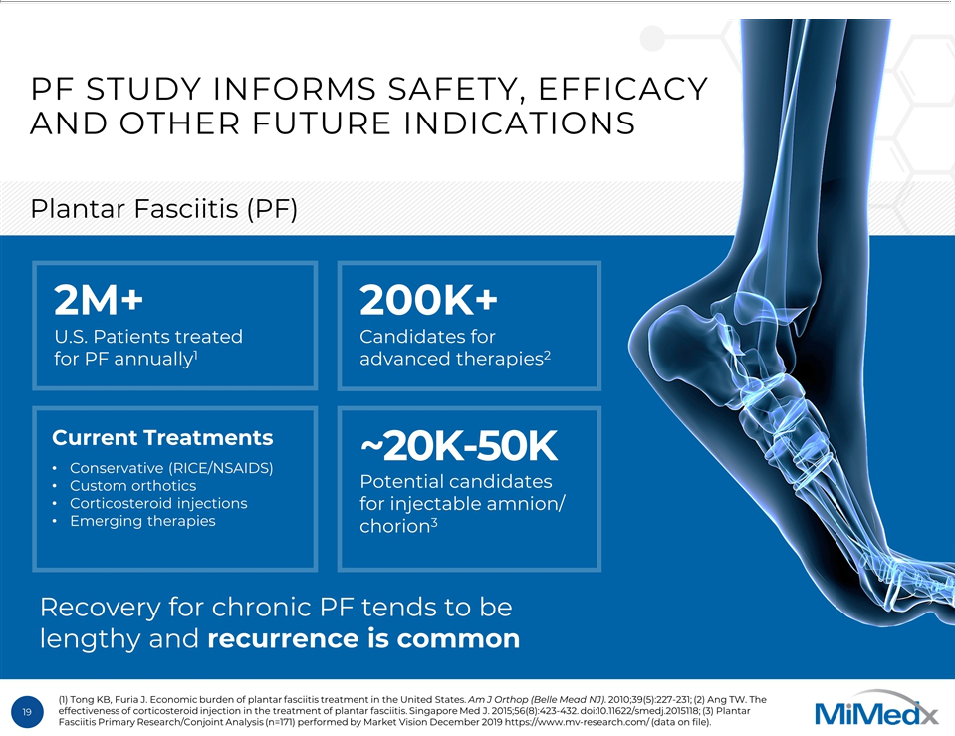

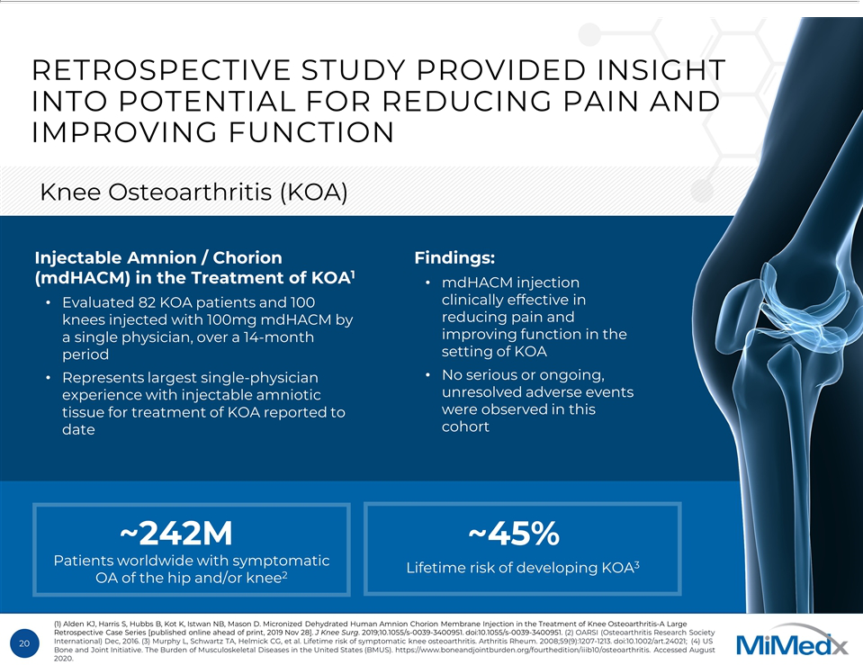

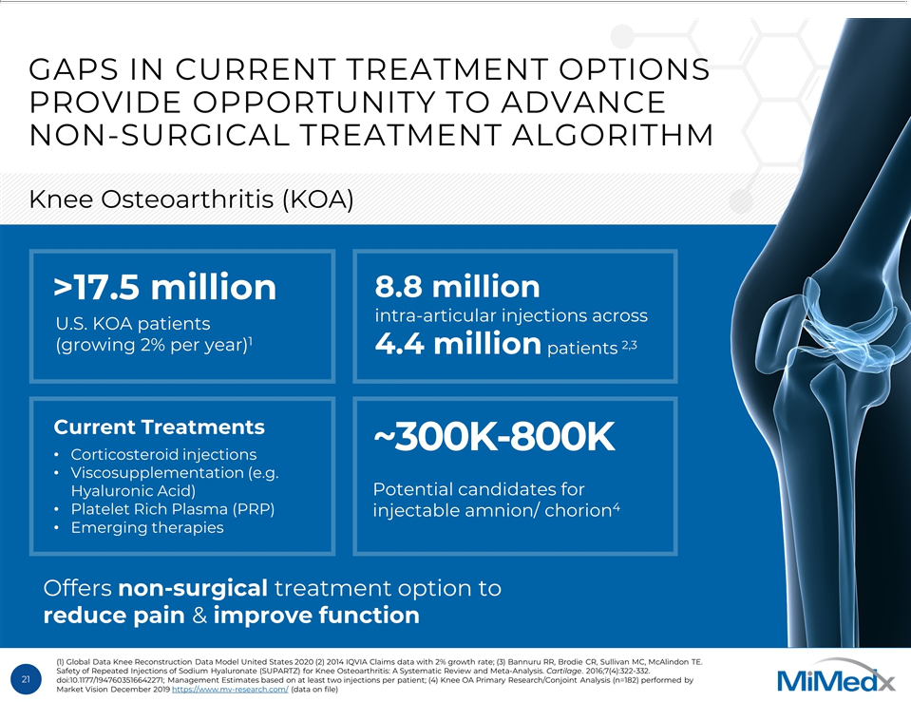

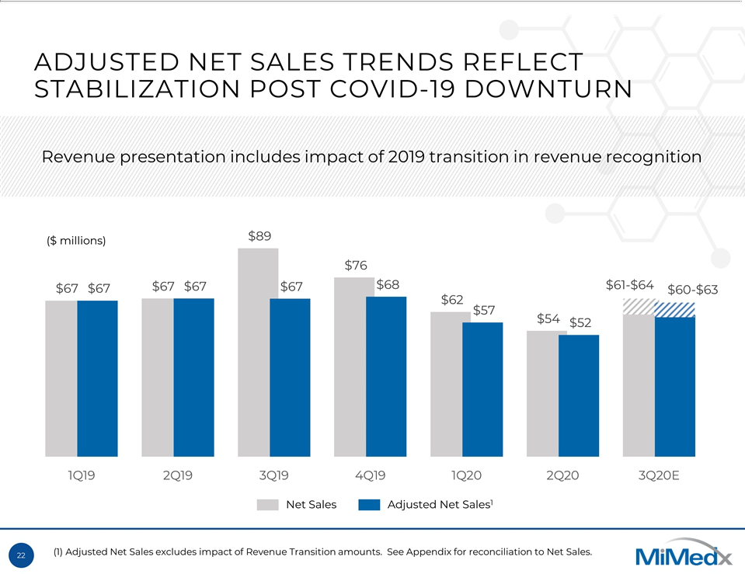

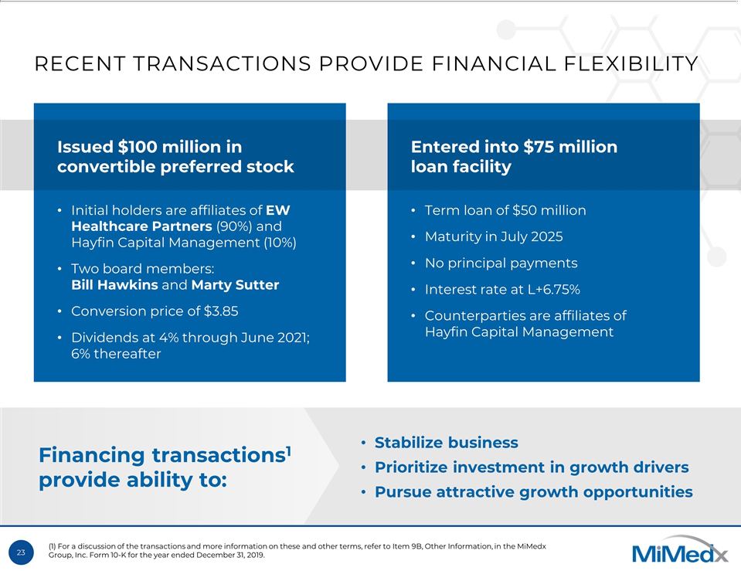



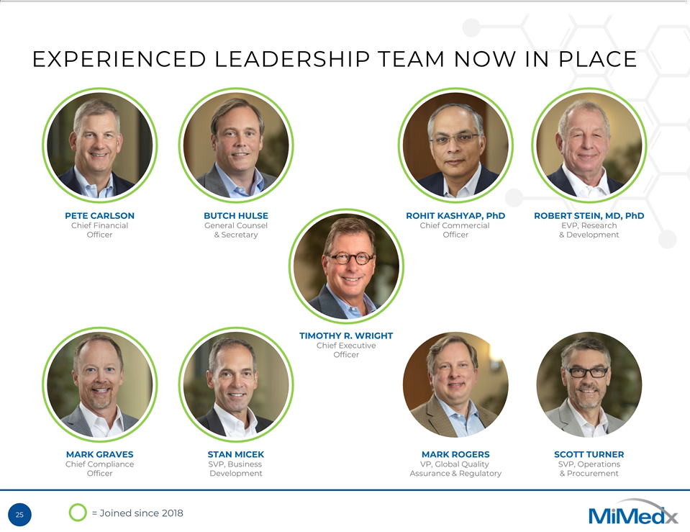

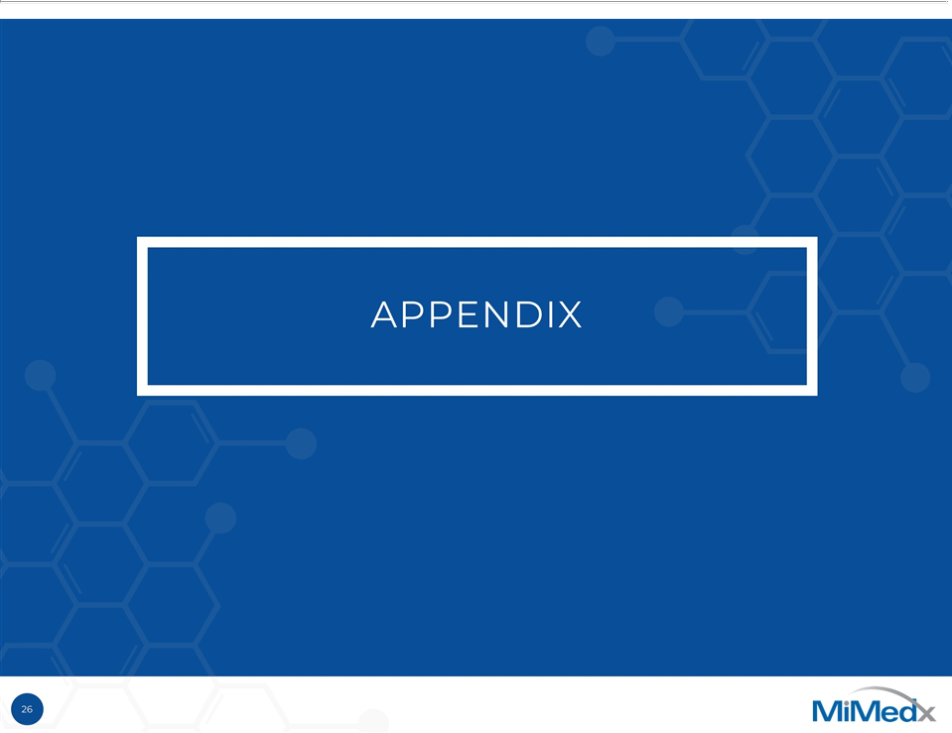

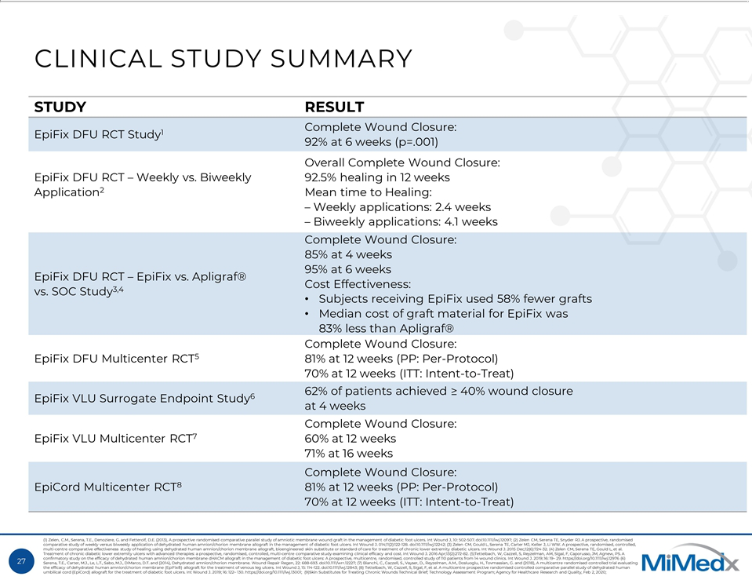

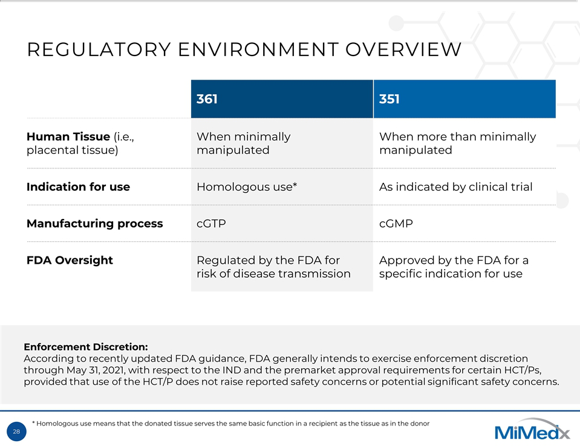

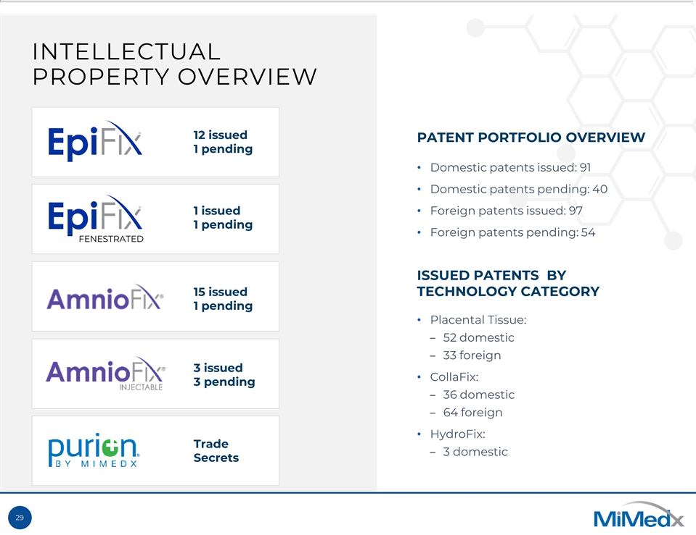

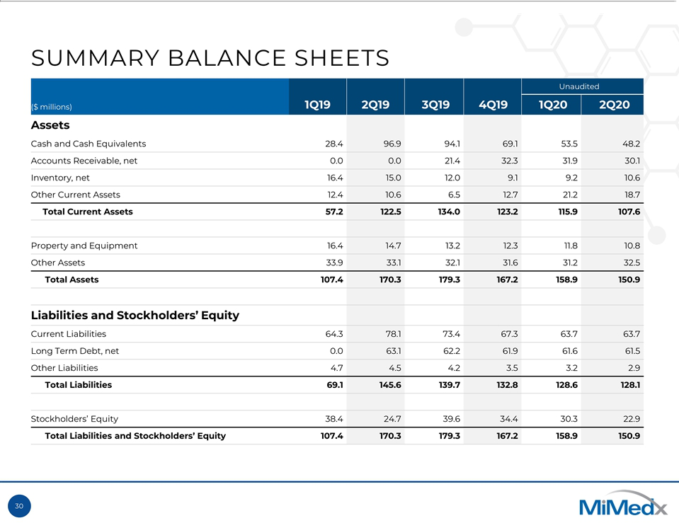

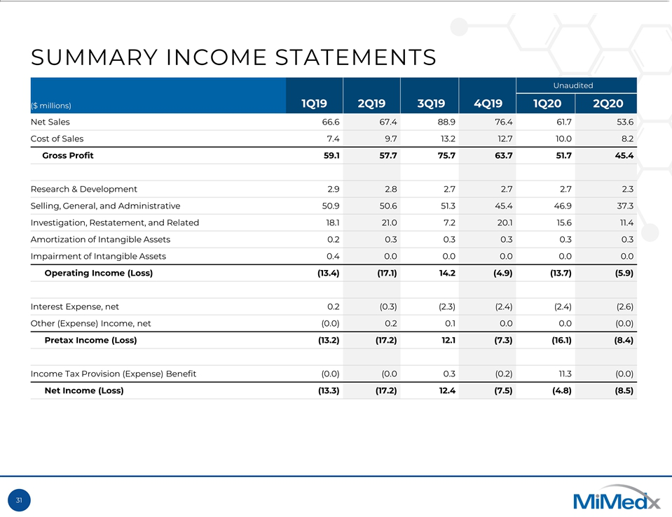

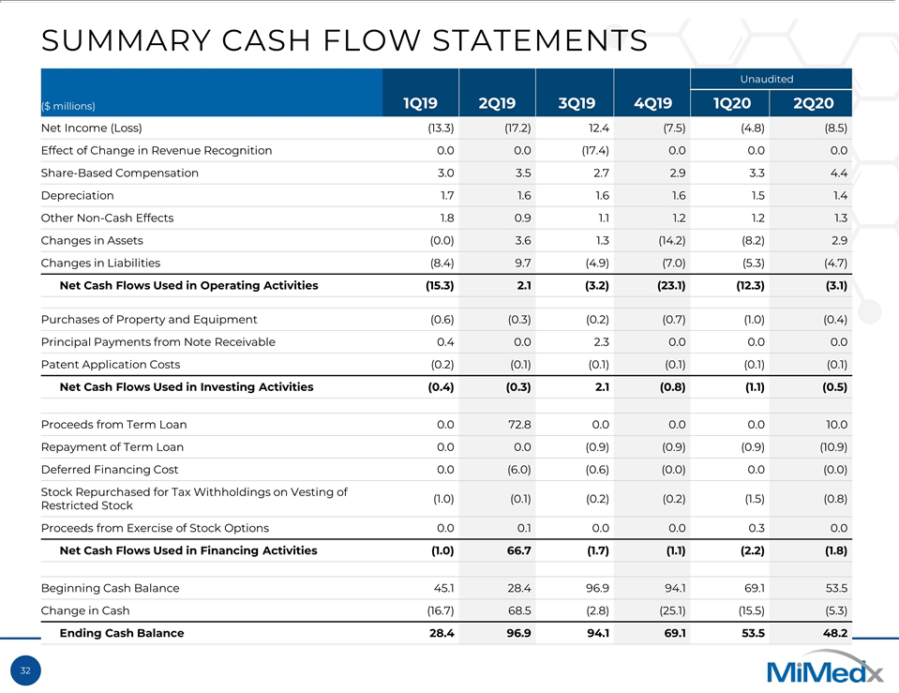

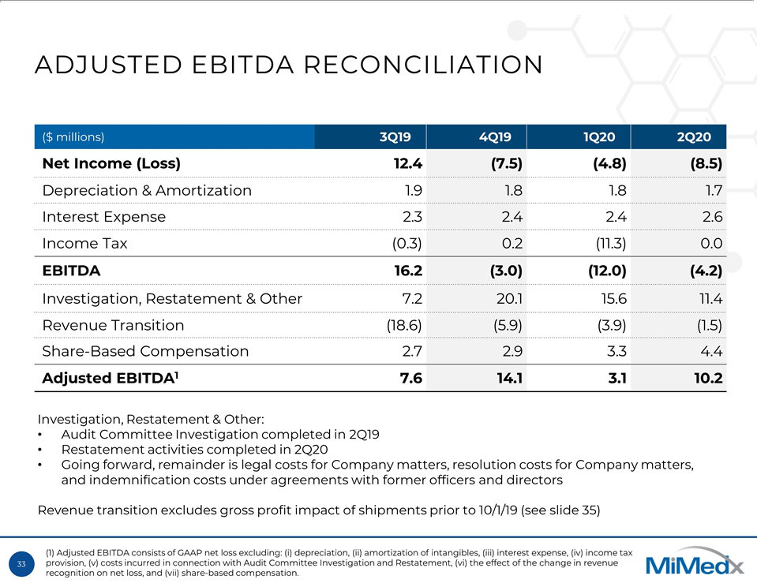

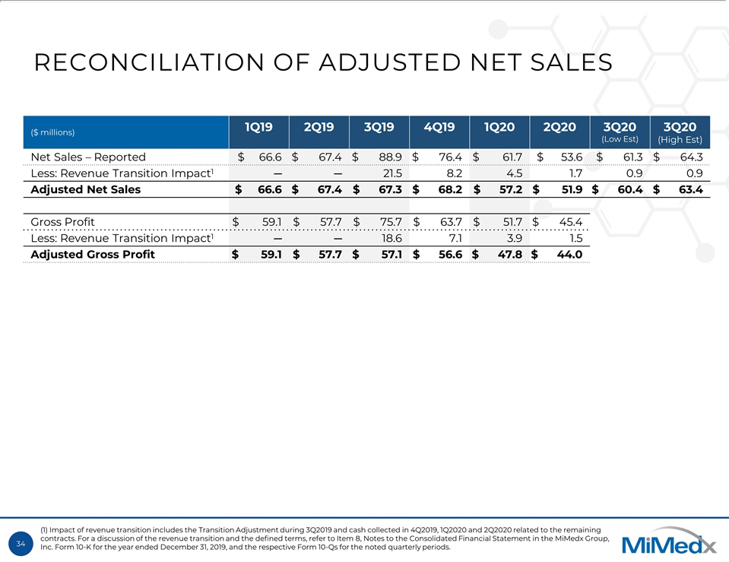

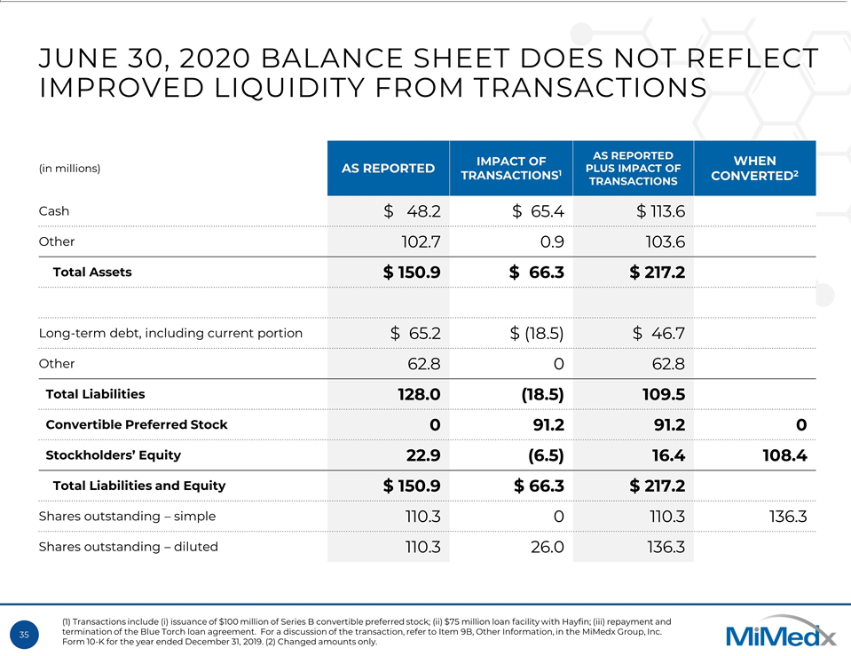

Exhibit 99.2

MiMedx Announces Preliminary Third Quarter 2020 Net Sales

Third Quarter 2020 Net Sales Expected to be Between $61 Million - $64 Million

Latest Corporate Presentation Filed with SEC and Posted to IR Website

2020 Annual Meeting of Shareholders to be Held on November 20, 2020

MARIETTA, Ga., September 21, 2020 — MiMedx Group, Inc., (OTC PINK: MDXG) (“MiMedx” or “the Company”), an industry leader in advanced wound care and a therapeutic biologics company, today provided guidance regarding certain unaudited, preliminary third quarter financial results. Net sales for the quarter ended September 30, 2020, are expected to be between $61 million and $64 million. This compares to $88.9 million reported for the quarter ended September 30, 2019. Net sales for the quarter ended September 30, 2019, include a benefit of $21.5 million resulting from a change in the Company’s methods for recognizing revenue from the time of cash collection to the time of shipment (the “Transition”). For more information regarding the Transition, refer to Note 3 to the Consolidated Financial Statements included in the Company’s 2019 Annual Report on Form 10-K. The Company expects to recognize revenue of approximately $1 million in the quarter ended September 30, 2020 relating to the collection of cash from invoices that were outstanding but not yet collected at the time of the Transition. This amount is included in the range above.

Without the revenue recognition benefits of the Transition, the Company expects net sales will have increased between 16% and 22% from the quarter ended June 30, 2020; and declined between 6% and 11% from the quarter ended September 30, 2019. These preliminary results are not audited and remain subject to the completion of our quarter-end financial close process.

Timothy R. Wright, MiMedx Chief Executive Officer, commented, “We achieved numerous milestones in stabilizing our business and we believe that we created a solid foundation for sustainable and profitable growth as evidenced by the sequential increase in our preliminary third quarter 2020 net sales. Our market-leading platform backed by our best-in-class clinical evidence gives us a strong position in the large and growing advanced wound care sector. Going forward, we will continue to increase the value of our portfolio, innovate through our promising product pipeline, and invest in new market opportunities to maximize value for our shareholders.”

Beginning on September 21, 2020, certain executive officers of the Company will hold conference calls with institutional investors. The Company has filed a copy of the presentation materials to be used during these calls with the Securities and Exchange Commission (“SEC”), and has made it available on the Investor Relations section of its website.

2020 Annual Meeting of Shareholders

MiMedx will hold its 2020 Annual Meeting of Shareholders on November 20, 2020.

In light of public health concerns regarding the coronavirus (COVID-19) outbreak, the Company will conduct the Annual Meeting in virtual format only in order to assist in protecting the health and well-being of our shareholders, directors and employees, and to provide access to our shareholders regardless of geographic location.

Any shareholder proposals or nominations under the Company’s Amended and Restated Bylaws must be received by the Company on or before October 1, 2020 and otherwise comply with the Company’s Amended and Restated Bylaws. For any proposal to be included in the Company’s proxy statement for the 2020 Annual Meeting pursuant to Rule 14a-8 under the Securities Exchange Act of 1934, as amended, such proposal must be received by the Company on or before October 1, 2020 and otherwise comply with the requirements of Rule 14a-8.

About MiMedx

MiMedx® is an industry leader in advanced wound care and a therapeutic biologics company developing and distributing human placental tissue allografts with patent-protected processes for multiple sectors of healthcare. The Company processes the human placental tissue utilizing its proprietary PURION® process methodology, among other processes, to produce allografts by employing aseptic processing techniques in addition to terminal sterilization. MiMedx has supplied over 1.9 million allografts, through both direct and consignment shipments. For additional information, please visit www.mimedx.com.

Important Cautionary Statement

This press release contains forward-looking statements. Statements regarding expected levels of net sales for the quarter ended September 30, 2020 and the timing of the 2020 annual meeting of shareholders are forward-looking statements. In addition, all statements relating to events or results that may occur in the future are forward-looking statements, including, without limitation, statements regarding the following: “possible,” “could,” “estimate,” “may,” “anticipate,” “to be” and similar expressions.

Investors are cautioned against placing undue reliance upon these statements. These statements are based on numerous assumptions and involve known and unknown risks, uncertainties and other factors that could significantly affect the Company’s operations and may cause the Company’s actual actions, results, financial condition, performance or achievements to differ materially. Factors that may cause such a difference include, without limitation, those discussed under the heading “Risk Factors” in our most recent Form 10-Q and in our Form 10-K for the year ended December 31, 2019. Unless required by law, the Company does not intend, and undertakes no obligation, to update or publicly release any revision to any forward-looking statements, whether as a result of the receipt of new information, the occurrence of subsequent events, a change in circumstances or otherwise.

Contact:

Hilary Dixon

Investor Relations & Corporate Communications

770.651.9066

investorrelations@mimedx.com

